Dear Parent/Carer,

Although the school is currently closed due to Coronavirus, we are continuing to provide educational tasks for your children to complete.

In year 9, we suggest that children try to complete;
- 1.5 hours per week of English, Maths and Science (ie 4.5 hours a week in total)
- 1 hour per week of their 5 option subjects (ie 5 hours a week in total)
- 30 minutes of PE per day
- 30 minutes of reading per day

Home learning tasks can be supplemented with work from a number of websites (see the school home learning page on the website for examples of these).

Teachers will set a weekly programme for your child to work through at home. This will be available for you to access on the school website every Monday. Please note that to access the work on a mobile or laptop you may need to install Word (available here for Android and here for Apple) and Powerpoint (available here for Android and here for Apple). If accessing the work on a laptop then pupils should be able to use Office 365 through their web browser and won't need to install any extra programs. If you have any problems accessing the work then please email Mr Gibson (gibsonr@mayfield.portsmouth.sch.uk).

Whilst it is important for your child to keep up with their learning at home, we appreciate that this can be a stressful time for children and adults. Looking after mental health is vital. Therefore, we suggest that the day is broken up into manageable learning chunks, interspersed with physical exercise, fun activities and time together as a family. Activities such as the 30 day Lego challenge and the daily Joe Wicks PE lessons could be a good place to start.

As well as educational learning, the children could also begin to learn different life skills – make a meal for the family, sew on a button, write a letter to a distant family member, bake a cake using a recipe book etc.

We hope you are all keeping well and staying positive.

Core subject work for all pupils

English
In order to expand your understanding of figurative language, poetry and descriptive writing, we would like you to work on a minimum of ONE (or for our most able students TWO) of the tasks from the English Mastery Student Workbook you can find here. We have included an answer book to help you review your work and check you haven’t made any mistakes. You can find this here.
If your parents are trying to help you, there’s a guide for them too – but why not be resilient and explain it to them!
So, this week, it’s Lesson 3 ‘Dreams’ by Langstone Hughes. Remember, to be resourceful and challenge yourself to complete all the tasks and work on deeper thinking skills! You could even move on to the following lesson if you’re feeling like a bigger challenge this week or catch up with the previous lessons if you missed them.
In addition, we want you to work on your spelling! You can find the third week’s spellings here. Remember, use your strategies: look, cover, write and check. Also, if any of the words are unfamiliar, look them up using a dictionary or online.
Also, in preparation for your GCSEs, we’d like you to look at reading comprehension. Attempt a minimum of ONE task a day from the modern texts booklet you can find here. For our more able, or those hoping to exceed a Grade 5 at GCSE, have a go at a more challenging text from here as well.
Finally, a reminder to be reading privately and completing Accelerated Reader quizzes for the books you read. Try to make time for 15 minutes reading MINIMUM a day. How about before bed?

Maths
First task - 1 Hour PIXL Maths APP (https://mathsapp.pixl.org.uk/PMA2.html)
Make sure that you click ‘allow Adobe’
PIXL Login
School ID - MF2916
User ID - Surname and initial (eg Joe Bloggs = BloogsJ)
Password - PASSWORD
Your teacher has set the relevant tasks. Once logged on:
1. Click "Select task"
2. Click "Homework Task" - This brings up the most recent HW set by your teachers.
3. Complete the questions set. If you need support click on "Video" or "Power Point".
If you click "Previous HW task" - brings up previous task questions
If you click "Homework Results" you can see your marks for each of your homeworks you have completed.
If you cannot access PIXL please email Mr Ralph on the following ralphs@mayfield.portsmouth.sch.uk with your: Name, Year, School Username, and Maths Class and he will help you.

Second task - 30 mins on Maths box https://www.mathsbox.org.uk/64.html

Scroll to the bottom on the page and Select W/B 6th April 2020
Set 1 - Answer and mark the Year 9 questions
Set 2 - Answer and mark the Year 9 questions
Set 3 - Answer and mark the Foundation A questions. If you get lots incorrect try the Foundation B questions.
Set 4 - Answer and mark the Foundation B questions

Science
Please write any answers on paper, you do not need to print out any sheets. (although feel free if you want to) - keep these well-ordered so you can show them to you class teacher when we return.

This week you are going to refresh your memory relating to transfer of substances int he body. You all know there are three basic ways substances transfer; Osmosis, diffusion or active transport, but what do these words actually mean and what factors affect them?

Click on this link to access the revision sheet questions:

You can also find answers for last week’s work by clicking here. You should use some of the time you have allocated to science to check through the answers you’ve put, reflect on any mistakes and correct them.

If you have any questions, or would like to send some examples of your work to us please email them to Mrs Stedman – Stedmank@Mayfield.portsmouth.sch.uk

PE
The key benefits of doing PE are enjoyment, challenge and improved mental health. Therefore we suggest that you should undertake 30 minutes of physical activity every day. This could include jogging, cycling, or some form of indoor exercise (for example Joe Wicks daily PE activity on YouTube) with other people in your household.
You could also create a training log to record how your fitness progresses. Things you could record are:
- Distances and times achieved
- Heart rates
- How does your body feel?
- Plan for future sessions

PSHE
This week you will be continuing with your home learning on the environment. Last week you learnt about the different ways that the lockdown had positively impacted the environment, including cleaner air, clearer water and more wildlife being seen. Read back over your notes to remind yourself of what you learnt.
Once the lockdown in the UK has finished, it is likely that people will quickly return to their old habits with regards to using cars etc. This will therefore have a negative effect on the environment again.
- Make a list of the things that people might start doing again, which could reverse the impact that lockdown is having on the environment.
- For each one, write an alternative that people could start doing, to ensure that pollution levels remain lowered.
- Challenge: Can you think of any ways that communities or companies could work together to maintain an improved environment? For example, the tourist boat companies in Venice could agree to only do a set number of trips per day, to maintain the clearer waters.

Option Subject Based Work
(only to be completed by pupils who study these subjects)

Art
Research the artist Ian Murphy. You are going to create an artist research page on his work. Begin with the following:
- Create the title of his name (Ian Murphy)
- Write information about his work. What does he do? How does he create his work?
- Creating an artist study of his work (copying one of his pieces of artwork onto your paper in his style).
Use this link to help your research - http://www.ianmurphyartist.com/about/
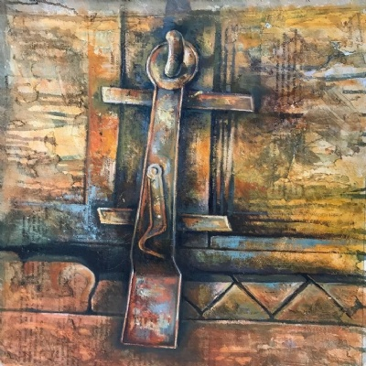
If you are not able to access the internet then pleas use this Ian Murphy piece.

Business Studies
Task one (10 minutes) – explain the journey of a loaf of bread from production to your toaster? You can do this as a comic strip, mind map, flow chart or in writing.
Task two (10 minutes) – there are three sectors involved in making a product or buying a service, primary, secondary or tertiary. Write a definition of each as three revision cards.
Card 1 side 1 – what is meant by the primary sector?
Card 1 side 2 – write the definition of the primary sector.
Card 2 side 1 – what is meant by the secondary sector?
Card 2 side 2 – write the definition of the secondary sector.
Card 3 side 1 – what is meant by the tertiary sector?
Card 3 side 2 – write the definition of the tertiary sector.
Task three (10 minutes) - Can you think of examples of companies in each sector? Try to think of at least one national company and one local company. Do this as a table.
Task four (30minutes) - Create a poster showing the journey of a raw material through each sector, becoming a product and arriving in the tertiary sector.

Computing
During your computing time this week we would like you to work on your programming skills. If you are a confident programmer then you can do any of the following tasks:
- Carry on working through the homework tasks you have been using all year (click here)
- Start work on these advanced challenges (this is a new booklet many of you won’t have seen before – click here)
- Continue working on any program you have begun this year (for example your text based adventure game)
If you are not feeling so confident with your programming skills then you may want to use the Codecademy Python course – although it is set up for Python 2 there are only a few small differences to what you have been taught (click here).

Dance
Practical: (50 minutes)
Full class, including warm up, technique and routine (https://www.youtube.com/watch?v=-VK2hNMfetE)
Theory: (10 minutes)
Using these headings;
- Physical skills
- Expressive skills
- Mental Skills
Put the following terms in the correct list;
- Posture
- Movement memory
- Flexibility
- Facial expressions
- Focus
- Confidence
- Alignment
- Projection
- Commitment
- Concentration
- Isolation
- Coordination
- Musicality
- Spatial awareness
- Extension
- Strength
- Mental rehearsal

Drama
Research into the role of a director - https://www.bbc.co.uk/bitesize/guides/zhf8gwx/revision/1
Design a poster on the role and responsibilities of a director (i.e. having a vision for the production, communication etc)
If you do not have access to the internet then use the information you already know about the role of a director.

French
Task 1
You are to follow the link to a Google Form retrieval quiz https://forms.gle/m8xmLu1Bv91bQrFGA
Please complete the relevant information with your name, class (if you know it) and your teacher.
There are 10 questions and each question is worth 3 marks. You will be completing one of these retrieval quizzes every week so keep a track of your scores and see where your strengths are and where you need a bit more work on.
Task 2
https://www.bbc.co.uk/bitesize/guides/znb4t39/revision/1
Follow the link to BBC Bitesize and complete the activities regarding Food & Drink in French. Once you have completed the activities, make some flashcards with key phrases in French to help you remember them.
Task 3 – Optional extra
You are to research a famous person from a French-speaking country and write a description about them. They can be an actor, singer, athlete, politician, etc. Write about their physical appearance, personality, and why you respect them. You can do this on the computer or create a poster- get creative! Email your work to painter-emily@mayfield.portsmouth.sch.uk

Geography
Introduction to Weather Hazards and Climate Change.
There is a brand new assignment on Seneca on a new topic that is part of the GCSE course.
Click on the link below. You need to go to this link and create a Seneca account with your school email. This can be completed on a PC, laptop, tablet of phone.
https://app.senecalearning.com/dashboard/join-class/ktcizymj6l
Once you have created your account then click on the button that says start assignment and you will then go through the learning and questions.
The main case study that we will be learning about for your GCSE is Typhoon Haiyan.
Complete some research about the Typhoon using the internet.
Create a flash cards with the following information
  - When did it occur?
  - Which countries did it affect?
  - What was the death toll of the disaster?
  - How powerful was the typhoon? Wind speed? Storm category?

History
This Friday, May 8th, is a bank holiday. This is because it marks the 75th Anniversary of VE day and is a time of national celebration. As a school we would like to ensure students have an awareness of this occasion and an opportunity to celebrate it as a school community any way we can.
Therefore, the History task this week is based on VE Day, but if you wish to become involved further there are many more things you can do as listed below. Please send any photos you have of what you do to your Head of House and/or Miss Rich.
Task 1: What is VE day and how was it celebrated at the time?
https://www.bbc.co.uk/teach/class-clips-video/history-ks2-ve-day/z7xtmfr Once on the page scroll down and play the video. It is aimed at KS2 but is very informative and includes an account of someone who lived through it.
Read this information from Newsround. https://www.bbc.co.uk/newsround/48201749 It explains what VE Day is and how it was celebrated at the time.
Click on this link: https://www.bbc.co.uk/teach/ve-day-How-did-the-british-plan-to-celebrate/zndn7nb scroll down to the ‘Hear the sounds’ and press the play button to hear the speech of Winston Churchill, then scroll through the pictures showing how Londoners celebrated.
Click http://www.bbc.co.uk/history/ww2peopleswar/about/lzone_sources_endofwar.shtml read the memories of the people who lived through VE day.

Task 2: Complete one or as many of these task as you wish. If you can’t get involved in a mini celebration then completing one of the written/poster tasks is fine.
-Imagine it is May 8th 1945: write a diary entry of how you celebrated the end of the war in Europe. Consider what you do, how you feel, what you have been through, what you think about the future etc. Would everyone think the same?
-Imagine it is May 9th 1945: write a newspaper report about VE day, how people celebrated, how the war came to an end etc. Think about the different reactions
-Design a 75th Anniversary VE day poster to put in your window,
-Take part in a garden party! In 1945 street parties across Britain took place. Whilst circumstances mean street parties can’t happen this year private garden parties can! Organise a party for your family in your garden/house. This could involve a BBQ. Making cakes, making Union Jack banners, music, dancing and much more. Remember if you do this…..send us the pictures!

IT ( BTEC)
Assignment work
Over the last couple of months, you have been working on an assignment which is all about creating a User Interface for a customer, this assignment can be found here, the support sheets for this assignment can be found here. If you are able to complete this, please do so.
Next Steps
- If you are unable to finish that assignment or you have finished it, you will find the next sets of tasks/learning here. They are broken down into lessons, which will take you approx. 30/40 to complete.
- Keep All the work/notes/answers - you will need them for Y10/11.

Music
Listening Diary – Select 3 pieces of Electronic Dance Music and write an analysis of them. You should discuss the Tempo, Texture, Dynamics, Mood, Form/Structure, Rhythm, Timbre, Duration and what you like about each piece and what you do not like about each piece. If possible, select each piece from a different style of Electronic Dance Music

PE GCSE
You are going to be using Seneca for your learning this week – Mr Campbell has emailed you details. You continue with the following online lessons:
2.1.1Lever Systems
2.1.2Mechanical Advantage
2.1.3Basic Sporting Movements
2.1.4Basic Sporting Movements 2

Sports Studies
Sports Studies materials are all saved in the students’ folders on SharePoint. Any resources required are also in the folders for students to use.
Review of Learning – Access your Learning Outcome 1 in Unit 3 on SharePoint and reflect on Task 3 Leadership qualities.
These include:
- Reliability / punctuality
- Confidence
- Communication
- Creativity
Add additional examples, description and pictures to each Leadership quality.

Photography
Referring to your photoshoot plan from the previous week, use this hour to photograph objects around your home with the focus of using viewpoints to present them in a more interesting and creative way. You should take at least 20 photographs. If you do not have access to a camera or a phone which has a camera then look to draw some of the objects you had chosen to photograph in your photoshoot plan (these do not have to be detailed sketches).

Spanish
Topic: School subjects and teachers
Task 1
You are to follow the link to a Google Form retrieval quiz here
Please complete the relevant information with your name, class (if you know it) and your teacher.
There are 15 questions and each question is worth 3 marks. You will be completing one of these retrieval quizzes every week so keep a track of your scores and see where your strengths are and where you need a bit more work on.
Task 2
https://quizlet.com/146246586/las-asignaturas-subjects-flash-cards/
Follow the link to Quizlet and complete the activities regarding school subjects. Strengthen your knowledge by reviewing the set of terms provided through the study section (flashcards, learn, write, spell, test), then engage with the play section (match, gravity) to consolidate what you have learnt. Once you have completed the activities, make some flashcards of your own with key phrases in Spanish to help you remember them.
Task 3 – Optional extra
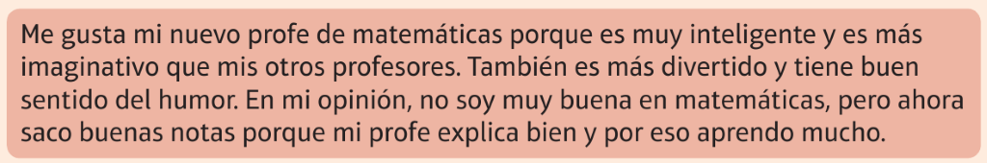
Translate the text above. Furthermore, write a text about your teachers including the following criteria:
- description of at least two teachers
- subjects you used to like/dislike when in primary school
- comparatives (más…que, menos…que)
- opinión phrases (e.g.: creo que, pienso que, para mí)
- connectives and intensifiers
- extra phrases to extend your writing (e.g.: explica bien, da consejos…)
Either handwrite or type this and send to me. Please, do NOT use Google Translate as that teaches you nothing. Instead, use https://www.wordreference.com/ for an online dictionary.

Travel and Tourism
- Write definitions of the following key words and include some examples. Turn them into flash cards to memorise.
- Natural attractions
- Built attractions

- Find a map of either Cornwall, Cumbria and the Lake District and copy it into a PowerPoint Slide.
  - locate as many tourist attractions as you can.
  - Use a code to identify on the map which of the attractions are natural and which are built.
  - Add to the map by indicating which of the attractions are free and which charge for entry.
  - Finally identify the main purpose of each attraction, for example to entertain or to educate visitors.
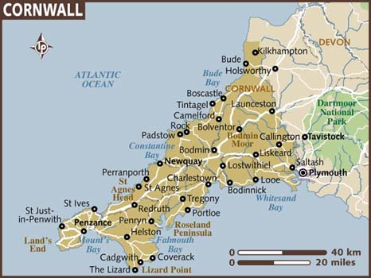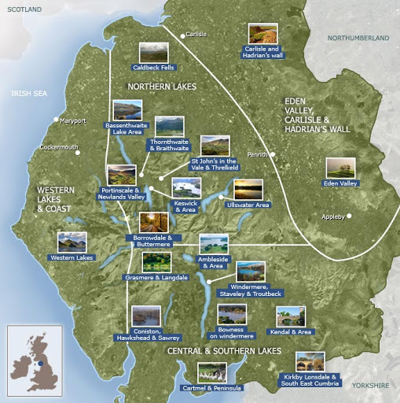

Save all your work into your Travel and Tourism folder one and send a copy or share a link to Mr Royle.

