Business Studies
Induction Task
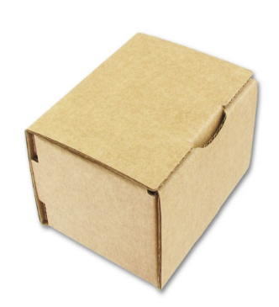
The Box

You have been given this cardboard box.
How are you going to turn it into a profitable product?

Your task, in groups of three, is to turn this box into a product that will make a profit. You can do anything to it: redesign the packaging, put things inside it and so on. The box itself costs 8p.
You must:
- Draw a design of your product
- Write a brief business plan on lined paper (a minimum of two pages) including:
  - An outline of what your product is and why you chose it;
  - The finances you will need to set up your business. This should include estimate costs, selling prices and forecast sales/profit;
  - The area of the market you are entering including an outline of your customer and your competition.
- Create an accompanying set of prompt cards outlining the plans that you would be prepared to present on the first day. You will present your product design the outline of your product to your class at the end of the lesson.

Get your thinking caps on and good luck!
Some ideas that you cannot steal!
