**Year 9 Business Studies Homework**



**Name:……………………………………………….**

**Class:………………………………………………**

**Teacher:………………………………………….**

**PURPOSE OF BUSINESS**

**Reasons for Starting a Business**

**Starting up a business**

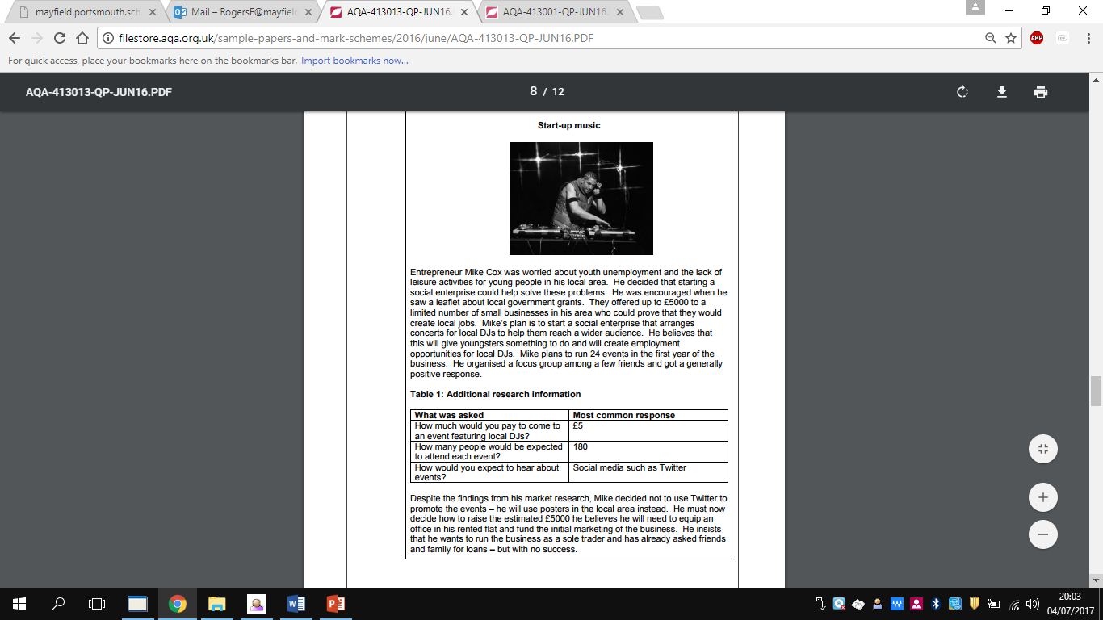

1. Explain what is meant by the term “social enterprise” (2 marks)
2. Why would using Twitter instead of posters to promote a social enterprise in particular be a good idea? (4 marks)
3. Why would someone like Mike choose to set up a social enterprise? Use the case study to support your answer. (4 marks)

**Basic Functions and Types of Business**

**Business Ownership**

**Nadir’s Repairs**

Nadir Ahmed has been working for a large garage for the last 8 years. He has specialised in fixing scratched and dents. He is good at his job and has recently been given a pay rise. However, he wants to work for himself and start his own repair business, which will fix any damage to a car’s bodywork. He will need about £25 000 to set up with a small workshop, to buy some equipment and to start promoting the business. He has about three quarters of this money himself but would need to raise the rest of the money from somewhere else. He thinks he will set up as a sole trader but his friends have told him he should set up a company instead.

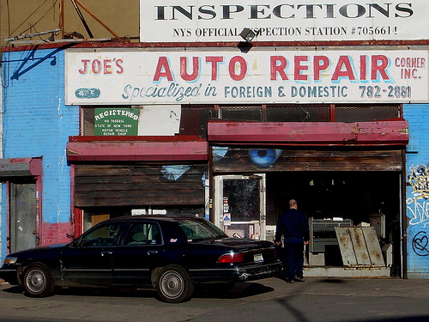

1. State two advantages to Nadir of setting up as a sole trader (2 marks)

2. Explain two disadvantages to Nadir of setting up as a sole trader (5 marks)

3. Discuss whether it might be better for Nadir to set up as a LTD rather than as a sole trader (12 marks)

**Extension exercise**

What do you think will determine whether or not Nadir finds investors for his business? Explain your answer (6 marks)

**Business Enterprise**

For the following key terms write the definition and also give a real life business example.

|  |  |
| --- | --- |
| **Key Term** | **Definition** |
| Sole Trader |  |
| Partnership |  |
| Limited Liability Partnership |  |
| Private Limited Company |  |
| Public Limited Company |  |
| Franchise |  |
| Limited Liability |  |

**Entrepreneurship**

**Starting a Business**

Bo Belle

Claire Watt Smith worked for several years as a buyer choosing products for Monsoon, the fashion company. She decided to leave Monsoon, use her savings and set up her own business selling fair trade jewellery, accessories and baby clothes online. She created a name and logo for her business, ‘Bo Belle’. To get the business started she often worked 10 hours a day 7 days a week but she said she had a real sense of achievement. Her business is only just covering its costs now but interest is

growing and she has recently been approached by Topshop who have given her the opportunity of selling in one of their stores in return for a percentage of the profits. If she did this, a lot of her time would be spent in the Topshop store.

(See www.bobelle.co.uk)

**Questions**

1. State two possible problems that Claire might have had in setting up her business. (2 marks)
2. Explain two skills Claire might need to be a successful entrepreneur. (4 marks)
3. Discuss the reasons why Claire might have wanted to set up her own business. (6 marks)
4. Do you think Claire should accept the Topshop offer? (12 marks)

**WHAT ARE BUSINESS AIMS AND OBJECTIVES?**

**Purpose of Setting Objectives**

**Role of Objectives in Running a Business**

**Changing Objectives**

**Use of Objectives in Judging Success**