Dear Parent/Carer,

As the school is currently only partially open to Year R and Year 1 due to Coronavirus, we are continuing to provide educational tasks for your children to complete whilst they are at home. On the days your child is in school, they will be completing those days of learning within their ‘bubble’.

In primary, we suggest that children complete;
- 30 minutes a day reading to/with an adult (this could be a bedtime story)
- 30 minutes of Maths a day
- 30 minutes of English a day
- 30 minutes of PE/ physical activity
- A weekly topic/creative task
Home learning tasks can be supplemented with work from a number of websites (see list below for ideas)

Teachers will set a weekly programme for your child to work through at home. This will be available for you to access on the school website every Monday.

Whilst it is important for your child to keep up with their learning at home, we appreciate that this can be a stressful time for children and adults. Looking after mental health is vital. Therefore, we suggest that the day is broken up into manageable learning chunks, interspersed with physical exercise, fun activities and time together as a family. Activities such as the 30-day Lego challenge and using the real PE activities could be a good place to start.

As well as educational learning, the children could also begin to learn different life skills – how do boil an egg, sew on a button, learn to send an email, bake a cake using a recipe book etc.

We hope you are all keeping well and staying positive.

Kind regards,

Miss Percival, Mrs Jonkers, Mrs Moore and the Year R team.

jonkers-kerry@mayfield.portsmouth.sch.uk
percival-jessica@mayfield.portsmouth.sch.uk
moore-laura@mayfield.portsmouth.sch.uk

Ideas for Home Learning - Week 10 – 06/07/2020
Our topic this half-term is Adventures: Real or Imaginary. Each week will give you a range of activities that you can complete with your child to continue to consolidate their learning. Most importantly – please remember to read everyday!
 | Monday | Tuesday | Wednesday | Thursday | Friday
English | Phonics  Recap phase 3 sounds ch, sh, th, ng, ai, ee, igh, oa, oo long, oo short, ar, or, ur, ow, oi, ear, air, ure, er.  Phonics Play (still free to log on).  Play Dragons Den | Comprehension  Oxford Owl eBooks: Zoom Food  Read the story and then complete the questions on pg17. | LIVE Storytime  Join the ‘Year R’ Microsoft Teams at 9.30am for a story and challenge with Mrs Jonkers. If you can’t join at this time, we will record this session, so it will be available in Microsoft Teams to access after the session has finished.  What story do you think it will be this week? Here is a tiny clue! | Book Review  Can you complete a simple book review about the story that Mrs Jonkers read yesterday?  Scroll down to page 8 to see a format to follow. | Helicopter Stories  Have a go at making up your own Helicopter Story about a knight, a princess or a dragon. It could even feature all three!!  Please click the link below to learn more about Helicopter Stories at Home  https://helicopterstories.co.uk/2020/04/19/helicopter-at-home/?fbclid=IwAR0Lv4h_FkUToEGjRgrCseqMeTO8y6867c7VsO30dNCa4NRjzfH-b-I9Sgo
Maths | Feedback Task  Watch the video of Mrs Moore and Miss Percival demonstrating ‘counting back’. Link:  https://mayfieldschoolpo2.sharepoint.com/sites/YearR-ForHomeLearning2/Shared%20Documents/General/Year%20R%20Counting%20Back%20Monday%206th%20July%202020.mp4  It is also available in the ‘Files’ section on the Year R Microsoft Team.  Once you have watched the video, have a go at the same task using the numbers 1-10.  Challenge: Use numbers up to 15.  This work can either be dropped off in a box at reception, or simply send a photo in an email to your class teacher. We will be giving individual feedback based on what we are sent. Please submit this work by Monday 13th July so we can feedback on Wednesday 15th July. | Counting Back  Think back to what we did yesterday. Can you do this activity again, but this time using numbers up to 20.  Challenge: Use any two-digit number (up to 30) and a one-digit number. E.g. 29 - 7 = ____. | Number Problems  Scroll down to the bottom (pages 9 to 11) to look at the number problems. Can you use your counting back skills to find the answers? | Construction  Make a tower of 20 bricks. Take it in turns to roll a dice and take that amount away from your tower. Count back each time you take bricks away. E.g. I have 20 blocks already so I will start on 20 and then take away 2. “20, 19, 18.”  Challenge: Record your sums on a piece of paper each time you take blocks away. (E.g. 20-3=17, 17-5=12) | Countdown game  Create a countdown game. For example, chalk outside (or write on pieces of paper) numbers 10-0 leading towards a rocket or water blaster. Provide a dice. The children roll the dice and jump from 10-0. First to reach the rocket shouts ‘blast off!’ to win the game.
Wider Curriculum | A New Adventure  This week our adventure comes back to Earth, I wonder where we will be?  On a tablet or laptop etc bring up a picture of a castle. Do not show the children yet- cover the picture with some paper, and in the paper cut a small circle.  Slowly start to move the ‘spotlight’ around the picture can you guess where we are going?  What is a castle, do we have them now, what were they for, who lived there?  Have a look at different castles online, you could even go for a walk around or sightseeing at Portchester Castle or Southsea Castle! | Castles  Look at the features of a castle (there is a picture at the end of this document - Page 7) Have a look at what they are and their functions.  Can you design your own castle and include those features, don’t foget to label it.  If you want a challenge you can tell someone (or even write) who lives there. What do they do? Are they a knight/ a princess/ king/ queen, maybe even a mythical creature? | LIVE Challenge  We have a challenge for you! Join the ‘Year R’ Microsoft Teams at 9.30am for a story and challenge with Mrs Jonkers. If you cannot join at this time, we will record this session, so it will be available in Microsoft Teams to access after the session has finished. | Dragons  In myths and legends, you can read about fearsome dragons.  https://www.youtube.com/watch?v=QHDeEJ-9utI  Let’s make our own dragons to start with. Using a kitchen roll or toilet roll tube, can you paint it any colour you like, now with card and paper cut out some wings.  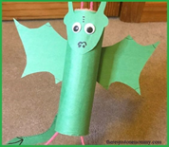  You can always make a dragon head out of a painted egg box.  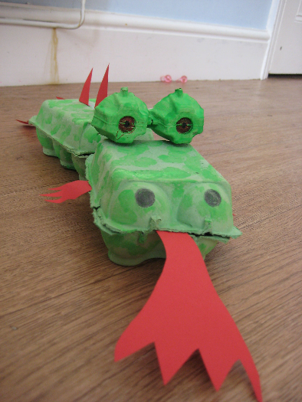 | Catapult!  In the myths and stories, dragons used to attack the castles, so they needed to be defended. They would use catapults to fight off their enemies.  - Take 5 sticks and stack them, securing one end with a rubber band. ...  - Slide one more stick between the bottom stick and the rest of the stack.  - Secure the other end with a rubber band.  - Place the spoon on top and attach the end of the spoon to the end of the single stick with the last rubber band.  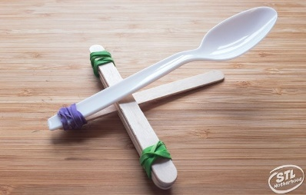
https://whiterosemaths.com/homelearning/early-years/

https://www.themathsfactor.com/

https://nrich.maths.org/primary

https://www.literacyshed.com/home.html

https://monsterphonics.com/?gclid= EAIaIQobChMI56aEu9yh6AIVFeDtCh2NMAcIEA AYASAAEgK1b_D_BwE

https://www.oxfordowl.co.uk/welcome-back/for-home/reading-owl/kids-activities

http://www.phonicsplaycomics.co.uk/comics.html

https://hungrylittleminds.campaign.gov.uk/#3

https://helicopterstories.co.uk/2020/04/19/helicopter-at-home/?fbclid=IwAR0Lv4h_FkUToEGjRgrCseqMeTO8y6867c7VsO30dNCa4NRjzfH-b-I9Sgo

https://www.thenational.academy/online-classroom/reception/?fbclid=IwAR3rmEvVhInbaoHEwFTzDlPvjYyhdgg0uRqE3j3RYsh-BeANFtomxOaC_iA#schedule

https://abcdoes.com/home-learning/?fbclid=IwAR073jDtoh8q18bQ69aszb2EY1VCMls8z4rPu54vA9uHhFcGWW2-6xTLBHg

https://www.gosh.org/power-of-play-hub?fbclid=IwAR3GE6wpig3g3FWhm0gfqO53MCTVUbYV14N_lXiokKgY0T9kT-2e0-S9fHI

https://www.eyfshome.com/?fbclid=IwAR22Kn0jIpWTg0DHnyYAU9peAltEJhdoKZy9XE2cdLgkeuE6Zui3S208B6I

https://www.booktrust.org.uk/books-and-reading/have-some-fun/storybooks-and-games/?fbclid=IwAR3nMgPF-ElsUY9Kd7Mk-2V-tr1B38RtJ1WXq541wCWA3Mgl7bjmqDp5C10

Please feel free to share any other websites with us that your child has enjoyed using.

