Dear Parent/Carer,

As the school is currently only partially open to Year R and Year 1 due to Coronavirus, we are continuing to provide educational tasks for your children to complete whilst they are at home. On the days your child is in school, they will be completing those days of learning within their ‘bubble’.

In primary, we suggest that children complete;
- 30 minutes a day reading to/with an adult (this could be a bedtime story)
- 30 minutes of Maths a day
- 30 minutes of English a day
- 30 minutes of PE/ physical activity
- A weekly topic/creative task
Home learning tasks can be supplemented with work from a number of websites (see list below for ideas)

Teachers will set a weekly programme for your child to work through at home. This will be available for you to access on the school website every Monday.

Whilst it is important for your child to keep up with their learning at home, we appreciate that this can be a stressful time for children and adults. Looking after mental health is vital. Therefore, we suggest that the day is broken up into manageable learning chunks, interspersed with physical exercise, fun activities and time together as a family. Activities such as the 30-day Lego challenge and using the real PE activities could be a good place to start.

As well as educational learning, the children could also begin to learn different life skills – how do boil an egg, sew on a button, learn to send an email, bake a cake using a recipe book etc.

We hope you are all keeping well and staying positive.

Kind regards,

Miss Percival, Mrs Jonkers, Mrs Moore and the Year R team.

jonkers-kerry@mayfield.portsmouth.sch.uk
percival-jessica@mayfield.portsmouth.sch.uk
moore-laura@mayfield.portsmouth.sch.uk

Ideas for Home Learning - Week 8 – 15/06/2020
Our topic this half-term is Adventures: Real or Imaginary. Each week will give you a range of activities that you can complete with your child to continue to consolidate their learning. Most importantly – please remember to read everyday!
 | Monday | Tuesday | Wednesday | Thursday | Friday
English | Phonics  Recap phase 2 sounds ch, sh, th, ng, ai, ee, igh, oa, oo long, oo short, ar, or, ur, ow, oi, ear, air, ure, er.  Watch the alphabet song:  https://www.youtube.com/watch?v=wlbQLBhLk_4  Can you name all the letters of the alphabet? What sound do they make?  Challenge: What is the first letter of your name? Write down 5 things that begin with the same letter. | Comprehension  Oxford Owl eBooks: The Starfish  In this story the adult needs to read the text in the top left corner of each page. Then encourage your child to read what the children are saying.  As you read there are tasks/activities to complete on each page. | Phonics  Recap phase 2 sounds ch, sh, th, ng, ai, ee, igh, oa, oo long, oo short, ar, or, ur, ow, oi, ear, air, ure, er.  Can you make your own upper and lower case matching cards. See below for examples?  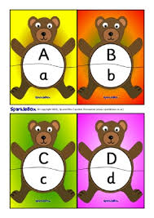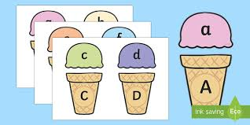  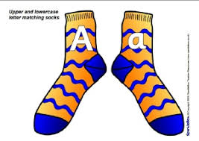 | Writing  Rockpools – What sea creatures would you find in a rock pool? Can you draw and label your own rock pool?  Challenge: Can you write a sentence about each sea creature?  Don’t forget to use a capital letter at the beginning of your sentences, a finger space between each word and a full stop at the end of each sentence. | Writing  Postcards – Imagine you are on holiday at the seaside. Write a postcard to a family member or friend to tell them about the fun you are having.  Don’t forget to use a capital letter at the beginning of your sentences, a finger space between each word and a full stop at the end of each sentence.
Maths | Money  Recap Money – Look at the different coins. Can you remember what each of them are?  How many 1p’s would you need to make 5p? How many 1p’s would you need to make 10p?  Can you make 5p using 2p’s and 1p’s? How many ways can you find?  Challenge: Can you make 10p using 1p’s and 2p’s? How many ways can you find?  Bigger challenge (only if you child is confident with above): Lets introduce 5p’s. How many ways can you make 10p using 1p’s, 2p’s and 5p’s? | Money  Paying for ice creams.  Can you draw an ice cream menu with different ice creams costing different amounts (up to 10p).  Can you draw the 1p coins next to your pictures to match the amount written.  Challenge: Use amounts up to 20 and/or 1p’s and 2p’s | Money  Pocket money sharing.  Granny has some pennies to share between her grandchildren.  Draw three children to help you with this task and ask an adult for 10p in 1p coins.  Can you answer the questions?  In the beach shop, Granny gives 3 coins to the children. How many coins does each child get?  In the cafe, Granny gives 6 coins to the children. How many coins does each child get?  At the funfair, Granny gives 12 coins to the children. How many coins does each child get? | Data  Collecting data  What is your favourite ice cream flavour?  Make your own blank tally chart with a choice of up to 5 flavours. Ask your family what their favourite flavour is and keep a tally of the answers.  Once you have your completed tally chart, write the total amount at the end of each column. We will use this data tomorrow! | Data  Making a graph  Today you are going to use your results from yesterday’s tally chart to make a block graph, to show your results.  The number of people you asked goes up the left hand side. The flavours go along the bottom. (This is called an axis.) Then you need to colour one block for each tally.  Challenge: What flavour did people like the most? What flavour did people like the least?
Wider Curriculum | The Snail and the Whale  Listen to the story the Snail and the Whale  https://www.youtube.com/watch?v=EmMnaSkeKqQ  What was your favourite part of the story?  What did you notice about the words in the story?  If you were the snail, where would you want the whale to take you? Can you draw a picture and/or write a sentence to say where? | The Snail and the Whale Craft  Can you use any media you have at home to make your own snail or whale?  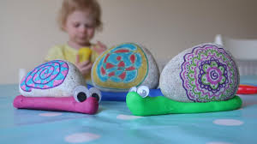  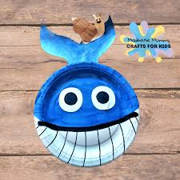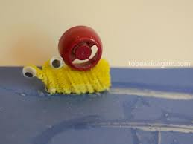 | Squish the Fish – Cosmic Yoga  You’ve been working really hard. Time to chill out and go on an adventure!  https://www.youtube.com/watch?v=LhYtcadR9nw | Sun Safety  Talk to an adult about how to stay safe in the sun. What do you need to remember?  Make a sun safety poster to display in your home. | Floating and sinking  Can you use items from your recycling to make a junk model boat that floats?  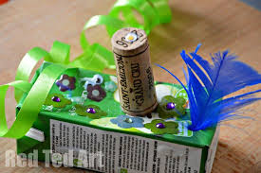  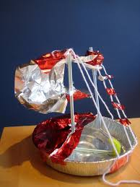  Test your boat. Did it float? Why did it float? What would you need to add to make it sink?
https://whiterosemaths.com/homelearning/early-years/

https://www.themathsfactor.com/

https://nrich.maths.org/primary

https://www.literacyshed.com/home.html

https://monsterphonics.com/?gclid= EAIaIQobChMI56aEu9yh6AIVFeDtCh2NMAcIEA AYASAAEgK1b_D_BwE

https://www.oxfordowl.co.uk/welcome-back/for-home/reading-owl/kids-activities

http://www.phonicsplaycomics.co.uk/comics.html

https://hungrylittleminds.campaign.gov.uk/#3

https://helicopterstories.co.uk/2020/04/19/helicopter-at-home/?fbclid=IwAR0Lv4h_FkUToEGjRgrCseqMeTO8y6867c7VsO30dNCa4NRjzfH-b-I9Sgo

https://www.thenational.academy/online-classroom/reception/?fbclid=IwAR3rmEvVhInbaoHEwFTzDlPvjYyhdgg0uRqE3j3RYsh-BeANFtomxOaC_iA#schedule

https://abcdoes.com/home-learning/?fbclid=IwAR073jDtoh8q18bQ69aszb2EY1VCMls8z4rPu54vA9uHhFcGWW2-6xTLBHg

https://www.gosh.org/power-of-play-hub?fbclid=IwAR3GE6wpig3g3FWhm0gfqO53MCTVUbYV14N_lXiokKgY0T9kT-2e0-S9fHI

https://www.eyfshome.com/?fbclid=IwAR22Kn0jIpWTg0DHnyYAU9peAltEJhdoKZy9XE2cdLgkeuE6Zui3S208B6I

https://www.booktrust.org.uk/books-and-reading/have-some-fun/storybooks-and-games/?fbclid=IwAR3nMgPF-ElsUY9Kd7Mk-2V-tr1B38RtJ1WXq541wCWA3Mgl7bjmqDp5C10

Please feel free to share any other websites with us that your child has enjoyed using.

