Dear Parent/Carer,

As the school is currently only partially open to Year R and Year 1 due to Coronavirus, we are continuing to provide educational tasks for your children to complete whilst they are at home. On the days your child is in school, they will be completing those days of learning within their ‘bubble’.

In primary, we suggest that children complete;
- 30 minutes a day reading to/with an adult (this could be a bedtime story)
- 30 minutes of Maths a day
- 30 minutes of English a day
- 30 minutes of PE/ physical activity
- A weekly topic/creative task
Home learning tasks can be supplemented with work from a number of websites (see list below for ideas)

Teachers will set a weekly programme for your child to work through at home. This will be available for you to access on the school website every Monday.

Whilst it is important for your child to keep up with their learning at home, we appreciate that this can be a stressful time for children and adults. Looking after mental health is vital. Therefore, we suggest that the day is broken up into manageable learning chunks, interspersed with physical exercise, fun activities and time together as a family. Activities such as the 30-day Lego challenge and using the real PE activities could be a good place to start.

As well as educational learning, the children could also begin to learn different life skills – how do boil an egg, sew on a button, learn to send an email, bake a cake using a recipe book etc.

We hope you are all keeping well and staying positive.

Kind regards,

Miss Percival, Mrs Jonkers, Mrs Moore and the Year R team.

jonkers-kerry@mayfield.portsmouth.sch.uk
percival-jessica@mayfield.portsmouth.sch.uk
moore-laura@mayfield.portsmouth.sch.uk

Ideas for Home Learning - Week 7 – 08/06/2020
Our topic this half-term is Adventures: Real or Imaginary. Each week will give you a range of activities that you can complete with your child to continue to consolidate their learning. Most importantly – please remember to read everyday!
 | Monday | Tuesday | Wednesday | Thursday | Friday
English | Phonics  Recap phase 2 sounds ch, sh, th, ng, ai, ee, igh, oa, oo long, oo short, ar, or, ur, ow, oi, ear, air, ure, er.  Listen to the tricky word song.  https://www.youtube.com/watch?v=TvMyssfAUx0  Can you speed write the Phase to tricky words (the, I, no, go, to) | Comprehension  Oxford Owl eBooks: Dad, can You Do This?  Read the story and then answer the after reading questions at the back of the book. | Phonics  Recap phase 2 sounds ch, sh, th, ng, ai, ee, igh, oa, oo long, oo short, ar, or, ur, ow, oi, ear, air, ure, er.  Listen to the tricky word song.  https://www.youtube.com/watch?v=R087lYrRpgY  Rainbow writing:  Can you write the words, he, she, we, me, be. Choose a different colour and write over them again. Repeat this with a different colour. | ‘Helicopter Stories’ at Home  https://helicopterstories.co.uk/2020/04/19/helicopter-at-home/?fbclid=IwAR0Lv4h_FkUToEGjRgrCseqMeTO8y6867c7VsO30dNCa4NRjzfH-b-I9Sgo  At school, your children love to take part in ‘Helicopter Stories’, whether it’s telling their own story or acting out someone else’s. Click the link to read a summary of ‘Helicopter Stories’ and how this can be done at home with family members. There is also a video example on their website.  Challenge:  Tell an adult a story to write down (or have a go at writing your own). Act it out, you can be the ‘teacher’ and tell everyone what they need to do. Have fun with it! | Writing  Scroll down to pages 6, 7 and 8 of this document to see some pictures of the beach. Have you been to the beach recently? What did you do while you were there? What was your favourite part?  Challenge:  Write about what you can see in the pictures.  OR  If you have been to the beach, write about what you enjoyed while you were there.  Don’t forget to use a capital letter at the beginning of your sentences, a finger space between each word and a full stop at the end of each sentence.
Maths | Sharing  What is sharing? Ask if your child can explain. Find some toys or food, e.g. raisins and ask them to share them out. How do you know it is fair? | Sharing  Recap sharing. Go to the link below to play a sharing game.  https://pbskids.org/curiousgeorge/busyday/dogs/ | Halving  Make you own halving mat.  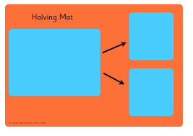  Can you put a number of small objects on your mat and then halve that amount? Can the amount be halved?  Challenge: Use even numbers up to 20 and halve the numbers instead of objects. | Sharing  Find some bowls or plates at home. If you have family members at home, give one to them. There can be 2, 3 or 4 bowls or plates.  Find something that can be shared (for example, grapes, paperclips, lego or anything you can find).  Have a go at sharing different quantities between the plates or bowls.  Is it fair every time? Why not?  What happens if you try to share 9 between 2 bowls? What happens if you try to share 9 between 3 bowls? | Halving  Have a go at some of the halving problems. (Scroll down to page 9 of this document to find the problems.)
Wider Curriculum | Ocean Life  What sea creatures do you know? Watch the video to find out more about ocean life.  https://www.youtube.com/watch?v=JOJkvhSpBiQ  Can you draw a picture of your favourite sea animal?  Challenge: Can you label your picture? | Magical Sea Animals  Do you think there are any creatures who live in the sea that we have never seen?  Can you make up your own magical sea animal? What would it look like? Where would it live? What would it eat?  Use any media of your choice, (e.g. pencils, paint, collage, junk modelling) to make your own sea animal.  Challenge: Can you write a description about it? | Sea Creatures  Find out 3 facts about a creature that lives under the sea.  Draw a picture of the creature you have chosen. | Water Safety  Talk to an adult about how to stay safe around water. What do you need to remember?  Make a safety poster to display in your home. | The Magic Shell  Imagine you have found a magic shell. You can have one wish. Draw a picture to show us what your wish would be.
https://whiterosemaths.com/homelearning/early-years/

https://www.themathsfactor.com/

https://nrich.maths.org/primary

https://www.literacyshed.com/home.html

https://monsterphonics.com/?gclid= EAIaIQobChMI56aEu9yh6AIVFeDtCh2NMAcIEA AYASAAEgK1b_D_BwE

https://www.oxfordowl.co.uk/welcome-back/for-home/reading-owl/kids-activities

http://www.phonicsplaycomics.co.uk/comics.html

https://hungrylittleminds.campaign.gov.uk/#3

https://helicopterstories.co.uk/2020/04/19/helicopter-at-home/?fbclid=IwAR0Lv4h_FkUToEGjRgrCseqMeTO8y6867c7VsO30dNCa4NRjzfH-b-I9Sgo

https://www.thenational.academy/online-classroom/reception/?fbclid=IwAR3rmEvVhInbaoHEwFTzDlPvjYyhdgg0uRqE3j3RYsh-BeANFtomxOaC_iA#schedule

https://abcdoes.com/home-learning/?fbclid=IwAR073jDtoh8q18bQ69aszb2EY1VCMls8z4rPu54vA9uHhFcGWW2-6xTLBHg

https://www.gosh.org/power-of-play-hub?fbclid=IwAR3GE6wpig3g3FWhm0gfqO53MCTVUbYV14N_lXiokKgY0T9kT-2e0-S9fHI

https://www.eyfshome.com/?fbclid=IwAR22Kn0jIpWTg0DHnyYAU9peAltEJhdoKZy9XE2cdLgkeuE6Zui3S208B6I

https://www.booktrust.org.uk/books-and-reading/have-some-fun/storybooks-and-games/?fbclid=IwAR3nMgPF-ElsUY9Kd7Mk-2V-tr1B38RtJ1WXq541wCWA3Mgl7bjmqDp5C10

Please feel free to share any other websites with us that your child has enjoyed using.

Friday Writing: Picture One
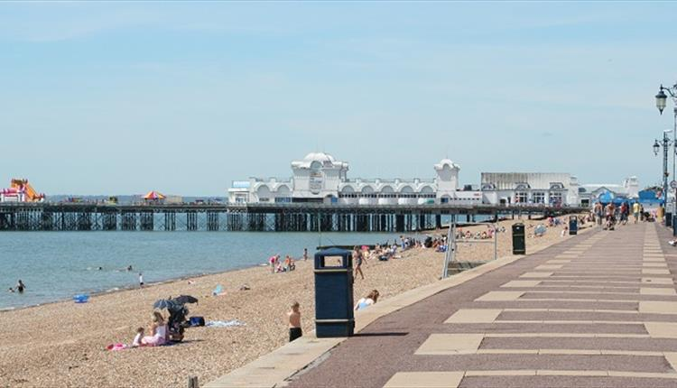

Friday Writing: Picture Two
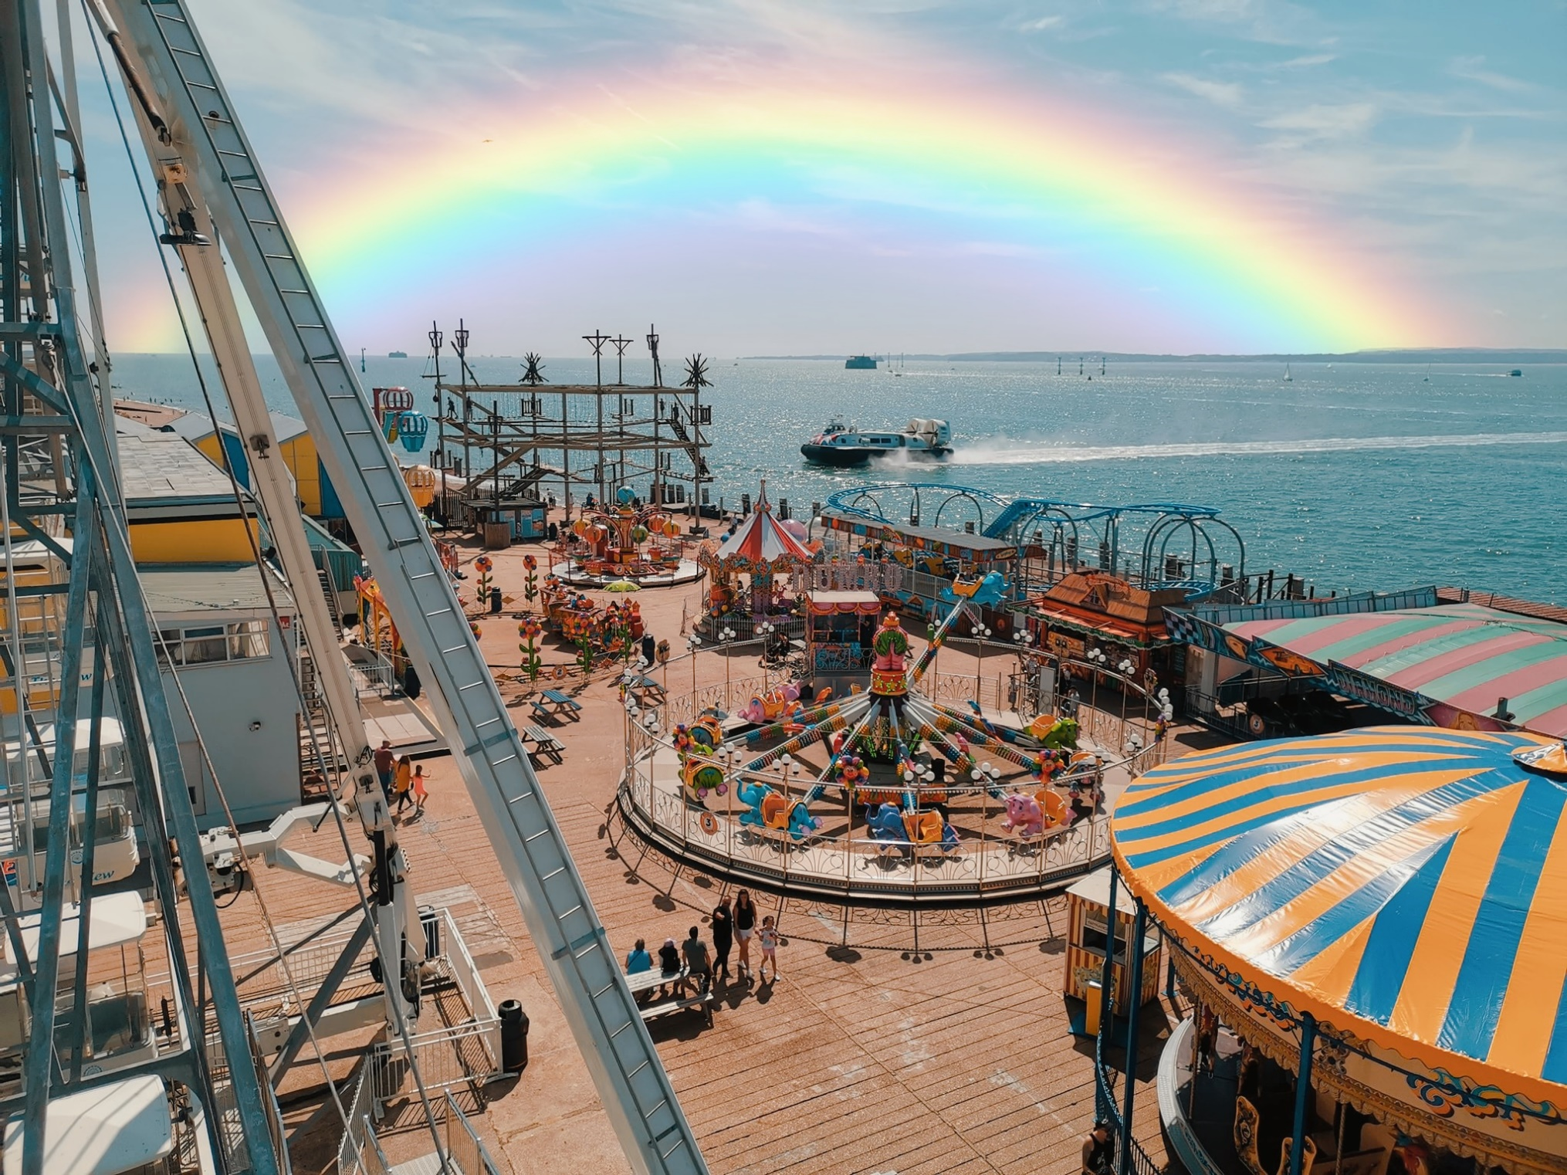
Friday Writing: Picture Three

