Dear Parent/Carer,

Although the school is currently closed due to Coronavirus, we are continuing to provide educational tasks for your children to complete.

In primary, we suggest that children complete;
- 30 minutes a day reading to/with an adult (this could be a bedtime story)
- 30 minutes of Maths a day
- 30 minutes of English a day
- 30 minutes of PE/ physical activity
- A weekly topic/creative task

Home learning tasks can be supplemented with work from a number of websites (see list below for ideas)

Teachers will set a weekly programme for your child to work through at home. This will be available for you to access on the school website every Monday.

Whilst it is important for your child to keep up with their learning at home, we appreciate that this can be a stressful time for children and adults. Looking after mental health is vital. Therefore, we suggest that the day is broken up into manageable learning chunks, interspersed with physical exercise, fun activities and time together as a family. Activities such as the 30 day lego challenge and using the real PE activities could be a good place to start.

As well as educational learning, the children could also begin to learn different life skills – how do boil an egg, sew on a button, learn to send an email, bake a cake using a recipe book etc.

We hope you are all keeping well and staying positive.

Kind regards,

Mrs Guy and Mrs Sheppard and the Year 1 team.

YEAR 1 HOME LEARNING TASKS
WEEK BEGINNING: 1.6.2020
ENGLISH TASKS  MONDAY – bubble/home learning  I can recall previous sounds taught.  Recap on Ph3 phonics  https://www.youtube.com/watch?v=aNcBWSBxSp0  https://www.youtube.com/watch?v=vU2vWZKS7rY  Adult to then say a sound for you to write a word containing that sound.  Turn the sound down for this clip and you read the captions.  https://www.youtube.com/watch?v=QGECmpOwNEk  Write out the captions.  TUESDAY – bubble/homelearning  I can write a dictated sentence.  Adult to slowly read out the words for you to use all the correct skills to write out these sentences.  I am in a rush to get to the shops.  The rich man had a big chin.  I will wait for a taxi.  I need to feed my cat and dog.  WEDNESDAY –  I can write sentences.  Write sentences for this picture. Don’t forget capital letters, full stops, cursive letters. It can be a story, questions or just what you can see.  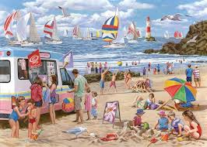  THURSDAY –  I can spell common exception words  here, there, where, love, come  - Find these spellings in books.  - Use a one-minute timer to see how many times you can correctly write each word.  - Using colouring pens/pencils rainbow write the words.  - Find the words hidden in your garden and write them down when you find them.  FRIDAY –  I can write instructions.  Write a set of instructions on how to grow a plant.  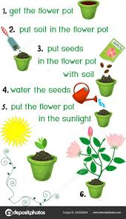 | MATHS TASKS  MONDAY – I can recognise common 2D shapes.  Search and draw different 2D shapes around your environment. For example, draw a circle and label as a clock. Can you find all the shapes? Are there any that you can't see? How many sides and vertices do they have?  TUESDAY – I can name common 2D shapes.  Name the shapes that you drew yesterday. You could make a shape picture. Draw a picture of your house, your car, flowers in the garden, whatever you like but you must label the shapes you have drawn correctly. Have you drawn a semi-circle? Could you add a rectangle?  WEDNESDAY – I can recognise 3D shapes.  What is the difference between a 2D and a 3D shape? Find some objects at home that are different 3D shape. Take a photo and send it in to your teacher.  THURSDAY – I can name 3D shapes.  Watch this video with the names of the 3D shapes. https://www.youtube.com/watch?v=6khakMTvRno Can you find each of these 3D shapes around the house? Write labels for them.  FRIDAY – I can build 3D structure out of 3D shapes.  Find objects that are different 3D shapes. Make a picture/structure using them. Was it easy or hard to find the 3D shapes at home? What did you build?  Or using spaghetti and marshmallows build some 3D shapes. Like this:  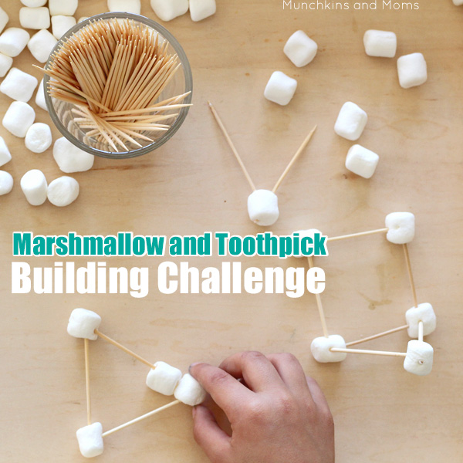
TOPIC/CREATIVE  Monday bubble school/home learning  I can name a variety of common, wild and garden plants.  First find out everything your child knows about plants. Record this down on a sheet of paper. Research plants on the internet.  https://www.youtube.com/watch?v=etUDbosy1ik  https://www.bbc.co.uk/bitesize/topics/zpxnyrd/articles/zw2y34j  https://www.bbc.co.uk/bitesize/clips/zthxpv4  https://www.bbc.co.uk/bitesize/clips/zvp6n39  https://www.bbc.co.uk/bitesize/clips/zn89wmn  After your research record all your new findings on the sheet. Ask your child these questions. What new things did you learn? Can you name different types of plants? What is the difference between a tree and a herb?  Tuesday bubble school/home learning  I can name a variety of common, wild and garden plants.  What do plants need to survive?  https://www.bbc.co.uk/bitesize/topics/zpxnyrd/articles/zxxsyrd  https://www.bbc.co.uk/bitesize/topics/zpxnyrd/articles/z2vdjxs  After watching these clip discuss what a plant needs to grow. Children to then draw and label the different steps that a plant needs to grow.  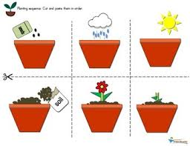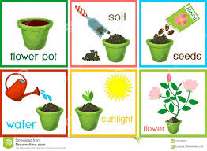  Wednesday, Thursday, Friday Home learning  You could:  - Design your own garden  - Make your own mini garden  - Go on a walk and record all the different plants you see. Try and find out their names.  - Grow your own plant  Please feel free to email pictures or tell your teachers about the work you have been doing. We would love to hear from you.  Guym@mayfield.portsmouth.sch.uk  Shepparda@mayfield.portsmouth.sch.uk | LEARNING WEBSITES  https://www.topmarks.co.uk/maths-games/hit-the-button  http://www.crickweb.co.uk/Key-Stage-1.html  https://www.mathplayground.com/  https://www.topmarks.co.uk/maths-games/7-11-years  https://whiterosemaths.com/homelearning/  https://nrich.maths.org/primary  https://ttrockstars.com/  https://www.bbc.co.uk/bitesize/levels/zbr9wmn  https://www.literacyshed.com/home.html  https://www.spellingshed.com/  https://pobble.com/  https://monsterphonics.com/?gclid= EAIaIQobChMI56aEu9yh6AIVFeDtCh2NMAcIEA AYASAAEgK1b_D_BwE  https://www.oxfordowl.co.uk/welcome-back/for-home/reading-owl/kids-activities  https://www.topmarks.co.uk/english-games/7-11-years  Audible are doing a free 30 day trial so that children can listen to lots of books online.

