Dear Parent/Carer,

Although the school is currently closed due to Coronavirus, we are continuing to provide educational tasks for your children to complete.

In primary, we suggest that children complete;
- 30 minutes a day reading to/with an adult (this could be a bedtime story)
- 30 minutes of Maths a day
- 30 minutes of English a day
- 30 minutes of PE/ physical activity
- A weekly topic/creative task

Home learning tasks can be supplemented with work from a number of websites (see list below for ideas)

Teachers will set a weekly programme for your child to work through at home. This will be available for you to access on the school website every Monday.

Whilst it is important for your child to keep up with their learning at home, we appreciate that this can be a stressful time for children and adults. Looking after mental health is vital. Therefore, we suggest that the day is broken up into manageable learning chunks, interspersed with physical exercise, fun activities and time together as a family. Activities such as the 30 day lego challenge and using the real PE activities could be a good place to start.

As well as educational learning, the children could also begin to learn different life skills – how do boil an egg, sew on a button, learn to send an email, bake a cake using a recipe book etc.

We hope you are all keeping well and staying positive.

Kind regards,

Mrs Guy and Mrs Sheppard and the Year 1 team.

YEAR 1 HOME LEARNING TASKS
WEEK BEGINNING: 11.5.2020
ENGLISH TASKS  MONDAY – Spellings  They, be, he, she, me, we  - Find these spellings in books.  - Use a one-minute timer to see how many times you can correctly write each word.  - Using colouring pens/pencils rainbow write the words.  - Write out the alphabet in order, recap your alphabet knowledge. Then using a car or your finger find the letters to spell out your words.  TUESDAY – Reading comprehension  I can explore a traditional tale/story  Read a favourite book. Show your knowledge of the book you have read/shared by drawing four pictures that summarises the story. You can draw each picture on a separate sheet or split a page into four parts. Don’t forget to annotate and label your picture.  WEDNESDAY – Phonics  I can apply my phonic sounds.  Phonic sounds au, ey a-e e-e  Research these sounds on You Tube:  https://www.youtube.com/watch?v=dOHDkQGhku4  https://www.youtube.com/watch?v=jua0OODatow  https://www.youtube.com/watch?v=L7faYbILI1s  Watch the different clips for each sound.  Write a list of words for each sounds.  Write your favourite words in a sentences using the correct writing skills.  MAKE SURE you write cursively.  Can you find these sounds in books?  Remember a split digraph are two sounds holding hands with a naughty sound that has snuck in the middle:  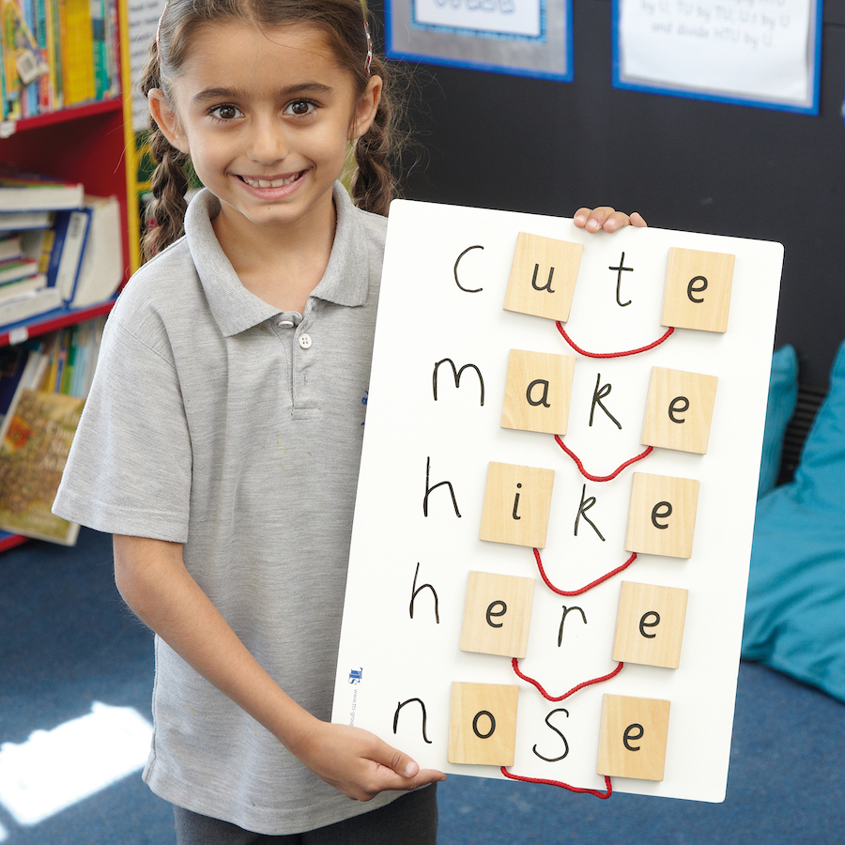  THURSDAY/FRIDAY–  I can write instructions/questions.  Board game  This may take a while, so it has been spread over a couple of days. Design a board game for you and your family to play. It can have elements of a tradition game with your own spin on it. Write a list of instructions on how to play the game. If you are feeling creative feel free to make your game, we would love to see the finished product.  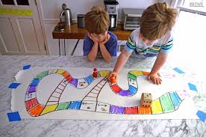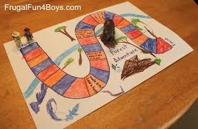  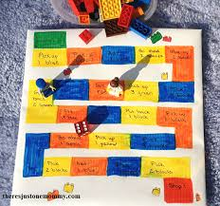 | MATHS TASKS  MONDAY – I can count backwards from any number to 100.  Play ‘What is the time Mr Wolf’. Focus on counting backwards. Start counting and stop counting at different numbers. Play hide and seek and work on counting backwards to count down.  TUESDAY – I can subtract a one-digit number from a two-digit number.  Get a family member to write some subtraction number sentences out for a challenge. Use pasta shapes, lego, pencils, playdough to help you work it out. E.g 14-9= 17-5=  WEDNESDAY – I can subtract a one-digit number from a two-digit number.  Roll a dice once for the tens digit and roll it again for the ones digit. You have made a two-digit number!  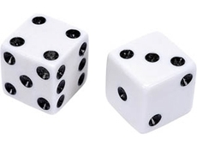 = 43  Roll the dice again and subtract that from the two-digit number. E.g 43 – 4 =  How many different subtraction number sentences can you make? If you don’t have a dice use a random number generator app or make your own using this net: https://www.twinkl.co.uk/resource/t2-m-387-cube-net.  How will you work out the answer?  THURSDAY – I can spot the difference between two objects.  Play spot the difference https://www.youtube.com/watch?v=3k17XVLgAu8  Now play spot the difference with different shapes and numbers e.g http://www.attentionworksheets.com/wp-content/uploads/2013/08/Spot-3-differences-shapes-for-kids-images_10.jpeg.  Use your mathematical language to discuss what is different.  FRIDAY – I can find the difference between two numbers.  Find the difference between different amounts using subtraction.  Challenge! Visit https://nrich.maths.org/6227/index for an interactive version of this:
TOPIC/CREATIVE  Materials  Can you remember our Supertato learning from the beginning of the year! This week we are focusing on materials.  You could:  - Find a lovely song on YouTube to recap your knowledge on Key Stage 1 materials.  - Go around your house and find different materials to match each heading: wood, metal, glass, plastic, fabric, stone.  - Make a poster for materials.  - Experiment with different materials to find out which materials are the most waterproof.  - Design a cape for Supertato.  - Make a cape for Supertato.  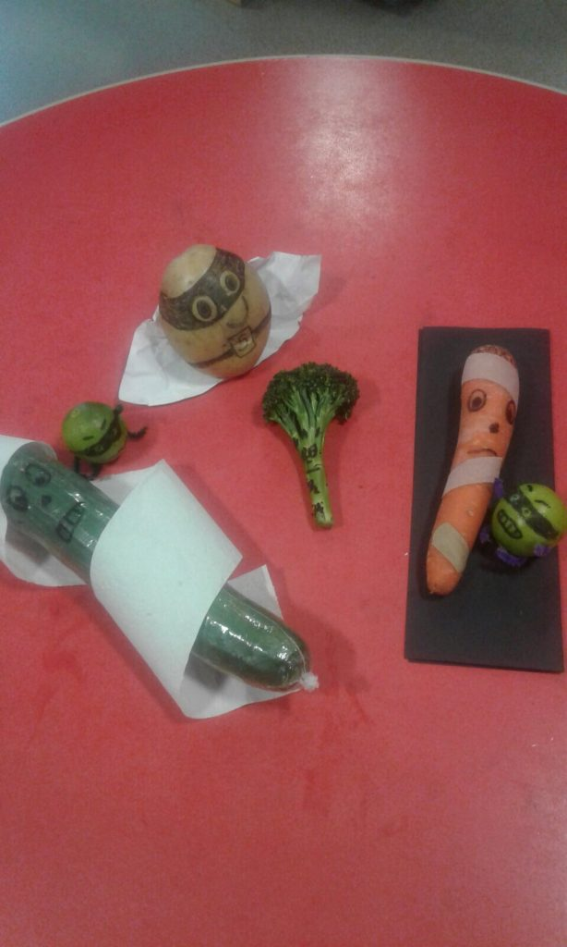  - Experiment with different objects to find out which ones are transparent.  - Complete the activities on materials on KS1 BBCBitesize: https://www.bbc.co.uk/bitesize/topics/zrssgk7  Please email pictures or tell your teachers about the work you have been doing. We would love to hear from you.  Guym@mayfield.portsmouth.sch.uk  Shepparda@mayfield.portsmouth.sch.uk | LEARNING WEBSITES  https://www.topmarks.co.uk/maths-games/hit-the-button  http://www.crickweb.co.uk/Key-Stage-1.html  https://www.mathplayground.com/  https://www.topmarks.co.uk/maths-games/7-11-years  https://whiterosemaths.com/homelearning/  https://nrich.maths.org/primary  https://ttrockstars.com/  https://www.bbc.co.uk/bitesize/levels/zbr9wmn  https://www.literacyshed.com/home.html  https://www.spellingshed.com/  https://pobble.com/  https://monsterphonics.com/?gclid= EAIaIQobChMI56aEu9yh6AIVFeDtCh2NMAcIEA AYASAAEgK1b_D_BwE  https://www.oxfordowl.co.uk/welcome-back/for-home/reading-owl/kids-activities  https://www.topmarks.co.uk/english-games/7-11-years  Audible are doing a free 30 day trial so that children can listen to lots of books online.

