Dear Parent/Carer,

Although the school is currently closed due to Coronavirus, we are continuing to provide educational tasks for your children to complete.

In primary, we suggest that children complete;
- 30 minutes a day reading to/with an adult (this could be a bedtime story)
- 30 minutes of Maths a day
- 30 minutes of English a day
- 30 minutes of PE/ physical activity
- A weekly topic/creative task

Home learning tasks can be supplemented with work from a number of websites (see list below for ideas)

Teachers will set a weekly programme for your child to work through at home. This will be available for you to access on the school website every Monday.

Whilst it is important for your child to keep up with their learning at home, we appreciate that this can be a stressful time for children and adults. Looking after mental health is vital. Therefore, we suggest that the day is broken up into manageable learning chunks, interspersed with physical exercise, fun activities and time together as a family. Activities such as the 30 day lego challenge and using the real PE activities could be a good place to start.

As well as educational learning, the children could also begin to learn different life skills – how do boil an egg, sew on a button, learn to send an email, bake a cake using a recipe book etc.

We hope you are all keeping well and staying positive.

Kind regards,

Mrs Guy and Mrs Sheppard and the Year 1 team.

YEAR 1 HOME LEARNING TASKS
WEEK BEGINNING: 18.5.2020
ENGLISH TASKS  MONDAY – Spellings  No, go, so, by, my  - Find these spellings in books.  - Use a one-minute timer to see how many times you can correctly write each word.  - Using colouring pens/pencils rainbow write the words.  - Write out the alphabet in order, recap your alphabet knowledge. Then using a car or your finger find the letters to spell out your words.  TUESDAY – Reading comprehension  I can explore a traditional tale/story  Read a favourite book.  Write out questions that you would like to ask about the character.  WEDNESDAY – Phonics  I can apply my phonic sounds.  Phonic sounds I-e, o-e, u-e  Research these sounds on You Tube:  https://www.youtube.com/watch?v=rAMUOVVFQEM  https://www.youtube.com/watch?v=gC1fTHlWLOI  https://www.youtube.com/watch?v=x-H4SezDuo4  Watch the different clips for each sound.  Write a list of words for each sound.  Write your favourite words in sentences. MAKE SURE you write cursively and remember full stops, capital letters and spaces.  Can you find these sounds in books?  Remember a split digraph are two sounds holding hands with a naughty sound that has snuck in the middle:  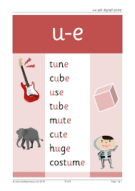  THURSDAY  I can apply my phonic knowledge into my writing  On your daily walk today, take some paper and a pencil with you. Write down all the different things that you see. Make sure you use your phonic knowledge. Try to get some split digraphs in your list.  Friday  I can form a short narrative.  Using your list from your daily walk today you are going to use your words to write a short story. It can be about your walk or make it an adventure story with a different character.  For Example:  George the sausage dog loved to go on walks. He walked along the road to get to the hill. He barked when he saw people and screamed when he saw a cat. The cat ran up a tree to get away from him and the people crossed the road... | MATHS TASKS  MONDAY – I can half an amount.  Using a paper plate or a normal plate with felt tip, draw a line to split it in half. Find different objects to find the half of. Can you find a half of any number?  TUESDAY – I can half a number.  Get your family to test your skills. Ask them to find a number for you to half. If you need objects to help, that is ok. Work out which whole numbers you can half and which you can’t. Start to recite them.  WEDNESDAY – I can double an amount.  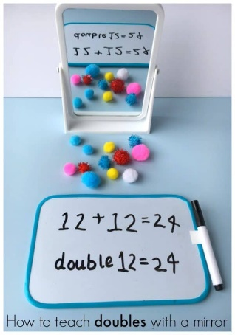  Use a mirror and collect some objects. Count the objects that are there and the ones that are reflected. How many have you got altogether? Write out the number sentences.  THURSDAY – I can double a number.  Using what you learned from yesterday, start to recite your doubles. Use YouTube to sing some doubling songs. What do you notice about all the doubled answers? Do they have something in common?  FRIDAY – I can use doubles and halves to play a game. https://nrich.maths.org/10654  Play Doubles or halves?  This is a game for two players.  You will need a dice  How to play:  - Decide on a target number. This is the total that both players are trying to make.  - Player 1 throws the dice. S/he can choose whether to double the number shown or halve the number shown.  - Player 2 throws the dice. In the same way, s/he can choose whether to double the number shown or halve the number shown. Player 2 adds his/her number onto Player 1's number to make a running total.  - Play continues like this with each player rolling the dice, halving or doubling the number and adding the result onto the running total.  - The winner is the player who reaches the agreed target exactly.  Must each player always take a turn?  Does it matter if you go first or second?  Are there any particularly good numbers to choose as your target?
TOPIC/CREATIVE  Revisit what you know about animals this week.  Sort any toy animals you have at home in different ways.  How many different ways can you sort them?  - Number of legs,  - Does it lay eggs or not?  - Does it live in a hot or cold place?  - Fur, scales or feathers?  Think about your animal groups: mammal, fish, reptile, amphibian, insect, bird. How can you work out what an animal is by using your prior knowledge?  Think about whether they are carnivore, omnivore or herbivore. How do you know?  Here are some ideas to help you:  - Create a presentation to share with your family about different animals and how they live,  - Create your own animal and explain what animal group it belongs to and why,  - Make a poster about the different animal types,  - Research a different animal that you’re not familiar with such as, koala, tarantula, jellyfish, penguin, worm, lobster.  - Watch some national geographic videos on YouTube,  - Pretend to be David Attenborough and make a voice over for an animal documentary (don’t forget to film it),  - Categorize your pets,  - Draw a range of habitats on a map and place the animals in the correct place,  - Go out in a safe environment with your family and see what animals you can find, can you sort them? 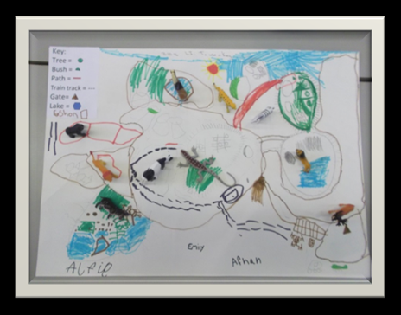  Extend yourself by learning about life cycles, food chains, extinct animals, endangered animals or the tree of life and evolution.  Please feel free to email pictures or tell your teachers about the work you have been doing. We would love to hear from you.  Guym@mayfield.portsmouth.sch.uk  Shepparda@mayfield.portsmouth.sch.uk | LEARNING WEBSITES  https://www.topmarks.co.uk/maths-games/hit-the-button  http://www.crickweb.co.uk/Key-Stage-1.html  https://www.mathplayground.com/  https://www.topmarks.co.uk/maths-games/7-11-years  https://whiterosemaths.com/homelearning/  https://nrich.maths.org/primary  https://ttrockstars.com/  https://www.bbc.co.uk/bitesize/levels/zbr9wmn  https://www.literacyshed.com/home.html  https://www.spellingshed.com/  https://pobble.com/  https://monsterphonics.com/?gclid= EAIaIQobChMI56aEu9yh6AIVFeDtCh2NMAcIEA AYASAAEgK1b_D_BwE  https://www.oxfordowl.co.uk/welcome-back/for-home/reading-owl/kids-activities  https://www.topmarks.co.uk/english-games/7-11-years  Audible are doing a free 30 day trial so that children can listen to lots of books online.

