Dear Parent/Carer,

Although the school is currently closed due to Coronavirus, we are continuing to provide educational tasks for your children to complete.

In primary, we suggest that children complete;
- 30 minutes a day reading to/with an adult (this could be a bedtime story)
- 30 minutes of Maths a day
- 30 minutes of English a day
- 30 minutes of PE/ physical activity
- A weekly topic/creative task

Home learning tasks can be supplemented with work from a number of websites (see list below for ideas)

Teachers will set a weekly programme for your child to work through at home. This will be available for you to access on the school website every Monday.

Whilst it is important for your child to keep up with their learning at home, we appreciate that this can be a stressful time for children and adults. Looking after mental health is vital. Therefore, we suggest that the day is broken up into manageable learning chunks, interspersed with physical exercise, fun activities and time together as a family. Activities such as the 30 day lego challenge and using the real PE activities could be a good place to start.

As well as educational learning, the children could also begin to learn different life skills – how do boil an egg, sew on a button, learn to send an email, bake a cake using a recipe book etc.

We hope you are all keeping well and staying positive.

Kind regards,

Mrs Guy and Mrs Sheppard and the Year 1 team.

YEAR 1 HOME LEARNING TASKS
WEEK BEGINNING: 20.4.2020
ENGLISH TASKS  This week’s spellings/phoneme:  the, a, do, to, today, of  - Find these spellings in books.  - Use a one-minute timer to see how many times you can correctly write each word.  - Using colouring pens/pencils rainbow write the words.  Phonic sounds ew, ph, wh  Research these sounds on You Tube. Watch the different clips for each sound. Come up with and write words for each of the sounds. Then write the words into sentences using the correct writing skills. MAKE SURE you write in cursive letters.  MONDAY - I can write an email to my teacher.  We have missed you! Write an email to your teacher, telling them how you are and what you have been up to.  What have you enjoyed doing so far? How was Easter at home? Attach a picture if you want to!  Guym@mayfield.portsmouth.sch.uk  Shepparda@mayfield.portsmouth.sch.uk  TUESDAY –  I can retell the story of the 3 little pigs.  Read the story of the 3 little pigs or listen to the story online. Act out the story or make props/use your toys to retell the story in your own words. Use your family as the audience.  WEDNESDAY –  I can use describing words to make a wanted posted.  Make a wanted posted for the big bad wolf. Make it bright, colourful and write words to describe the wolf and why he was bad.  THURSDAY –  I can write in sentences to write a sorry letter from the wolf.  Use your writing skills to write a sorry letter from the wolf to the pigs. Write why he is sorry and how he will make it up to them. Make sure you include capital letters, full stops, finger spaces, cursive letters, ‘and’ to extend your sentences. Read your work back to your family to make sure it makes sense and use your editing skills to make corrections.  FRIDAY –  I can show an understanding of traditional tales.  Using your knowledge of the 3 Little Pigs come up with an alternative version where the pigs are bad, and the wolf is good. It could be that the wolf just wanted to be friends and that’s why he kept chasing the pigs and knocking on their doors. You can write your own version or draw a story board of what happens at each stage of the story. | MATHS TASKS  MONDAY – I can count, read and write numbers to 100 in numerals.  Go on a number hunt around the house. How many different numbers can you find?  What is the largest and smallest number? Can you put the numbers in order? Can you write and say the numbers correctly? Can you spell the numbers in words?  TUESDAY – I can estimate and count objects accurately.  Find differing amounts of objects such as lego, pasta, tins, toothbrushes.  Estimate how many there are and then count them. Were you right? Record your estimates and actual amounts. Remember to record the numbers carefully.  WEDNESDAY – I can count in multiples of ten.  Find 100 objects eg straws, bricks. Group them into sets of ten.  Practice counting in tens from 0-100.  Can you write the numbers down accurately?  What do you notice about the numbers?  Ask someone to count in tens but miss one out. Do you know which one it is?  THURSDAY – I can count in multiples of five.  Repeat yesterday’s activities but with groups of 5.  FRIDAY – I can solve a number problem.  Always, sometimes, never…  Amir says  ‘When you count in tens, your digits will be 0, 10, 20, 30, 40.’  Prove it.
TOPIC/CREATIVE  Explore your senses in order to create a poster about your body and how it recognises different types of senses.  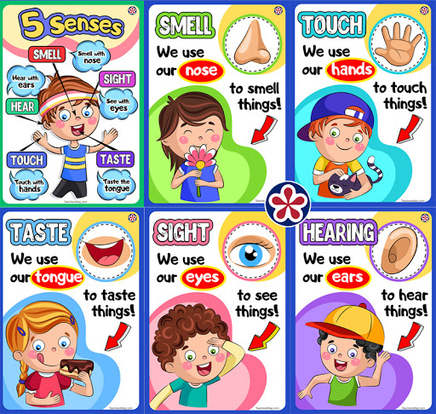  There are many activities that allow you use your different senses in different ways. For example:  - Blindfolded tasting to identify the types of tastes such as, salty, sweet, sour, bitter  - Blindfolded colouring  - Blindfolded obstacle courses  - Blind man’s bluff  - Recognising what instrument is being played without looking  - Listening to the noises outside and identifying what you can hear  - Identifying objects by their smell  - Use your feet to feel different objects and describe it  You could write a poem using your senses or make a piece of art that includes all the senses. | LEARNING WEBSITES  https://www.topmarks.co.uk/maths-games/hit-the-button  http://www.crickweb.co.uk/Key-Stage-1.html  https://www.mathplayground.com/  https://www.topmarks.co.uk/maths-games/7-11-years  https://whiterosemaths.com/homelearning/  https://nrich.maths.org/primary  https://ttrockstars.com/  https://www.bbc.co.uk/bitesize/levels/zbr9wmn  https://www.literacyshed.com/home.html  https://www.spellingshed.com/  https://pobble.com/  https://monsterphonics.com/?gclid= EAIaIQobChMI56aEu9yh6AIVFeDtCh2NMAcIEA AYASAAEgK1b_D_BwE  https://www.oxfordowl.co.uk/welcome-back/for-home/reading-owl/kids-activities  https://www.topmarks.co.uk/english-games/7-11-years  Audible are doing a free 30 day trial so that children can listen to lots of books online.

