Dear Parent/Carer,

As the school continues to remain closed due to Coronavirus, we are continuing to provide educational tasks for your children to complete. We have received positive feedback on the new format of the home learning daily tasks. As always, please continue to keep in touch about your child’s home learning and let us know if there are any problems.

In primary, we suggest that children try to complete;
- 30 minutes a day of independent reading/reading to an adult
- 30 minutes of maths a day
- 30 minutes of English a day
- 30 minutes of topic based/creative learning
- 30 minutes of PE/ physical activity

Home learning tasks can be supplemented with work from a number of websites (see list below for ideas.) Daily work set on the BBC website is particularly useful as it contains tutorial videos.
https://www.bbc.co.uk/bitesize/primary

Teachers will set a weekly programme for your child to work through at home. This will be available for you to access on the school website every Monday. We know that children work at different speeds and different levels, so please have a look at work in other year groups too for extra support.

Friday 8th May marks the commemoration of 75 years since victory in Europe was announced at the end of the Second World War. We were arranging a number of activities for the children to participate in at school, but have had to adjust these in light of the current situation. We still feel that it is important that the children understand the significance of this day and, as such, we have provided some different activities for the children to access at home. These can be seen in some of the activities and also in the link in the topic section.

Whilst it is important for your child to keep up with their learning at home, we appreciate that this can be a stressful time for children and adults. Looking after mental health is vital. Therefore, we suggest that the day is broken up into manageable learning chunks, interspersed with physical exercise, fun activities and time together as a family. Activities such as the 30 day lego challenge and using the real PE activities could be a good place to start. Setting up a weekly timetable can be a good place to start. As well as educational learning, the children could also begin to learn different life skills – how to boil an egg, sew on a button, learn to send an email, bake a cake using a recipe book etc.

Guidance for parents, regarding home learning, has been released by the government and can be found at the following link;
https://www.gov.uk/guidance/supporting-your-childrens-education-during-coronavirus-covid-19

We hope you are all keeping well and staying positive.
Kind regards,

Kind regards,

Mrs Browne, Miss Lewis, Mrs Threadingham, Miss Williams and the Year 3 team.

YEAR 3 HOME LEARNING TASKS
WEEK BEGINNING:
ENGLISH TASKS  SPELLINGS FOR THIS WEEK (see list below)  Calendar, centre, century, certain, circle, complete, consider and continue (Can you use the first 3 letters of the word to look up the meaning in a dictionary?) Keep practising these throughout the week  MONDAY:  Draw an outline of two characters from a fiction book that you have been reading. Gather speech from the story and write this out around the characters. What do you learn about the character from what they say? What sort of person are they?  TUESDAY –  Using the two characters from yesterday, imagine they are having a conversation about something. (Think - are they discussing an adventure to go on or are they cross about something?) Then use speech marks when writing their dialogue (what they are saying to each other).  Remember SCAPS! – Speech Marks, Capital Letter, Actual words spoken, Punctuation, Speech Marks  “Let’s meet at Platform 9 ¾ ,” whispered Harry Potter.  WEDNESDAY –  Using the same story as yesterday. Can you shrink the story down to a 100 words tale? Remember to vary your sentence starters. For example:  -start with an -ed, -ly, -ing word  -Use the subordinate conjunctions – When, If, Because  -Use a fronted adverbial  THURSDAY –  Pigeon Impossible  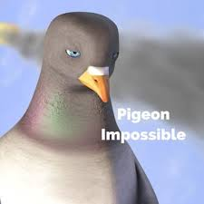  Watch the video - https://www.literacyshed.com/pigeon-impossible.html#  Create a comic strip or story board for the story.  FRIDAY -  Ask your adult to test your spellings.  Vocabulary builder - Watch the video again https://www.literacyshed.com/pigeon-impossible.html#  Generate a language bank (word list) to accompany the video. Focus on adjectives, verbs, adverbs and prepositions. | MATHS TASKS  Please see the link below for extra activities  https://whiterosemaths.com/homelearning/  MONDAY -  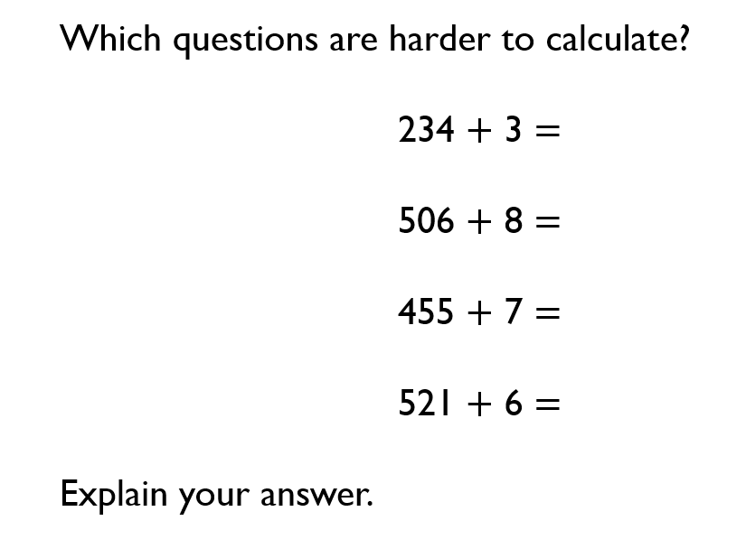  Generate your own 3-digit number + 1-digit number sums to add mentally. When you add ones to a number does it always, sometimes or never effect the tens column?  TUESDAY –  Practise your mental addition of 3-digit number + tens number (345 + 50) and a 3-digit number + hundreds number (653 + 200). Complete 25 mental additions in your books. Think – What place value column do I need to focus on?  WEDNESDAY –  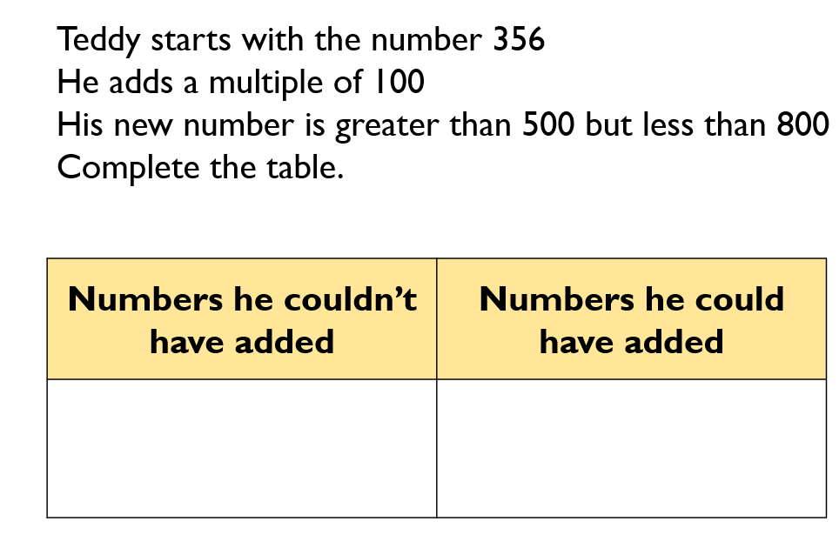  THURSDAY -  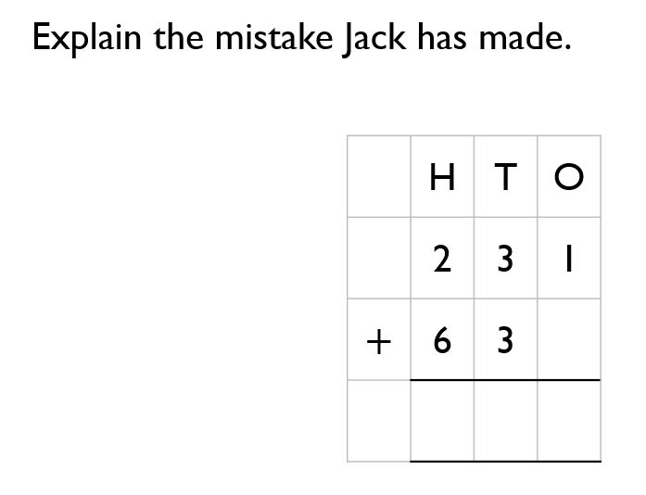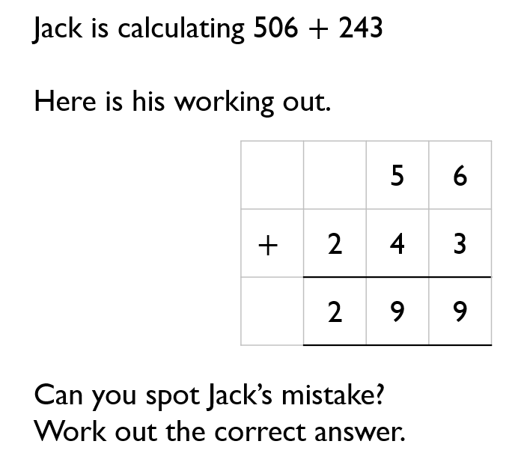  Now solve these:  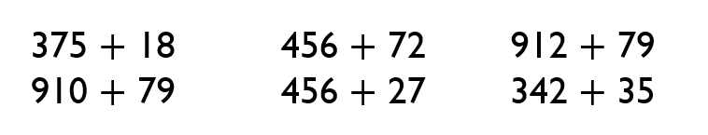  FRIDAY –  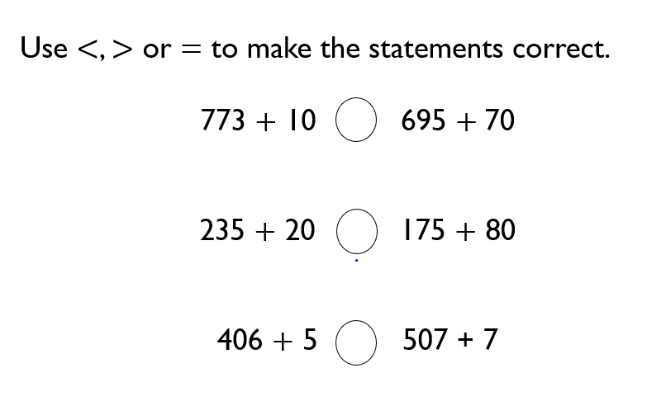  Can you create 5 of your own?
TOPIC/CREATIVE  MONDAY –  Mindfulness Monday  Spend some time focusing on relaxation and mindfulness. Nature mandalas are a great way to be creative whilst having time to be reflective. Take a photo of your finished art – we would love to see them!  TUESDAY –  This week on Friday marks the 75th anniversary of the end of the Second World War. Please research Victory in Europe Day (VE Day) by answering these questions:  -What date do we celebrate VE Day?  - Why do we celebrate it? What happened?  -How did/do we celebrate it?  - Who was the Prime Minister at the time?  -Why did people wear red, white and blue?  http://www.primaryhomeworkhelp.co.uk/war/end.html  http://www.britishlegion.org.uk  Record this information in your books.  WEDNESDAY –  Design a VE Day Medal to thank the British soldiers for their service in 1945. Your medal can be any shape or size. Please include:  -The years of the war (1939-45)  -A symbol to signify the war and the soldier’s sacrifice and victory  THURSDAY-  On 8th May 1945, the Prime Minister made an announcement that war in Europe had come to an end. Make your own radio broadcast to announce Victory in Europe. You could even pretend to be Winston Churchill. Record it thinking about how you would deliver such a message.  FRIDAY-  Party time! Have your own VE celebration party at home to commemorate the end of the Second World War. Draw and colour in a Union Jack Flag and display it in your window. Decorate your house in red, white and blue and enjoy a picnic in your garden. You could even play games and listen to music of the time. Look out for the BBC’s coverage of VE Day today.  VE Day Activities  If you copy the link below into your web browser, it will take you to a file of resources.  https://mayfieldschoolpo2.sharepoint.com/:f:/g/Student-Prep/Em41YfwrzrJHolOsnRKwynQBBfBea2M7VjEduiWpr2RPKw?e=0immgW | LEARNING WEBSITES  https://www.topmarks.co.uk/maths-games/hit-the-button  https://www.mathplayground.com/  https://www.topmarks.co.uk/maths-games/7-11-years  https://whiterosemaths.com/homelearning/  https://nrich.maths.org/primary  https://ttrockstars.com/  https://www.bbc.co.uk/bitesize/levels/zbr9wmn  https://www.literacyshed.com/home.html  https://www.spellingshed.com/  https://pobble.com/  https://monsterphonics.com/?gclid= EAIaIQobChMI56aEu9yh6AIVFeDtCh2NMAcIEA AYASAAEgK1b_D_BwE  https://www.oxfordowl.co.uk/welcome-back/for-home/reading-owl/kids-activities  https://www.topmarks.co.uk/english-games/7-11-years  Audible are doing a free 30 day trial so that children can listen to lots of books online.
YEAR 3 SPELLING WORDS

