Dear Parent/Carer,

As the school continues to remain closed due to Coronavirus, we are continuing to provide educational tasks for your children to complete. We have received positive feedback on the new format of the home learning daily tasks. As always, please continue to keep in touch about your child’s home learning and let us know if there are any problems.

In primary, we suggest that children try to complete;
- 30 minutes a day of independent reading/reading to an adult
- 30 minutes of maths a day
- 30 minutes of English a day
- 30 minutes of topic based/creative learning
- 30 minutes of PE/ physical activity

Home learning tasks can be supplemented with work from a number of websites (see list below for ideas.) Daily work set on the BBC website is particularly useful as it contains tutorial videos.
https://www.bbc.co.uk/bitesize/primary

Teachers will set a weekly programme for your child to work through at home. This will be available for you to access on the school website every Monday. We know that children work at different speeds and different levels, so please have a look at work in other year groups too for extra support.

Friday 8th May marks the commemoration of 75 years since victory in Europe was announced at the end of the Second World War. We were arranging a number of activities for the children to participate in at school, but have had to adjust these in light of the current situation. We still feel that it is important that the children understand the significance of this day and, as such, we have provided some different activities for the children to access at home. These can be seen in some of the activities and also in the link in the topic section.

Whilst it is important for your child to keep up with their learning at home, we appreciate that this can be a stressful time for children and adults. Looking after mental health is vital. Therefore, we suggest that the day is broken up into manageable learning chunks, interspersed with physical exercise, fun activities and time together as a family. Activities such as the 30 day lego challenge and using the real PE activities could be a good place to start. Setting up a weekly timetable can be a good place to start. As well as educational learning, the children could also begin to learn different life skills – how to boil an egg, sew on a button, learn to send an email, bake a cake using a recipe book etc.

Guidance for parents, regarding home learning, has been released by the government and can be found at the following link;
https://www.gov.uk/guidance/supporting-your-childrens-education-during-coronavirus-covid-19

We hope you are all keeping well and staying positive.

We would love to see some of the things you have been doing and have written our email addresses below so you can get in contact if you would like to.
Pountain-christina@mayfield.portsmouth.sch.uk
Campbell-morgon@mayfield.portsmouth.sch.uk
Emery-vikki@mayfield.portsmouth.sch.uk

YEAR 4 HOME LEARNING TASKS
WEEK BEGINNING: 4th May
ENGLISH TASKS  SPELLINGS FOR THIS WEEK (see list below)  century, certain, circle, complete, consider, continue, decide  MONDAY –  Read the extract from Chapter 1 of Charlie and the Chocolate factory  https://www.penguin.co.uk/articles/children/2017/charlie-and-the-chocolate-factory-extract/  Now answer these questions…  - Who lives at home with Charlie?  - Why was life uncomfortable for them?  - Why do you think Charlie loves chocolate so much?  - Roald Dahl describes chocolate as ‘creamy’. Can you think of 3 other words that could have been used instead?  TUESDAY –  Imagine you are Charlie Bucket standing outside a chocolate factory wondering what might be inside and desperately hoping you can visit. Use your imagination and write a prediction about what might be inside. Try to think of new ideas rather than the ones you already know!  I predict that inside the factory there will be…  WEDNESDAY –  Watch the scene from the film where Charlie finds the last golden ticket.  https://www.youtube.com/watch?v=1Fxq_n8e1qA  Write down Charlie’s feelings at each part of the clip.  How does he feel…  - When he thinks there are no more golden tickets.  - When he finds out there is one ticket remaining.  - When he opens the wrapper and realises the ticket is there!  THURSDAY – Watch the scene where the children enter the chocolate room.  https://www.youtube.com/watch?v=OMFQtY6655E  Imagine you are one of the children. Write a paragraph to describe the room.  Remember to:  Write in full sentences including fronted adverbials  Include prepositions (In the distance,)  Use some conjunctions – while, as, although  Use your senses | MATHS TASKS  Continue to practise your times tables daily.  MONDAY –  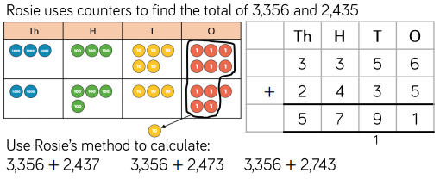  Using the same counters as Rosie, (5 thousands, 7 hundreds, 8 tens and 11 ones) create and solve 10 more calculations  TUESDAY –  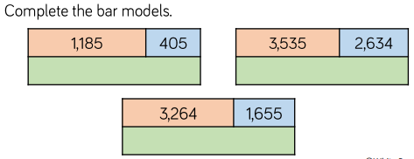  Use Monday’s method to support your working out.  Write a set of instructions that explains youre process.  WEDNESDAY –  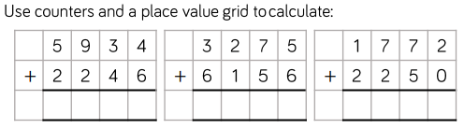  THURSDAY –  Use a method you are confident with to work each number sentence out accurately.  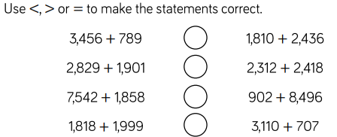
TOPIC/CREATIVE  MONDAY – Design your own sweet or chocolate that might be found in the chocolate factory.  Draw a picture of your idea and add some labels which explain why your idea is so scrumptious!  TUESDAY – Draw a picture of your chocolate factory. Which chocolates and sweets does it have? What do the rooms look like that contain them? Think about the rooms that Willy Wonka has for ideas. How can you adapt these in your design?  WEDNESDAY – Begin to think about VE day which is being commemorated on Friday. Can you create an information page about what VE day is? Use this clip to help you. https://www.bbc.co.uk/teach/class-clips-video/history-ks2-ve-day/z7xtmfr  There is lots of other information and resources about this on the Internet. What else can you find about it?  THURSDAY – Create something to help you and your family celebrate VE day which is happening tomorrow (8th May). Perhaps you could make some red, white and blue bunting? Or make some union jack flags? Maybe you could put these in your window to show others in your street that you are celebrating.  If you copy the link below into your web browser, it will take you to a file of resources.  https://mayfieldschoolpo2.sharepoint.com/:f:/g/Student-Prep/Em41YfwrzrJHolOsnRKwynQBBfBea2M7VjEduiWpr2RPKw?e=0immgW | LEARNING WEBSITES  https://www.topmarks.co.uk/maths-games/hit-the-button  https://www.mathplayground.com/  https://www.topmarks.co.uk/maths-games/7-11-years  https://whiterosemaths.com/homelearning/  https://nrich.maths.org/primary  https://ttrockstars.com/  https://www.bbc.co.uk/bitesize/levels/zbr9wmn  https://www.literacyshed.com/home.html  https://www.spellingshed.com/  https://pobble.com/  https://monsterphonics.com/?gclid= EAIaIQobChMI56aEu9yh6AIVFeDtCh2NMAcIEA AYASAAEgK1b_D_BwE  https://www.oxfordowl.co.uk/welcome-back/for-home/reading-owl/kids-activities  https://www.topmarks.co.uk/english-games/7-11-years  Audible are doing a free 30 day trial so that children can listen to lots of books online.
YEAR 3/4 SPELLING WORDS
