Dear Parent/Carer,

Although the school is currently closed due to Coronavirus, we are continuing to provide educational tasks for your children to complete.

In primary, we suggest that children try to complete;
- 30 minutes a day of independent reading/reading to an adult
- 30 minutes of maths a day
- 30 minutes of English a day
- 30 minutes of topic based/creative learning
- 30 minutes of PE/ physical activity

Home learning tasks can be supplemented with work from a number of websites (see list below for ideas)

Teachers will set a weekly programme for your child to work through at home. This will be available for you to access on the school website every Monday. We know that children work at different speeds and different levels, so please have a look at work in other year groups too for extra support.

Whilst it is important for your child to keep up with their learning at home, we appreciate that this can be a stressful time for children and adults. Looking after mental health is vital. Therefore, we suggest that the day is broken up into manageable learning chunks, interspersed with physical exercise, fun activities and time together as a family. Activities such as the 30 day lego challenge and using the real PE activities could be a good place to start.

As well as educational learning, the children could also begin to learn different life skills – how to boil an egg, sew on a button, learn to send an email, bake a cake using a recipe book etc.

We hope you are all keeping well and staying positive.

Kind regards,

Miss Turner, Miss Large & the Year 5 team.

YEAR 5 HOME LEARNING TASKS
WEEK BEGINNING:
ENGLISH TASKS  SPELLINGS FOR THIS WEEK (see list below)  accommodate, accompany, according, achieve, aggressive, amateur, ancient.  MONDAY – Write a book recommendation to share with friends. You should include: The title, author and any illustrators, for fiction details on – genre, main characters, plot and settings, for non-fiction include – layout and organisation, details on the subject it  covers, and facts you can remember, an explanation as to why you enjoyed reading it and reasons why someone else should read it.  TUESDAY – Write about your favourite event that has happened in school this year. Try to use past perfect tense when you are explaining the event.  WEDNESDAY – Pick two book characters. Write a list of similarities and differences between these characters. Can you use a PEE paragraph to explore the comparisons?  THURSDAY – Write a set of instructions for whatever you like (this could be for baking, tidying your room, an exercise routine or a game). Use modal verbs to indicate the possibility of the step. Explain the impact of the sentences when you use different modal verbs.  FRIDAY - Describe the below picture. Make sure that you are using concise expanded noun phrases when you are describing. Could you try and include parenthesis?  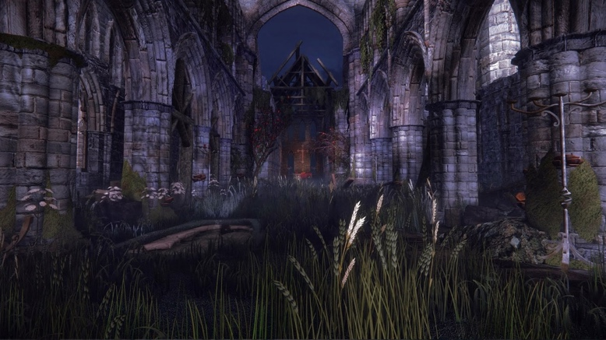 | MATHS TASKS  MONDAY –  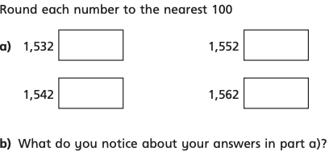  TUESDAY –  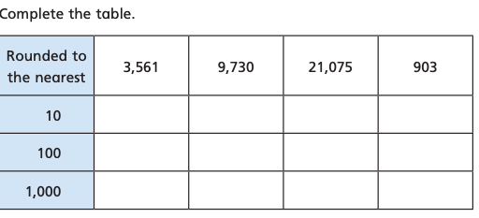  WEDNESDAY –  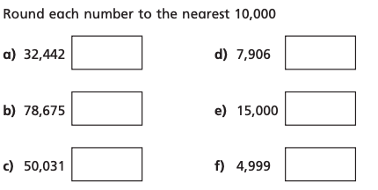  THURSDAY -  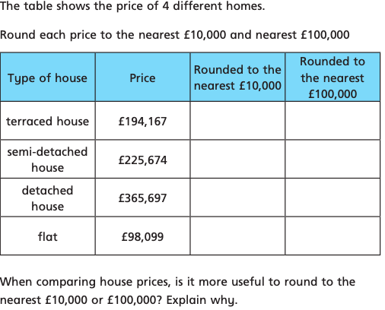  FRIDAY -  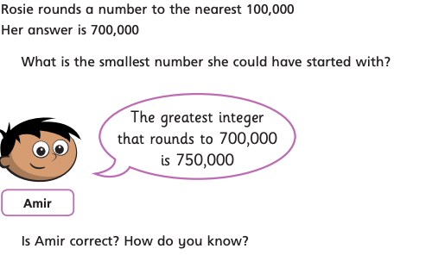
TOPIC/CREATIVE  MONDAY – Create a fact file for the beast that you created in your topic lessons.  TUESDAY – Pick an object from around your house to sketch, can you use the different sketching techniques to create texture?  WEDNESDAY – Create an exercise circuit that you can complete in your garden/flat.  Include a picture of your circuit with instructions of how to do the activity, how many of each exercise you will do etc.  THURSDAY– Create a poster to describe the forces. Include information on friction, water resistance and air resistance. Can you draw some illustrations to label?  FRIDAY– Investigate why Pluto was once considered a planet, and why it is no longer. Present this however you would like. | LEARNING WEBSITES  https://www.topmarks.co.uk/maths-games/hit-the-button  https://www.mathplayground.com/  https://www.topmarks.co.uk/maths-games/7-11-years  https://whiterosemaths.com/homelearning/  https://nrich.maths.org/primary  https://ttrockstars.com/  https://www.bbc.co.uk/bitesize/levels/zbr9wmn  https://www.literacyshed.com/home.html  https://www.spellingshed.com/  https://pobble.com/  https://monsterphonics.com/?gclid= EAIaIQobChMI56aEu9yh6AIVFeDtCh2NMAcIEA AYASAAEgK1b_D_BwE  https://www.oxfordowl.co.uk/welcome-back/for-home/reading-owl/kids-activities  https://www.topmarks.co.uk/english-games/7-11-years  Audible are doing a free 30 day trial so that children can listen to lots of books online.
YEAR 5-6 SPELLING WORDS
