Dear Parent/Carer,

As the school continues to remain closed due to Coronavirus, we are continuing to provide educational tasks for your children to complete. We have received positive feedback on the new format of the home learning daily tasks. As always, please continue to keep in touch about your child’s home learning and let us know if there are any problems.

In primary, we suggest that children try to complete;
- 30 minutes a day of independent reading/reading to an adult
- 30 minutes of maths a day
- 30 minutes of English a day
- 30 minutes of topic based/creative learning
- 30 minutes of PE/ physical activity

Home learning tasks can be supplemented with work from a number of websites (see list below for ideas.) Daily work set on the BBC website is particularly useful as it contains tutorial videos.
https://www.bbc.co.uk/bitesize/primary

Teachers will set a weekly programme for your child to work through at home. This will be available for you to access on the school website every Monday. We know that children work at different speeds and different levels, so please have a look at work in other year groups too for extra support.

Friday 8th May marks the commemoration of 75 years since victory in Europe was announced at the end of the Second World War. We were arranging a number of activities for the children to participate in at school, but have had to adjust these in light of the current situation. We still feel that it is important that the children understand the significance of this day and, as such, we have provided some different activities for the children to access at home. These can be seen in some of the activities and also in the link in the topic section.

Whilst it is important for your child to keep up with their learning at home, we appreciate that this can be a stressful time for children and adults. Looking after mental health is vital. Therefore, we suggest that the day is broken up into manageable learning chunks, interspersed with physical exercise, fun activities and time together as a family. Activities such as the 30 day lego challenge and using the real PE activities could be a good place to start. Setting up a weekly timetable can be a good place to start. As well as educational learning, the children could also begin to learn different life skills – how to boil an egg, sew on a button, learn to send an email, bake a cake using a recipe book etc.

Guidance for parents, regarding home learning, has been released by the government and can be found at the following link;
https://www.gov.uk/guidance/supporting-your-childrens-education-during-coronavirus-covid-19

We hope you are all keeping well and staying positive.
Kind regards,

The Year 5 team

YEAR 5 HOME LEARNING TASKS
WEEK BEGINNING: Monday 27th April 2020
ENGLISH (Description focus)  SPELLINGS FOR THIS WEEK:  bruise, category, cemetery, committee, communicate, community, competition.  MONDAY – Spelling Practice.  Using the words above, underline the trickiest part of the words to spell and create a memorable way of remembering this. Find words within words, what other words can you make from the letters that make up each spelling word?  TUESDAY – Reading Comprehension.  Using your inference skills, how do you think the man in the picture is feeling? Can you use PEE (point, evidence and explain) to describe how they are feeling and how you know this? I think the man is feeling patriotic, do you agree with me and why?  WEDNESDAY/ THURSDAY– Writing.  This week marks the 75th anniversary of VE day. Research this topic and find some information, maybe talk to relatives and ask what they know. This week your writing task is to write a diary entry from one of the people celebrating VE day in 1945. Remember that diary entries are written in first person, in past tense and include lots of feelings. | MATHS (Addition)  Times tables for this week:  Continue to test yourself weekly, on your target times table. Give yourself 30 seconds per calculation. You can include as many calculations as you wish to in the test. If you pass, move onto the next calculation. If you do not pass in time, continue to remain on that times table until you do pass.  If you would like further challenges, please follow the link below;  https://whiterosemaths.com/homelearning/year-5/  MONDAY –  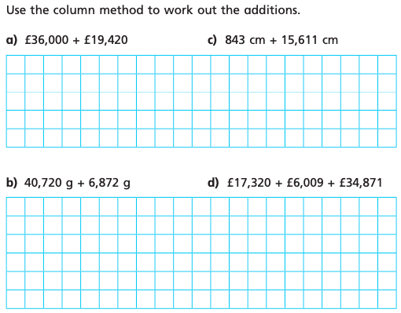  Write instructions on how to add using the column method.  TUESDAY –  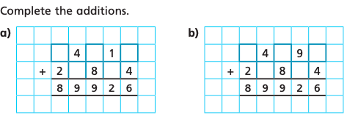  Explain how you got the answer for both a and b.  WEDNESDAY –  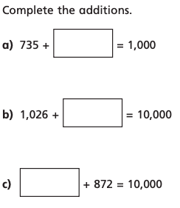  Explain the relationship between addition and subtraction.  THURSDAY -  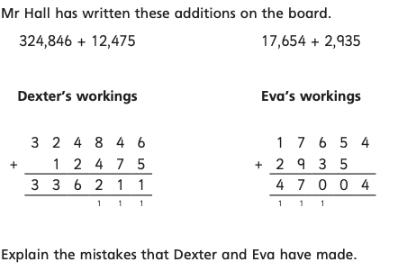
TOPIC (Recap Space – Art focus)  MONDAY –  Research space art and have a look at different varieties of artwork. Find the piece that you like the most, explain what you like about this piece.  TUESDAY –  Looking back at the artwork from yesterday, can you identify the different techniques the artist has used to create their picture? Explain why they may have used this technique. Look at the colours the artist has chosen to use, why might they have used that colour?  WEDNESDAY –  Using the piece of art that you identified as your favourite, research the artist and find some key facts. For example: how many pieces of art the artist produced, what techniques the artist used and what country the artist is from.  THURSDAY–  Using your knowledge of your chosen artist and their style, create your own space art that replicates their style. Annotate to show the different styles and techniques.  VE Day Activities  If you copy the link below into your web browser, it will take you to a file of resources.  https://mayfieldschoolpo2.sharepoint.com/:f:/g/Student-Prep/Em41YfwrzrJHolOsnRKwynQBBfBea2M7VjEduiWpr2RPKw?e=0immgW | LEARNING WEBSITES  https://www.topmarks.co.uk/maths-games/hit-the-button  https://www.mathplayground.com/  https://www.topmarks.co.uk/maths-games/7-11-years  https://whiterosemaths.com/homelearning/  https://nrich.maths.org/primary  https://ttrockstars.com/  https://www.bbc.co.uk/bitesize/levels/zbr9wmn  https://www.literacyshed.com/home.html  https://www.spellingshed.com/  https://pobble.com/  https://monsterphonics.com/?gclid= EAIaIQobChMI56aEu9yh6AIVFeDtCh2NMAcIEA AYASAAEgK1b_D_BwE  https://www.oxfordowl.co.uk/welcome-back/for-home/reading-owl/kids-activities  https://www.topmarks.co.uk/english-games/7-11-years  Audible are doing a free 30 day trial so that children can listen to lots of books online.
YEAR 5-6 SPELLING WORDS
