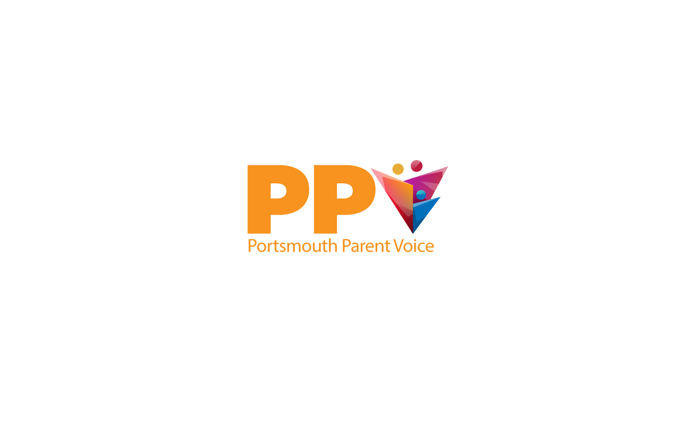

PPV help parent carers of young people

aged 0-25, with additional needs and

disabilities, to shape and improve

local services.

 

**Advice, support,**

**information & training.**



PPV is managed by

Portsmouth Disability Forum (PDF)

PDF Registered Charity no.: 109327

Company Limited by Guarantee: 4530443

Tel: 07825 185608 / 07712 439159

E-mail: [ppvadmin@p-d-f.org.uk](mailto:ppvadmin@p-d-f.org.uk)

Web: www.portsmouthparentvoice.org