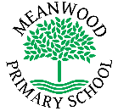 | Home Learning Task Year: Nursery  Theme - Under the Sea
Week beginning 13t^{h} July 2020 Try to complete 2-3 tasks a day
Weekly Maths Tasks |  | Weekly Reading Tasks
Count objects to 10 and beyond  All Children:  Learn the song 1.2.3.4.5 once I caught a fish alive  Pre school challenge:  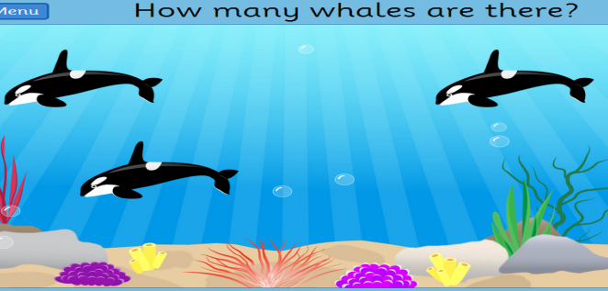  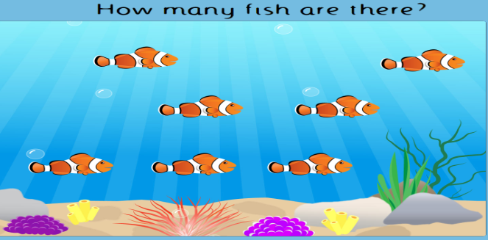  Continue counting by playing the game below  https://www.topmarks.co.uk/learning-to-count/underwater-counting |  | Listen to stories with increasing attention and recall.  All children  Enjoy the story below – Barry the Fish with Fingers  https://www.youtube.com/watch?v=Ewsgwj-wM4w  Preschool Challenge:  What was the name of the puffa fish?  What was different about Barry?  What is Barry’s favourite thing about having fish fingers?  What fell into the water?  How did they celebrate at the end?  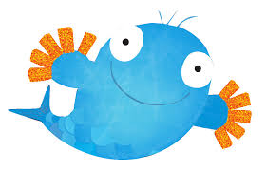
Weekly Phonic Task |  | Weekly mark making/writing Task
Letters and Sounds  All children  Play Guess the Sound – What unusual sounds can you hear?  https://www.youtube.com/watch?v=n1m4h79JZso  Preschool children  We are learning to recognise the sounds g and o. Watch Geraldine the Giraffe explain the n and p sound.  Name 3 objects that start with g and o.  g  https://www.youtube.com/watch?v=P2DdC5Q6D64  o  https://www.youtube.com/watch?v=YIQQo9eYVqk |  | Mark making/writing  All children mark making and pencil control  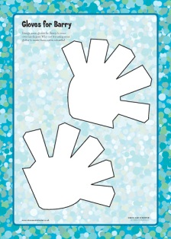  Design some gloves for Barry  Preschool children  Barry and his friends had a party. ‘Write’ an invitiation to a party for a friend.  Remember to write your name at the end.
Weekly Learning Task |  | Useful Websites
Understanding the world  Expressive arts and design  All Children:  Try some finger painting, or design your own fish. |  | - Cbbies.co.uk  - Topmarks.co.uk  - Ictgames.co.uk  - http://www.letters-and-sounds.com/phase-1.html  - Purplemash.co.uk  - Oxfordowls.co.uk
There will also be a daily activity for you to complete on our school Facebook page. There are also regular updates on here too!

