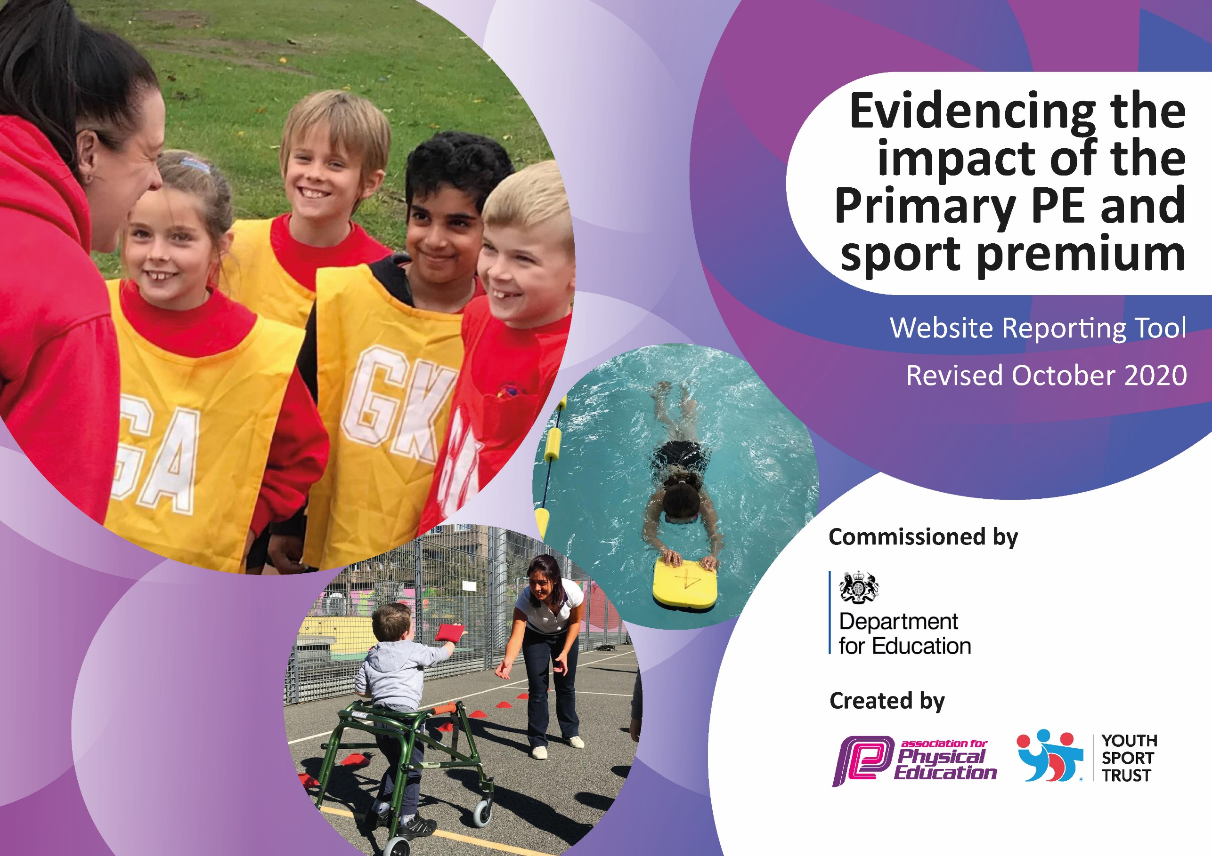
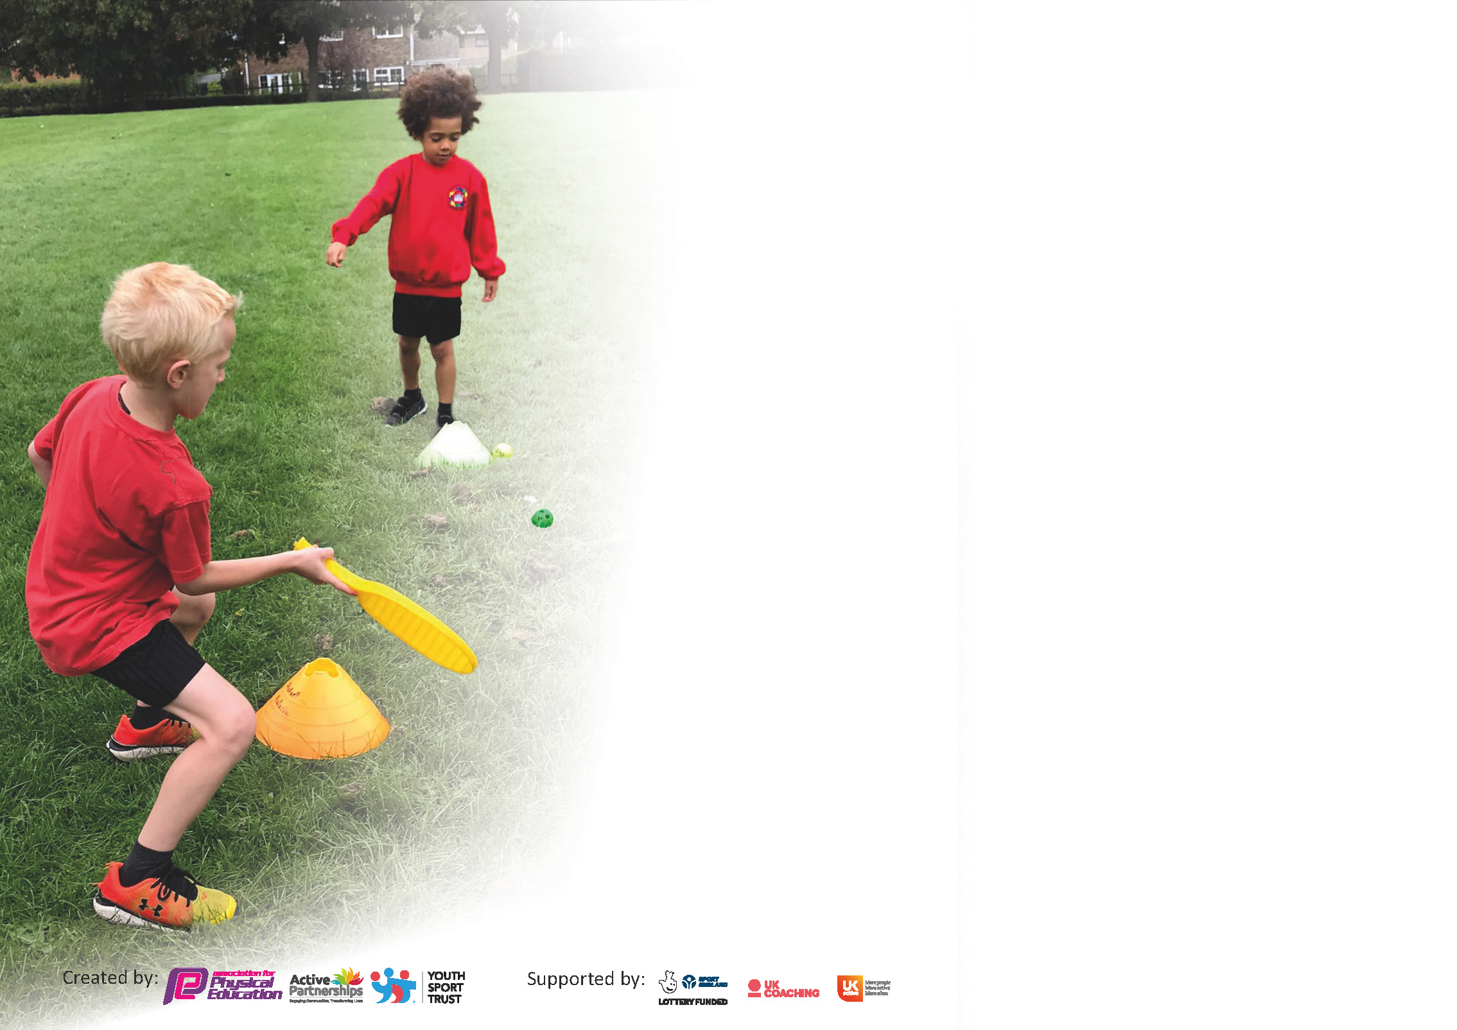

It is important that your grant is used effectively and based on school need. The Education Inspection Framework (Ofsted 2019 p64) makes clear there will be a focus on ‘whether leaders and those responsible for governors all understand their respective roles and perform these in a way that enhances the effectiveness of the school’.

Under the Quality of Education criteria (p41) inspectors consider the extent to which schools can articulate their curriculum (INTENT), construct their curriculum (IMPLEMENTATION) and demonstrate the outcomes which result (IMPACT).

To assist schools with common transferable language this template has been developed to utilise the same three headings which should make your plans easily transferable between working documents.

Schools must use the funding to make additional and sustainable improvements to the quality of Physical Education, School Sport and Physical Activity (PESSPA) they offer. This means that you should use
the Primary PE and sport premium to:

- Develop or add to the PESSPA activities that your school already offer
- Build capacity and capability within the school to ensure that improvements made now will benefit pupils joining the school in future years

Please visit gov.uk for the revised DfE guidance including the 5 key indicators across which schools should demonstrate an improvement. This document will help you to review your
provision and to report your spend. DfE encourages schools to use this template as an effective way of meeting the reporting requirements of the Primary PE and sport premium.

We recommend you start by reflecting on the impact of current provision and reviewing the previous spend.

Schools are required to publish details of how they spend this funding as well as on the impact it has on pupils’ PE and sport participation and attainment by the end of the summer term or by 31st July 2021 at the latest.

** In the case of any under-spend from 2019/20 which has been carried over this must be used and published by 31st March 2021.

We recommend regularly updating the table and publishing it on your website throughout the year. This evidences your ongoing self-evaluation of how you are using the funding to secure maximum, sustainable impact. Final copy must
be posted on your website by the end of the academic year and no later than the 31st July 2021. To see an example of how to complete the table please click HERE.
Created by: Supported by:

Please note: Although there has been considerable disruption in 2020 it is important that you publish details on your website of how you spend the funding - this is a legal requirement.
Support for review and reflection - considering the 5 key indicators from DfE, what development needs are a priority for your setting and your pupils now and why? Use the space below to reflect on previous spend and key achievements and areas for development.

N.B. In this section you should refer to any adjustments you might have made due to Covid-19 and how these will influence further improvement.
Key achievements to date until July 2020: | Areas for further improvement and baseline evidence of need:
- Installation of Health Track Activall for KS1 and KS2  - Trim Trail installed for EYFS/KS1  - New PE Lead – established plan for moving PE forward.  - Established new Scheme of Work across school (PE Passport) Free trial period.  - Raised confidence of staff in teaching Gymnastics  - Increased involvement with other schools in the RUSC  - Attended tournaments and sport fixtures within the Autumn and Spring terms  - Offered wider range of afterschool clubs to pupils  - Restocked equipment in both EYFS/KS1 and KS2 buildings  - Installation of all-weather purpose table tennis table for increased activity  - EYFS/KS1  - Contacts made with local providers – Rochdale Football Club, Rochdale Hornets, Commando Jo, Fit Camp, Little Fit, Abey Cricket  - School field marked out to enable more tournament and games to be held at Meanwood | - Support and monitor use of PE Passport  - Evidence of assessment for PE  - Involvement in more tournaments  - Increase participation in after school clubs and tournaments  - Offer wider opportunities for different sports and activities in school  - Establish sport leaders

Meeting national curriculum requirements for swimming and water safety.  N.B Complete this section to your best ability. For example you might have practised safe self-rescue techniques on dry land. | Please note that these figures are from Year 4 data and could not be verified with children due to Covid 19 restrictions
What percentage of your current Year 6 cohort swim competently, confidently and proficiently over a distance of at least 25 metres?  N.B. Even though your pupils may swim in another year please report on their attainment on leaving primary school at the end of the summer term 2020. | 17%
What percentage of your current Year 6 cohort use a range of strokes effectively [for example, front crawl, backstroke and breaststroke]? | 18%
What percentage of your current Year 6 cohort perform safe self-rescue in different water-based situations? | 15%
Schools can choose to use the Primary PE and sport premium to provide additional provision for swimming but this must be for activity over and above the national curriculum requirements. Have you used it in this way? | Yes/No

Action Plan and Budget Tracking
Capture your intended annual spend against the 5 key indicators. Clarify the success criteria and evidence of impact that you intend to measure to evaluate for pupils today and for the future.

Academic Year: 2019/20 | Total fund allocated: £19,394 | Date Updated:
Key indicator 1: The engagement of all pupils in regular physical activity – Chief Medical Officers guidelines recommend that primary school pupils undertake at least 30 minutes of physical activity a day in school |  |  |  | Percentage of total allocation:
 |  |  |  | %
Intent | Implementation |  | Impact
Encourage children in EYFS and KS1 to be more active during breaks and lunch times. | Installation of trim trail | £8,394 | Children are very keen to use the trim trail on a daily basis.  Children are undertaking at least 10mins of activity daily when using it (in addition to the 2 hours of PE a week). | The trim trail was purchased for long term.  Need to ensure it is maintained but this would be relatively small cost than the installation and would only be every couple of years.
Encourage children in KS1 and KS2 to be more active during breaks and lunch times. | Installation of Health Track Activall in both buildings. | £5,400 | Wider ranges of children are using it for fitness as an addition to their 2 hours of PE a week. | Staff to be trained in using it to support children.
Develop an overview of outside agencies who can support Physical Education in school during curriculum time. | Contact Commando Jo to work with KS2 in outdoor and adventurous activities.  Contact Rochdale Hornets to provide rugby training.  Contact other agencies in advance to support PE Curriculum.  Contact Abey Cricket | N/A  £400 | Wider range of children in KS2 were able to participate in different outdoor and adventurous activities.  External providers taught skill specific sessions to pupils while helping staff to upskill. | Re arrange activities for next year.  Need to confirm risk assessments for external visitors before booking.
Key indicator 2: The profile of PESSPA being raised across the school as a tool for whole school improvement |  |  |  | Percentage of total allocation:
 |  |  |  | %
Intent | Implementation |  | Impact
Introduce new scheme of work for PE | Select a few Teachers and Sports Coordinator to trial the scheme during Autumn term. | Free trial | Teachers reported it was easy to follow.  Provides PE Lead with overview from EYFS to Year 6.  Able to track children who were injured, missing PE kit and absent for each lesson.  Quick and efficient way to assess children’s progress via photos and videos. | Buy scheme.  Monitor through observations and checking lessons adapted.  Order iPads specifically for PE Passport (teaching lessons and assessing) and clubs.
Participate in the Rochdale School Games. | Access to the partnership by completing signing up form.  Use of partnership for competitive events and the support of developing PE across school. | £750 | Competitive events available in a range of sports for all children. | Reassess next year if restrictions are still in place for Covid, what would we still be paying for?  Stay in touch with RUCS schools – attempt virtual tournaments for free.
Raise profile of PE through school teams. Children to have a School Kit when attending fixtures and tournaments. | Complete inventory of Kits – buy shin pads.  Organise friendlies and tournament matches with schools in the RUSC.  Participate in tournaments through Rochdale School Games. | £27.23  N/A  Part of the fee above. | Children were able to feel part of the school team and share that with others in school.  Raised the confidence of children in playing sports and representing the school. | Complete another inventory for next year.
Encourage targeted children for improved fitness and well-being. | External provider to provide fitness to children. Kealey Dermody – Fit Camp.  Little Fit | £210  £390 | Selected children had an opportunity to participate in fitness and improve their well-being. | Can this be run again with Covid restrictions?  Can we encourage whole school fitness – especially after lockdown.

Key indicator 3: Increased confidence, knowledge and skills of all staff in teaching PE and sport |  |  |  | Percentage of total allocation:
 |  |  |  | %
Intent | Implementation |  | Impact
Improve staff’s confidence in teaching gymnastics. | Organise CPD for teaching gymnastics. (Sports Basics) | £424 | Staff share their experiences and successes with teaching gymnastics. | Continue sharing experiences.  Lesson observations in gymnastics.
PE passport used to support staff in teaching PE lessons. | Push out the app to all staff.  Training on App to support staff in use of this. | £699 | Develop confidence of staff in delivering PE lessons.  Resources available on the App to support. | PE Lead to work with all staff in deciding on the curriculum plan for next year.  Keep units from previous years which offer variety which PE Passport does not cater for. E.g. Archery.
PE Lead to highlight available training to support staff in delivering an effective PE lesson. | PE Lead to receive information from Rochdale School Games. | Part of cost for Rochdale School Games. | Ultimate Frisbee course attended by PE Lead.  Courses cancelled. | PE Lead to share skills and provide Ultimate Frisbee after school club.  Further training to be accessed when available.
Key indicator 4: Broader experience of a range of sports and activities offered to all pupils |  |  |  | Percentage of total allocation:
 |  |  |  | %
Intent | Implementation |  | Impact
Fully stocked equipment for lessons and activities outside. | Complete an inventory of stock.  Order and restock equipment. | £441.47 | Lessons have full stock of equipment. Children can participate with good quality resources.  Resources also used for 1:1 and play times. | Complete inventory again next year to replenish any stock.  Look at adding different equipment for playtimes to encourage more children to stay active.
Offer wider range of activities for children to participate in. | PE Lead to run an Ultimate Frisbee club.  Order and confirm Quidditch day and Quidditch week | N/A  £50  £2100  (not spent due to Covid) – some of money used for equipment) | Children were able to learn new skills and develop interest in another sport.  Cancelled and postponed for next year. | Re book the Quidditch week.  Order equipment to enable children to enjoy the sport after the week of emersion in the sport.
Offer children other sports to play during breaks and lunch times. | Install outdoor all weather table tennis table. | £649.99 | Wide range of children played table tennis soon after installation and is still a favourite at play times. | Re stock on balls and bats.  Organise school tournament for next year.

Key indicator 5: Increased participation in competitive sport |  |  |  | Percentage of total allocation:
 |  |  |  | %
Intent | Implementation |  | Impact
Participate in the Rochdale School Games. | Access to the partnership by completing signing up form.  Use of partnership for competitive events, training for Sports Leaders and the support of developing PE across school. | See above. | Competitive events available in a range of sports for all children. | Reassess next year if restrictions are still in place for Covid, what would we still be paying for?  Stay in touch with RUCS schools – attempt virtual tournaments for free.
Participate in RUSC Sports Association. | Access to tournaments through organiser – confirm interest and involvement. | Free this year.  £20 for the year 20/21 | Competitive events available in a range of sports for all children. | Continue to participate. Have field marked out and host games to avoid travelling.
Host more tournaments at Meanwood to enable easy access for children and avoid costs for travel. | Arrange for field to be marked out for pitches. (Duncan’s Sports Pitch services) | £300 | Children are able to compete in fixtures at school – easier for parent pick-up. | Continue to have filed marked out – extend to other pitches for different sports.

Signed off by
Head Teacher:
Date:
Subject Leader:
Date:
Governor:
Date:

