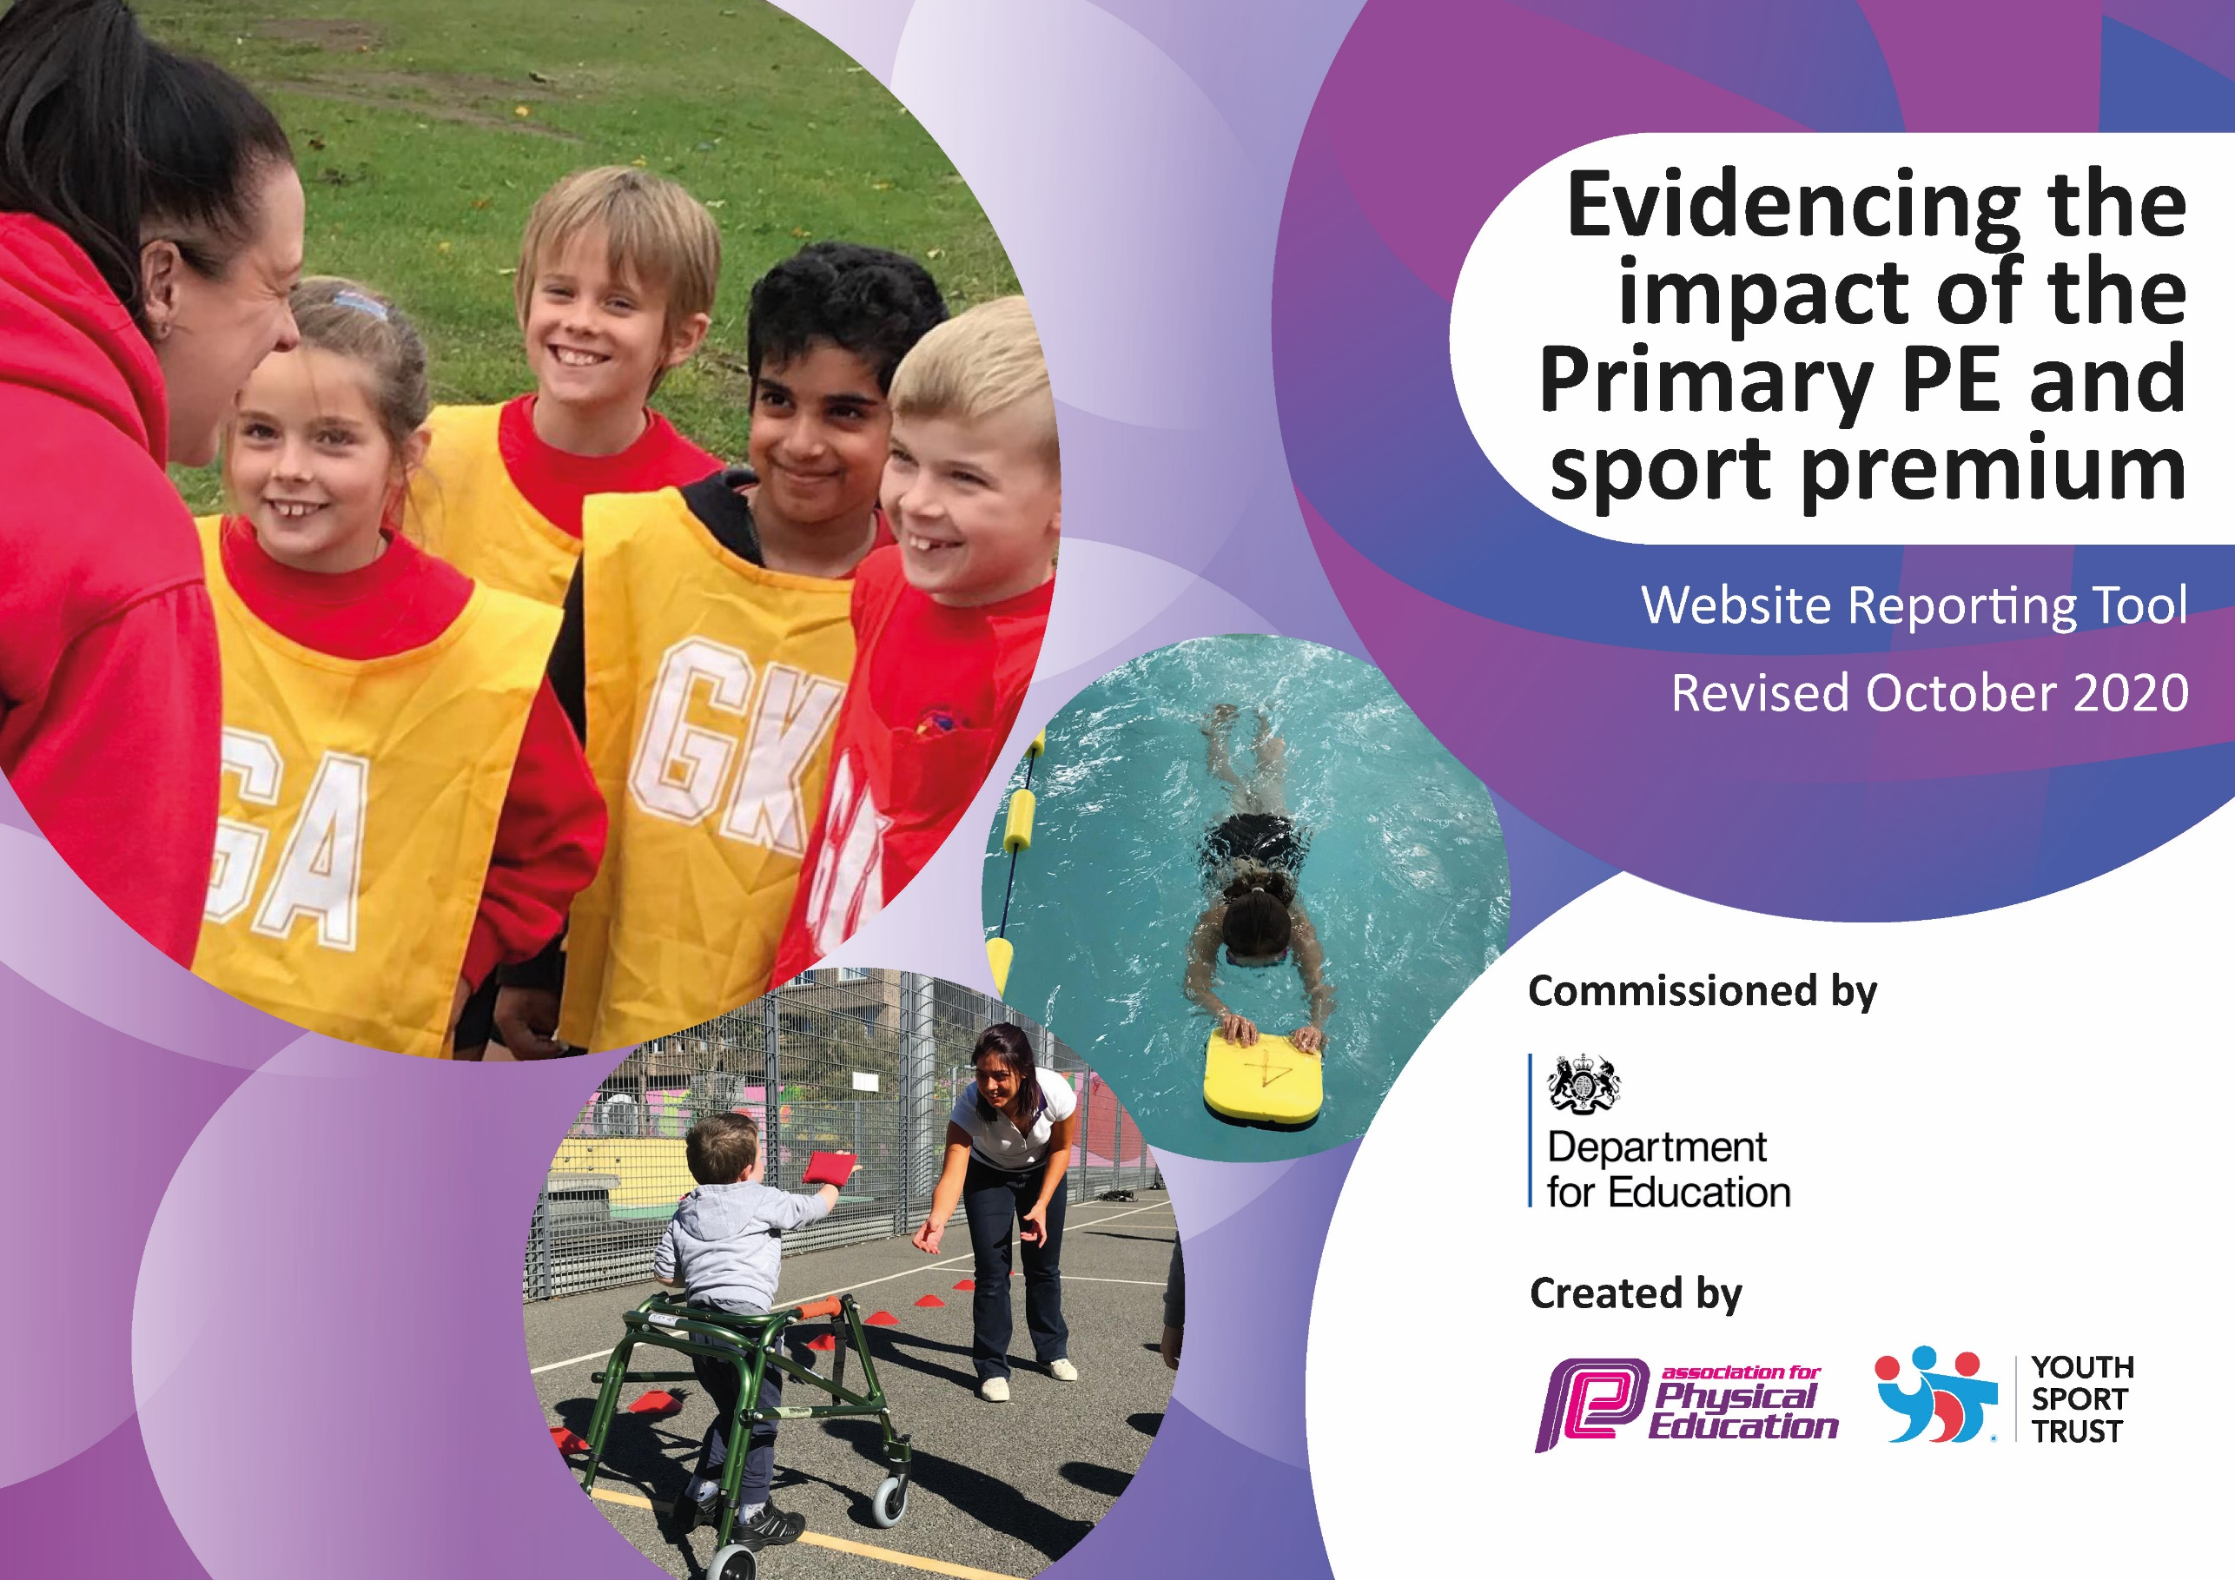
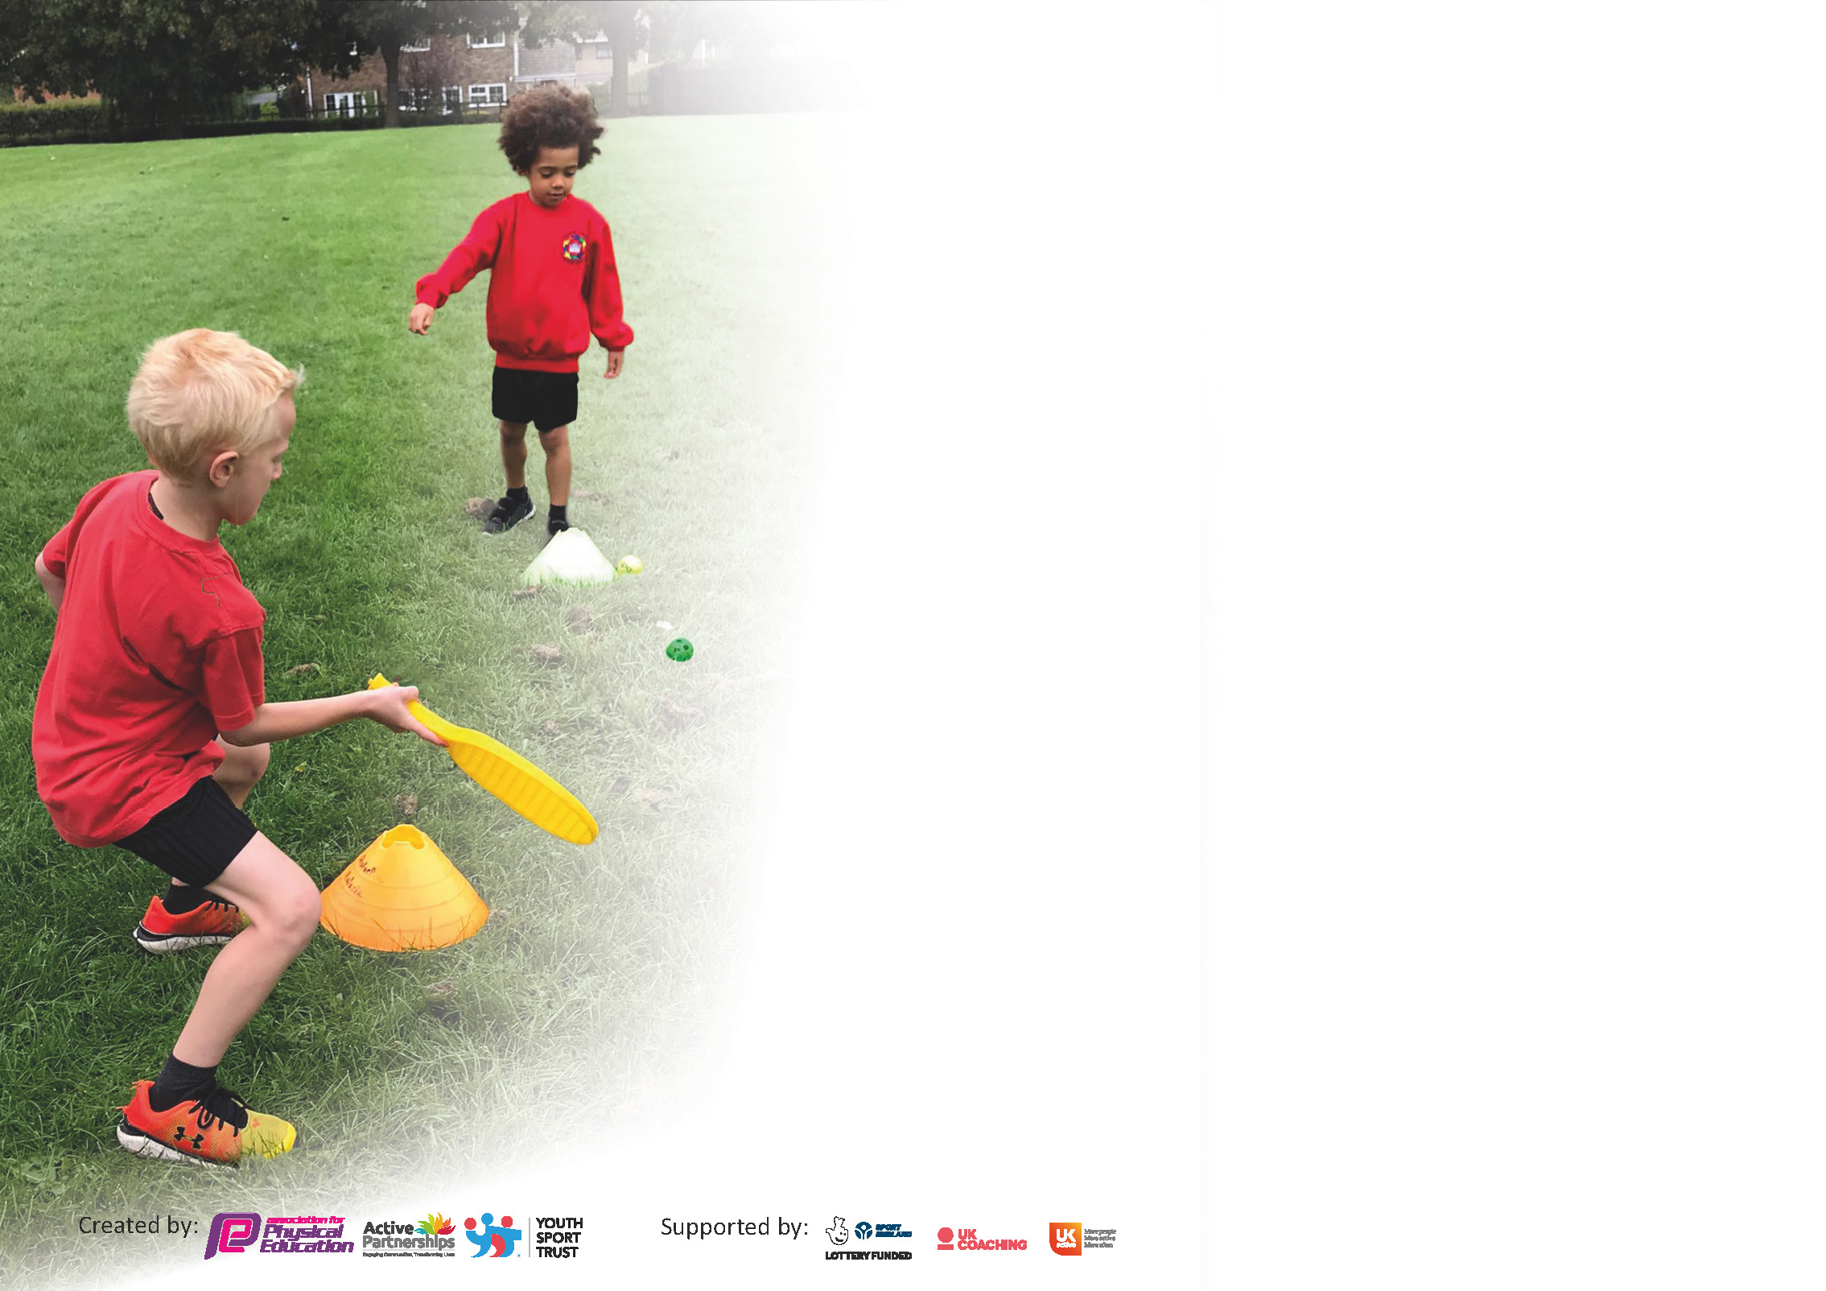

It is important that your grant is used effectively and based on school need. The Education Inspection Framework (Ofsted 2019 p64) makes clear there will be a focus on ‘whether leaders and those responsible for governors all understand their respective roles and perform these in a way that enhances the effectiveness of the school’.

Under the Quality of Education criteria (p41) inspectors consider the extent to which schools can articulate their curriculum (INTENT), construct their curriculum (IMPLEMENTATION) and demonstrate the outcomes which result (IMPACT).

To assist schools with common transferable language this template has been developed to utilise the same three headings which should make your plans easily transferable between working documents.

Schools must use the funding to make additional and sustainable improvements to the quality of Physical Education, School Sport and Physical Activity (PESSPA) they offer. This means that you should use
the Primary PE and sport premium to:

- Develop or add to the PESSPA activities that your school already offer
- Build capacity and capability within the school to ensure that improvements made now will benefit pupils joining the school in future years

Please visit gov.uk for the revised DfE guidance including the 5 key indicators across which schools should demonstrate an improvement. This document will help you to review your
provision and to report your spend. DfE encourages schools to use this template as an effective way of meeting the reporting requirements of the Primary PE and sport premium.

We recommend you start by reflecting on the impact of current provision and reviewing the previous spend.

Schools are required to publish details of how they spend this funding as well as on the impact it has on pupils’ PE and sport participation and attainment by the end of the summer term or by 31st July 2021 at the latest.

** In the case of any under-spend from 2019/20 which has been carried over this must be used and published by 31st March 2021.

We recommend regularly updating the table and publishing it on your website throughout the year. This evidences your ongoing self-evaluation of how you are using the funding to secure maximum, sustainable impact. Final copy must
be posted on your website by the end of the academic year and no later than the 31st July 2021. To see an example of how to complete the table please click HERE.
Created by: Supported by:

Please note: Although there has been considerable disruption in 2020 it is important that you publish details on your website of how you spend the funding - this is a legal requirement.
Support for review and reflection - considering the 5 key indicators from DfE, what development needs are a priority for your setting and your pupils now and why? Use the space below to reflect on previous spend and key achievements and areas for development.

N.B. In this section you should refer to any adjustments you might have made due to Covid-19 and how these will influence further improvement.
Key achievements to date until July 2020: | Areas for further improvement and baseline evidence of need:
- Rolled out use of new PE Scheme of work, PE Passport, across school.  - Enabled staff to have easy access to PE Passport with IPads specific to PE and printing lesson plans off.  - Took part in virtual cross-country with RUSC schools.  - Had the outdoor gym installed in KS2 playground.  - Introduced new units in the PE curriculum: Ultimate Frisbee, Volleyball and Leadership.  - Provided Online learning during lockdown.  - Restocked PE equipment.  - Safety check on all gymnastic equipment completed.  - Successful week of external coaches providing Quidditch for Y1-Y5 (Y6 missed out due to in isolation) | - Improve fitness of children across school.  - Ensure all aims from National Curriculum are covered by end of the year.  - More inter and intra tournaments to be set up across school.  - Assessment of PE to be more efficient and staff to improve their confidence in using it – PE Passport CPD planned for September INSET.  - Trial sport leaders in Y5 and Y6.

Did you carry forward an underspend from 2019-20 academic year into the current academic year? YES/NO * Delete as applicable

If YES you must complete the following section
If NO, the following section is not applicable to you

If any funding from the academic year 2019/20 has been carried over you MUST complete the following section. Any carried over funding MUST be spent by 31 March 2021.
Academic Year: September 2020 to March 2021 | Total fund carried over: £10,598.95 | Date Updated:  26/3/21
What Key indicator(s) are you going to focus on?  Key Indicator 1: Engagement of all pupils in regular physical activity.  Key indicator 4: Broader experience of a range of sports and activities offered to all pupils |  |  |  | Total Carry Over Funding:
 |  |  |  | £10,598.95
Intent | Implementation |  | Impact
Encourage and improve physical fitness in children. | Installation of outdoor gym. | Carry over funding allocated:  £8,750 | Evidence of impact: Children show a keen interest in using the equipment and it has generated excitement in all year groups.  Equipment can be used within a PE lesson or during breaks and lunches.  What has changed?  Children who are more reluctant to participate in fitness are eager to use the equipment. | The outdoor gym is an installation that should last years and will benefit all year groups.
Expose children to a broader variety of sports and activities. | Purchased equipment for specialist sports (Quidditch and Frisbee) and booked coaches to provide coaching of specialised sport. | Carry over funding allocated:  £886.35 | Evidence of impact: Children across KS1 and KS2 were introduced to a new sport and loved it.  What has changed? Children have a desire to improve their skills and knowledge of given sport. | Children experience a sport they are unlikely to be exposed to outside of school.

Meeting national curriculum requirements for swimming and water safety.

N.B Complete this section to your best ability. For example you might have practised safe self-rescue techniques on dry land.
What percentage of your current Year 6 cohort swim competently, confidently and proficiently over a distance of at least 25 metres?  N.B. Even though your pupils may swim in another year please report on their attainment on leaving primary school at the end of the summer term 2020. | %
What percentage of your current Year 6 cohort use a range of strokes effectively [for example, front crawl, backstroke and breaststroke]? | %
What percentage of your current Year 6 cohort perform safe self-rescue in different water-based situations? | %
Schools can choose to use the Primary PE and sport premium to provide additional provision for swimming but this must be for activity over and above the national curriculum requirements. Have you used it in this way? | Yes/No

Action Plan and Budget Tracking
Capture your intended annual spend against the 5 key indicators. Clarify the success criteria and evidence of impact that you intend to measure to evaluate for pupils today and for the future.

Academic Year: 2020/21 | Total fund allocated: £19,340 | Date Updated: 18/7/21
Key indicator 1: The engagement of all pupils in regular physical activity – Chief Medical Officers guidelines recommend that primary school pupils undertake at least 30 minutes of physical activity a day in school |  |  |  | Percentage of total allocation:
 |  |  |  | %
Intent | Implementation |  | Impact
Encourage children across school to be more active during lockdown and isolation periods. | Provide resources for year groups. Share joy of movement resource and challenges on PE Passport to assist with workout videos already available online. | free | Children were able to work through joy of movement resources with their family. This encourages and enables parents to see the value of fitness in the home. | PE team to consider ways to encourage families to become more active which will encourage children to be more active.
Ensure all equipment is safe for children to use. | Instruct external providers to provide a safety check of all equipment. | £78 | Staff are confident that children are safe when using equipment. | Annual check carried out – ensure equipment is checked annually and repair or replace equipment not safe.
Improve engagement of children in physical activity. | Install outdoor gym. | £8,750 | Children are excited to use the equipment. Equipment can be used in lesson time or during breaks and lunchtimes. It can be used for activities before and after school. | Long lasted equipment. Create a rota for lunchtimes where each year group can use it.  Create risk assessment for outdoor gym.

Key indicator 2: The profile of PESSPA being raised across the school as a tool for whole school improvement |  |  |  | Percentage of total allocation:
 |  |  |  | %
Intent | Implementation |  | Impact
Ensure every year group are confident with teaching the PE curriculum. | Renew scheme of work (PE Passport) | £718.80 | Y1-Y6 taught units they were able to while in school and adapted when isolating or on lockdown.  Reception and Nursery have also used found some of the units on PE Passport useful. | Continue to renew PE Passport, encourage staff to make amendments and edit as they become more familiar with the app.
Evaluate new scheme of work | Ask for feedback from staffs using the app. Audit what has been taught. | Free | Staff said it was easy to use and adapt.  Sports Leader was very positive about the app and found it easier to assess during each lesson. | Most staff were less confident when using the PE Passport for assessment. CPD needed for staff.
Make staff more aware of children becoming less active during lockdown and enlist staff in improving the fitness of children across school. | Shared findings with staff during curriculum recovery meeting.  Outdoor gym installed.  Fitness timetabled in first for most classes to cover in September. | Free | Staff are more aware of current need to improve fitness of children across school. Have equipment to support in engaging children more in physical activity. | Continue to provide children with wider opportunities to be more active in school.

Key indicator 3: Increased confidence, knowledge and skills of all staff in teaching PE and sport |  |  |  | Percentage of total allocation:
 |  |  |  | %
Intent | Implementation |  | Impact
Improve Subject Lead’s knowledge of current issues and findings within PE curriculum linked with current restrictions. | CPD course for PE Lead in May – range of topics which included Sports Day, recovery curriculum, school and community partnerships, leanings from lockdown and insight from virtual delivery. | £25 | Improve Subject Lead’s knowledge of current issues and support within sport and PE delivery.  Shared elements of aspects with staff when presenting PE curriculum recovery. | Continue with PE Association and Rochdale School Games – they provide training and organise tournaments.
Improve staff confidence in using PE Passport | PE Passport to be accessed by all teaching staff.  IPads set up to enable staff to use in the lesson. | Free | Feedback given from staff was that they found the units easy to follow yet some staff were reluctant to use the IPad in the lesson and preferred paper copies of the plans. Printing was arranged for staff. | CPD available in September.

Key indicator 4: Broader experience of a range of sports and activities offered to all pupils |  |  |  | Percentage of total allocation:
 |  |  |  | %
Intent | Implementation |  | Impact
Provide children with wider choice of equipment during breaks and lunchtimes. | Restock on equipment and order items children have not used before (E.g. Frisbees, stilts, Quidditch equipment) | £1,081.67 | More children seen using the equipment and becoming more active. | Train sport leaders up in how to correctly use equipment who can then show other children.
Offer wider range of activities for children to participate in. | Order and confirm Quidditch week.  Organise distribution of coaches and Year groups. | £2,100 | Children were able to learn new skills and develop interest in another sport. | Re book the Quidditch week for 2021/22.  Become more specialised as a school in sports not easily accessible in the local area.  E.g. Archery, Quidditch, Ultimate Frisbee.
Improve equipment for sport that staff specialise in. | Coordinate with specialised staff in archery. Complete inventory of equipment then repair, restock and replace. | £1,024.62 | Now have more than enough for more children to be active in a PE lesson for archery and more suitable bows for taller children, with an adult bow to better demonstrate. | Equipment to be kept in one place and maintained. Archery specialised in school to check equipment and train up PE Lead.

Key indicator 5: Increased participation in competitive sport |  |  |  | Percentage of total allocation:
 |  |  |  | %
Intent | Implementation |  | Impact
Provide children with an area to participate in competitive sport. | Have field marked out for sports and cross country.  Buy equipment needed to participate in competitive sports. | £300  See above | Children were able to compete in the virtual cross country | Make better use of the courts, installed equipment and field to encourage more competitive sports.
Participate in competitions. | Work alongside RUSC schools and participate in Cross Country tournament. | Free | Children across KS1 and KS2 participated and some were able to represent Meanwood in the top 5. | Plan and confirm tournaments and participation early on in Autumn.
Children participate in Sports Day | Organise activities while planning safety measures for social distancing with bubbles. | Free | Cancelled due to weather. | Plan to have Sport based activity days earlier in the year so they can be postponed if weather is not permitting.

Signed off by
Head Teacher:
Date:
Subject Leader:
Date:
Governor:
Date:

