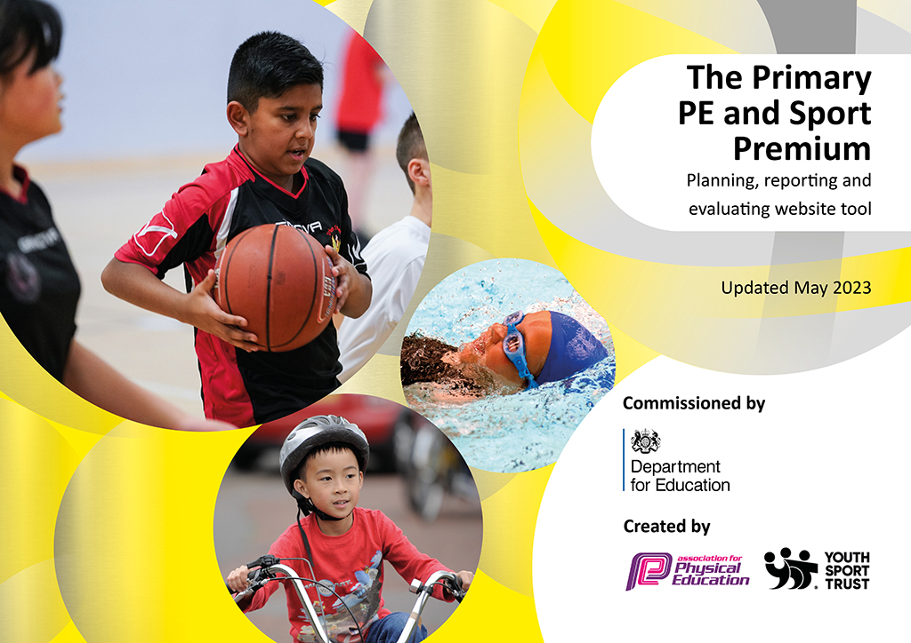
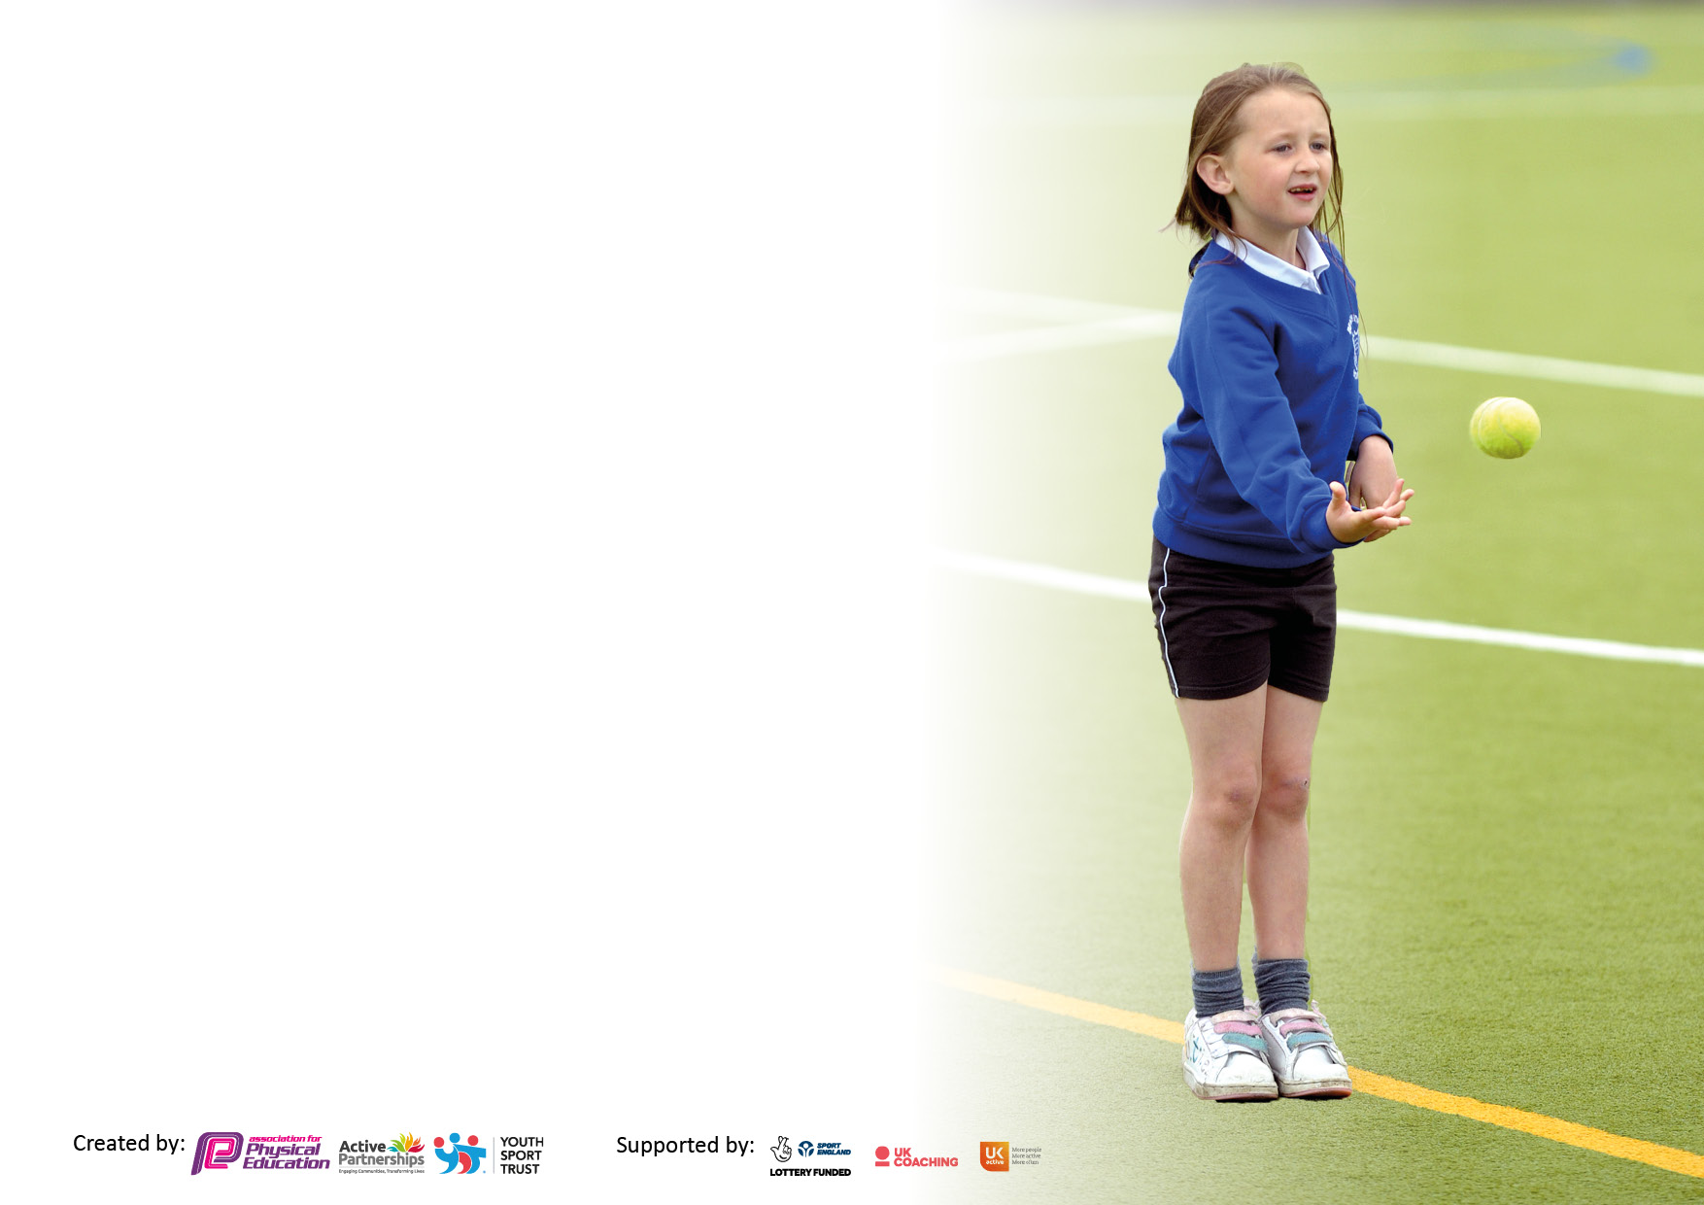

It is important that your grant is used effectively and based on school need. The Education Inspection Framework makes clear there will be a focus on ‘whether leaders and those responsible for governors all understand their respective roles and perform these in a way that enhances the effectiveness of the school’.

Under the Quality of Education Ofsted inspectors consider:
Intent - Curriculum design, coverage and appropriateness
Implementation - Curriculum delivery, Teaching (pedagogy) and Assessment
Impact - Attainment and progress

To assist schools with common transferable language this template has been developed to utilise the same three headings which should make your plans easily transferable between working documents.

Schools must use the funding to make additional and sustainable improvements to the quality of Physical Education, School Sport and Physical Activity (PESSPA) they offer. This means that you should use the Primary PE and sport premium to:

- Develop or add to the PESSPA activities that your school already offer
- Build capacity and capability within the school to ensure that improvements made now will benefit pupils joining the school in future years
- The Primary PE and sport premium should not be used to fund capital spend projects; the school’s budget should fund these.

Pleasevisitgov.ukfortherevisedDfEguidanceincludingthe5keyindicatorsacrosswhichschoolsshoulddemonstrate animprovement.Thisdocumentwillhelpyoutoreviewyourprovisionandtoreportyourspend.DfEencouragesschools to use this template as an effective way of meeting the reporting requirements of the Primary PE and Sport Premium.

We recommend you start by reflecting on the impact of current provision and reviewing the previous spend.

Schools are required to publish details of how they spend this funding, including any under-spend from 2021/2022, as well as on the impact it has on pupils’ PE and sport participation and attainment. All funding must be spent by 31st July 2023.

We recommend regularly updating the table and publishing it on your website throughout the year. This evidences your ongoing self-evaluation of how you are using the funding to secure maximum, sustainable impact. Final copy must be posted on your website by the end of the academic year and no later than the 31st July 2023. To see an example of how to complete the table please click HERE.

Details with regard to funding
Please complete the table below.

Total amount carried over from 2021/22 | £
Total amount allocated for 2021/22 | £19,600
How much (if any) do you intend to carry over from this total fund into 2022/23? | £957
Total amount allocated for 2022/23 | £19,600
Total amount of funding for 2023/23. To be spent and reported on by 31st July 2023. | £20,557
Swimming Data
Please report on your Swimming Data below.

Meeting national curriculum requirements for swimming and water safety.  N.B. Complete this section to your best ability. For example you might have practised safe self-rescue techniques on dry land which you can then transfer to the pool when school swimming restarts.  Due to exceptional circumstances priority should be given to ensuring that pupils can perform safe self rescue even if they do not fully meet the first two requirements of the NC programme of study | Please note that these children’s swimming lessons were severely disrupted by the Covid Pandemic in 2020-21.
What percentage of your current Year 6 cohort swim competently, confidently and proficiently over a distance of at least 25 metres?  N.B. Even though your pupils may swim in another year please report on their attainment on leaving primary school at the end of the summer term 2022.  Please see note above | 9%
What percentage of your current Year 6 cohort use a range of strokes effectively [for example, front crawl, backstroke and breaststroke]?  Please see note above | 9%
What percentage of your current Year 6 cohort perform safe self-rescue in different water-based situations? | 9%
Schools can choose to use the Primary PE and sport premium to provide additional provision for swimming but this must be for activity over and above the national curriculum requirements. Have you used it in this way? | Yes/No

Action Plan and Budget Tracking
Capture your intended annual spend against the 5 key indicators. Clarify the success criteria and evidence of impact that you intend to measure to evaluate for pupils today and for the future.

Academic Year: 2022/23 | Total fund allocated: | Date Updated:
Key indicator 1: The engagement of all pupils in regular physical activity – Chief Medical Officers guidelines recommend that primary school pupils undertake at least 30 minutes of physical activity a day in school |  |  |  | Percentage of total allocation:
 |  |  |  | %
Intent | Implementation |  | Impact
Your school focus should be clear what you want the pupils to know and be able to do and about  what they need to learn and to  consolidate through practice: | Make sure your actions to achieve are linked to your intentions: | Funding allocated: | Evidence of impact: what do pupils now know and what can they now do? What has changed?: | Sustainability and suggested next steps:
Maintain stock of equipment to ensure effective delivery of PE lessons and ensure children to be more active throughout the day. | Restock equipment for lessons and breaks. | £2,203 | Children able to participate in a range of activities and lessons within PE. | Use equipment already in stock – teach children to respect and take more responsibility of equipment used.
Key indicator 2: The profile of PESSPA being raised across the school as a tool for whole school improvement |  |  |  | Percentage of total allocation:
 |  |  |  | %
Intent | Implementation |  | Impact
Your school focus should be clear what you want the pupils to know and be able to do and about  what they need to learn and to  consolidate through practice: | Make sure your actions to achieve are linked to your intentions: | Funding allocated: | Evidence of impact: what do pupils now know and what can they now do? What has changed?: | Sustainability and suggested next steps:
Provide more opportunities for children to be active outside of school hours. | Meet with external provides who offer extracurricular opportunities. | £1,547 | Club of 30 mostly full weekly. Children start the day more alert and ready to learn. Other skills (self-respect, motivation, positivity) developed as a result. | Extend offer to more children.
 | Set up karate tuition for a before school club.

Key indicator 3: Increased confidence, knowledge and skills of all staff in teaching PE and sport |  |  |  | Percentage of total allocation:
 |  |  |  | %
Intent | Implementation |  | Impact
Your school focus should be clear | Make sure your actions to | Funding | Evidence of impact: what do | Sustainability and suggested
what you want the pupils to know | achieve are linked to your | allocated: | pupils now know and what | next steps:
and be able to do and about | intentions: |  | can they now do? What has
what they need to learn and to |  |  | changed?:
consolidate through practice:
Sustain teaching of PE and teacher development across the school.  Ensure consistency and progress across school. | Continue with PE Passport in delivery of PE lessons. | £499  Free  £1900 | PE Passport is consistently taught across school.  Y6 children engaged with orienteering resources when used within cross-curricular links. | Offer CPD to all staff relating to the orienteering – contact Enrich Education to deliver this.
 | Monitor lessons of PE.
 | Install orienteering resources across school and purchase resources for delivery.
Key indicator 4: Broader experience of a range of sports and activities offered to all pupils |  |  |  | Percentage of total allocation:
Intent | Implementation |  | Impact
Your school focus should be clear | Make sure your actions to | Funding | Evidence of impact: what do | Sustainability and suggested
what you want the pupils to know | achieve are linked to your | allocated: | pupils now know and what | next steps:
and be able to do and about | intentions: |  | can they now do? What has
what they need to learn and to |  |  | changed?:
consolidate through practice:
Provide wider range of activities and sports for children. | Organized Freestyle football workshop across KS2. | £667  Sessions free | Children showed increased engagement and was seen applying and practicing skills at breaks. | Continue to seek out more opportunities to provide children with specialized coaching.
Cricket sessions provided
Lacrosse sessions provided
Rugby sessions provided
Offer wider range of clubs across the school. | TA4s to deliver clubs after school and during lunchtimes. | £5,680 | Children’s confidence has improved in range of sports. Supported with children preparing for tournaments in the year. | Continue to plan around tournament fixtures and ensure other (more broader) activities are offered.
 | Dance instructor to take a after school club. | £1350 | Children experience range of clubs across school. | Continue next year.

Key indicator 5: Increased participation in competitive sport |  |  |  | Percentage of total allocation:
 |  |  |  | %
Intent | Implementation |  | Impact
Your school focus should be clear | Make sure your actions to | Funding | Evidence of impact: what do | Sustainability and suggested
what you want the pupils to know | achieve are linked to your | allocated: | pupils now know and what | next steps:
and be able to do and about | intentions: |  | can they now do? What has
what they need to learn and to |  |  | changed?:
consolidate through practice:
Continue to engage in RUSC tournaments. | Entre more competitions and tournaments this year. | £120  £825 | More children participated in tournaments.  Held more home tournaments/matches due to suitable venue. | Hold more tournaments in school while maintaining participation in RUSC tournaments.
 | Provide suitable venue (field) with markings to ensure more access for children participating in tournaments at home venue.

Signed off by
Head Teacher: | Helen Vyse
Date: | July 2023
Subject Leader: | Matthew Robinson
Date: | July 2023
Governor: | Steven Anstee
Date:

