Home Learning Task Year: Nursery
Theme - Space
Week beginning 6th July 2020 Try to complete 2-3 tasks a day
Weekly Maths Tasks |  | Weekly Reading Tasks
Say one less than a given number to 5  All Children:  Count down from 10 to 1 and get ready to blast off.  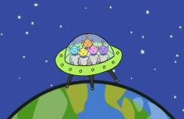  Sing – Five little men in a flying saucer  https://www.youtube.com/watch?v=2E3p_51tJx0  Preschool Challenge:  Say how many are left each time a man flies away? Can you say 1 less than a number to 5? E.g. 1 less that 5 is 4, 1 less than 4 is 3 etc.  Write the numbers 5,4,3,2,1,0 |  | Listen to stories with increasing attention and recall.  All children  Enjoy the story below – The Dinosaur that Pooped a Planet.  https://www.youtube.com/watch?v=hJLWmegE_CE  Preschool Challenge:  Danny forgets to take his lunch for himself and dinosaur. Can you name 3 healthy things you would take in your packed lunch?  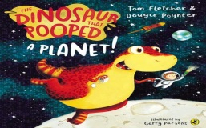  You could draw them. Can a grownup guess what they are?
Weekly Phonic Task |  | Weekly mark making/writing Task
Letters and Sounds  All children  Play Guess the Sound – What unusual sounds can you hear?  https://www.youtube.com/watch?v=v1wZskCJJDg  Preschool children  We are learning to recognise the sounds n and p. Watch Geraldine the Giraffe explain the n and p sound.  Name 3 objects that start with n and p.  n  https://www.youtube.com/watch?v=IQsCAyq-axU  p  https://www.youtube.com/watch?v=q0akp_j1nbcv=0gi8OBhl11U |  | Mark make for a purpose  All children  Design your own space rocket and get ready for count down!  Preschool children  ‘Write’ a list of special items you would take into space or things you might see in space.  Make marks to show your list. Grownups, ask your child to ‘read’ their marks back to you. Can they remember what they ‘wrote’?  Ask them to try to hear the sound at the start of their words, e.g. can they hear the rrrrr sound at the start of rocket? Write r to show them what it looks like.  Remember to tell them their ‘writing’ is really good and give lots of praise.
Weekly Learning Task |  | Useful Websites
Understanding the world  Expressive arts and design  All Children:  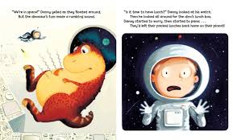  Gather things from around your house to make your own rocket. Tubes, cups, cereal boxes and think about the shapes you want to create. Remember to check with a grownup first.  Act out a story with your rocket. |  | - Cbbies.co.uk  - Flashacademy.co.uk  - Topmarks.co.uk  - Ictgames.co.uk  - http://www.letters-and-sounds.com/phase-1.html  - Purplemash.co.uk  - Oxfordowls.co.uk
There will also be a daily activity for you to complete on our school Facebook page. There are also regular updates on here too!

