**Year 1**

English

The children will be progressing on their phonics journey and will continue to learn 1 and 2 sounds.

**Set 1:** m, a, s, d, t, I, n, p, g, o, c, k, u, b, f, e, l, h, sh, r, j, v, y, w, th, z, ch, qu,x, ng and ng.

**Set 2:** igh, ow, oo, oo, ar, or, air, oy, ir, ay, ou, ng and ee.

**Set 3:** ea, oi, a-e, i-e, o-e, u-e, aw, are, ur, er, ow, ai, oa, ew, ire, ear, ure, tion, tious/cious

**Writing:**

All children will be building and holding sentences based upon what they have read. Our story that we are basing our writing upon is ‘Little Red Riding Hood’. We will continue to work upon the use of using capital letters, fingers spaces and full stops. In addition to this, we will be using adjectives, nouns, question marks and exclamation marks. We will practise our handwriting daily using correct letter formation.

**Reading:**

In our reading sessions, the children will reading, be listening to and discussing some of the following stories (there are more!): How to Catch a Star, The Way Back Home and Lost and Found.

Maths

**Multiplication and division**. The children will be learning how to make equal groups by grouping and sorting. The children will also make doubles, arrays, equal groups and adding equal groups.

**Fractions.** Whilst learning about fractions the children will be both finding and making a half, whole and a quarter of objects.

**Position and directions.** The children will be learning what a turn is and how to describe the turn that they have made, including what position they are in. They will be using language such as: North, South, East and West.

**Summer 1**

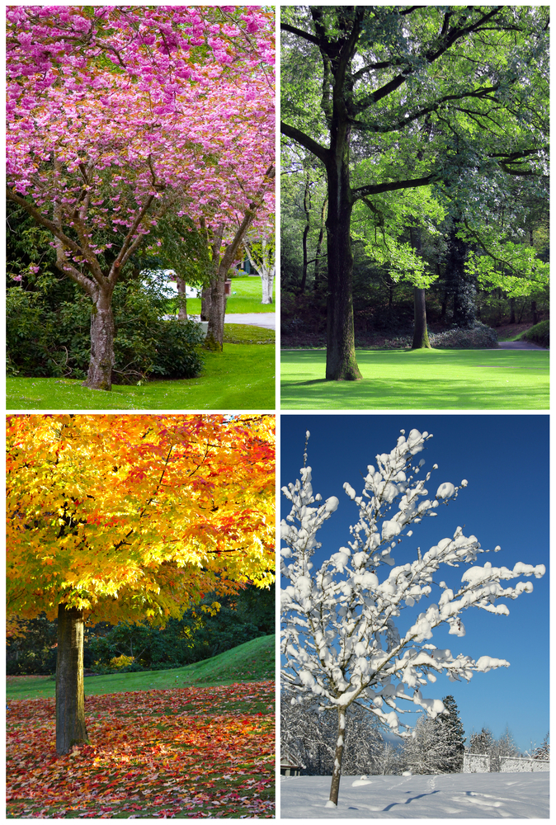

Science

Seasonal changes

How do we know it is summer or spring?

Children will look at how the day length varies from spring to summer. We will observe and describe the weather, and how to recognise the signs of summer. To conclude the unit, we will talk about how to stay safe in the sun – if we ever see any!

To end this term our question will be: **Are all materials the same?**

The children will be identifying and naming variety of everyday materials, including wood, plastic, glass, metal, water, and rock. We shall then begin to distinguish between an object and the material from which it is made. The materials will be looked at closely and we shall begin to describe the simple physical properties them. To end the unit, we’ll compare and group together everyday materials on the basis of their simple physical properties

Computing

This term we shall be focussing on coding and attempting to make a space programme! We will talk about what algorithms are and how they are used on digital devices. The children will create and debug simple programs, use logical reasoning to predict the behaviour of simple programs.

Art Our unit title is: Craft and design: Embellishments. During this unit of work the children look and identify the key features of Cecilia Vicuña’s work which included knots, plaits and weaving. They will weave with paper, alternating strips and making patterns. The children will be able to describe their own weaving and compare it to Vicuna’s work. Finally, they children will wave with fabric.

Music

In Music, the children will be singing with accuracy and expression (songs linked to Red Riding Hood), learning the difference between beat and rhythm and reading simple notation.

RE

**What does it mean to belong to a faith community?** The children will be discussing what a community is and what community groups the children could belong to such as: Cubs, Rainbows and sports clubs.

PSHE

During PSHE lessons we will be discussing the importance of money. This will include the borrowing of money. The children will be talking about people /family who are special to them and how we are kind and show kindness to all.

PE

**Invasion games**, the children learning how to throw and receive both bounce and chest passes with improved accuracy. They shall also be dribbling balls with one hand and using their finger to push a ball down.

**Dance –Minibeasts**

Moving to music in a variety of mini beast styles such as butterflies, worms and caterpillars.

**Spring Summer**