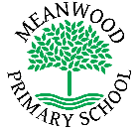 | Home Learning Task  Year 1
Week beginning 6th July 2020
Try to complete 3-4 tasks a day
Weekly Maths Tasks |  | Weekly Reading Tasks
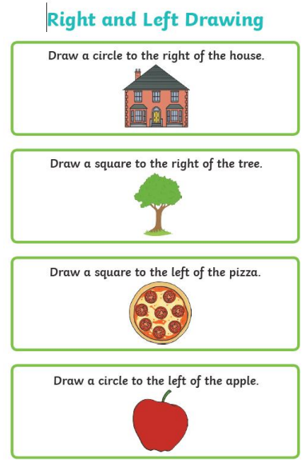 |  | 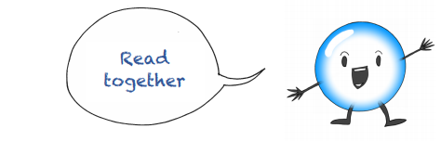  Listen to the story ‘Bob, the bubble who wanted to be useful’ by clicking on this link:  https://soundcloud.com/talkforwriting/bob/s-r4f63gDrqYb  - Talk together about the story  - Answer the questions:  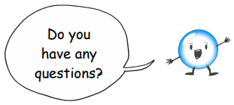  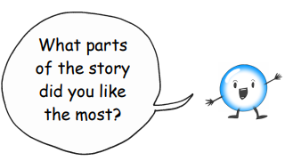  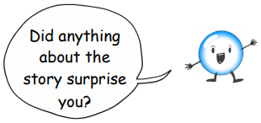
Weekly Spelling Tasks |  | Weekly Writing Tasks
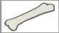  Practise writing these spellings. Remember to look, say, cover, write and check!  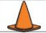  Split digraph o-e  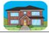  bone  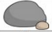  cone  home  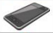  stone  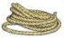  phone  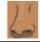  rope  nose  Challenge - Can you write each of these words in a sentence? |  | 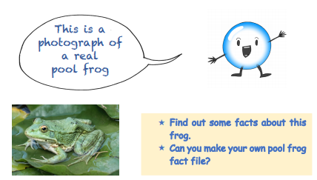  Write about what they eat, where they live and any other interesting facts that you find out!
Weekly Learning Tasks |  | Useful Websites
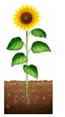  Science – Plants  Draw and label a sunflower.  Can you use the words below when you are labelling?  stem, roots, leaf, flower, petals |  | Writing/Science:  Science4fun.info  www.dkfindout.com  kids.kiddle.co/plant  www.scienceforkidsclub.com  www.itsybitsyfun.com  www.nationalgeographic.com
There will also be a daily activity for you to complete on our school Facebook page. There are also regular updates on here too!

