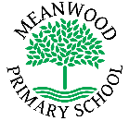 | Home Learning Task  Year 1
Week beginning 13th July 2020
Try to complete 3-4 tasks a day
Weekly Maths Tasks |  | Weekly Reading Tasks
Can you name each of these shapes?  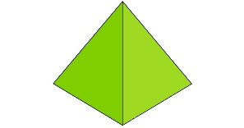  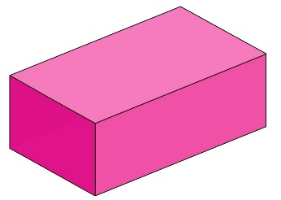 |  | Read chapter one of the ‘Tale of a Singing Zebra’ here: https://www.roythezebra.com/guided-reading-stories/chapter1.html#/section0  Think about these questions and talk about them with a grown-up:  1. Where does Roy live?  2. Do you think it is much fun at the zoo?  3. What is Roy not allowed to do at the zoo?  4. Who does Roy miss?  5. Who lives next door to Roy?  6. What does Lucy love to do?  7. Look at the picture from the story. What are Roy and Lucy dreaming about?  8. How do you think they feel in the picture?  9. Who meets Roy at the end of part 1?
Weekly Spelling Tasks |  | Weekly Writing Tasks
Practise writing these spellings. Remember to look, say, cover, write and check!  Split digraph a-e  cake  cave  gave  gate  grapes  safe  made  make  Challenge - Can you write each of these words in a sentence? |  | What do you think might happen next in the ‘Tale of a singing Zebra’?  Write 3 sentences about what you think might happen next.  Write 3 sentences about what could make the zoo more fun for Roy and Lucy.  Don’t forget to use finger spaces, capital letters and full stops!
Weekly Learning Tasks |  | Useful Websites
Art  There are lots of animals at the zoo with Roy and Lucy. Can you draw 5 different animals that you think might be at the zoo too?  Science Challenge – What do the animals that you have drawn eat? Are they carnivores, herbivores or omnivores? |  | Reading  https://www.oxfordowl.co.uk/for-home/find-a-book/library-page/  All Subjects  https://www.bbc.co.uk/bitesize/levels/z3g4d2p  Games/puzzles/quizzes  https://www.bbc.co.uk/cbeebies/puzzles
There will also be a daily activity for you to complete on our school Facebook page. There are also regular updates on here too!

