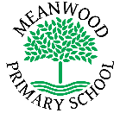 | Home Learning Task  Year 1
Week beginning 18th May 2020
Try to complete 3-4 tasks a day
Weekly Maths Tasks |  | Weekly Reading Tasks
Draw a picture for each month of the year and write the name of the month:  January  February  March  April  May  June  July  August  September  October  November  December |  | 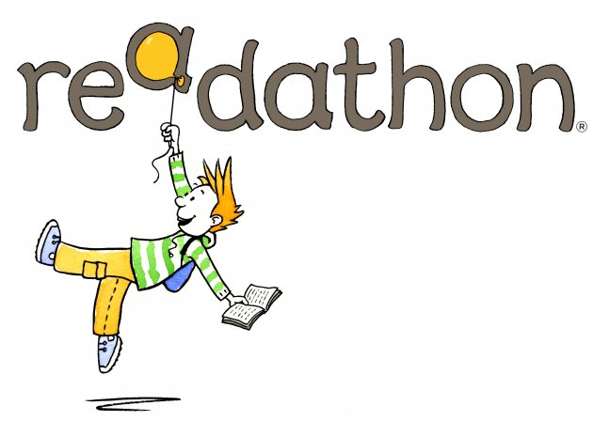  Why not have a ‘Readathon’ at home this week?  How many different books can you read in a week?  Write the names of all the books that you have read.  Write a sentence about your favourite book.
Weekly Spelling Tasks |  | Weekly Writing Tasks
Practise writing these spellings. Remember to look, say, cover, write and check!  book  took  good  wood  before  core  more  wore  score  shore  Challenge - Can you write each of these words in a sentence? |  | 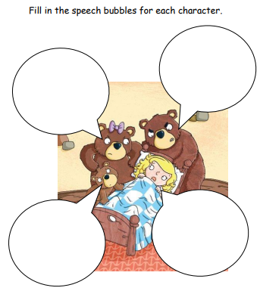
Weekly Learning Tasks |  | Useful Websites
Music  Why don’t you try some clapping notation?  https://www.youtube.com/watch?v=Wk43IDUQmTk  Try learning the song ‘Che che koolay’ and perform it to your friends and family! You could even video yourself and send it to the school’s email address.  https://www.youtube.com/watch?v=hIdp_Nj0tgk |  | Maths with Carol Vorderman https://www.themathsfactor.com/ (A range of fun maths activities for all ages)  iChild http://www.ichild.co.uk/ (A range of fun resources for all ages
There will also be a daily activity for you to complete on our school Facebook page. There are also regular updates on here too!

