Home Learning Task
Year Reception
Week beginning 6th July 2020
Try to complete 3-4 tasks a day
Weekly Maths Tasks |  | Weekly Reading Tasks
- Use 5 real coins and separate them into 2 piles. How many different ways can you sort them? (5+0, 1+4, 2+3)  - Solve this number problem:  Miss Johnson has 4 gold coins and Mrs Booth has 7. How many do they have altogether?  - Follow the link below to ways of making. Try making different numbers.  https://www.topmarks.co.uk/Flash.aspx?f=WaystoMake |  | - Below is a link to the story Pirates Love Underpants.  https://www.youtube.com/watch?v=Vd8_Y1bEzA8  _{What is the story about?}  - Now try reading My Granny is a Pirate.  https://www.youtube.com/watch?v=t8ZKIvRblpM  What is the story about?  Would you like to have a pirate in your family? Why?
Weekly Spelling Tasks |  | Weekly Writing Tasks
Learn these spellings. Use each word in a sentence and if you can write each one in a sentence.  that  this  them  then  with |  | - Draw and label a pirate treasure map.  - Draw and write a character description of a pirate. For example,  He has a black hat and a beard.
Weekly Learning Tasks |  | Useful Websites
- Can you make a pirate and his parrot?  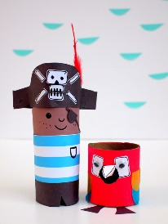  - Make your own treasure chest from an egg box.  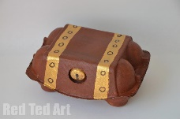 |  | Phonicsplay.co.uk  Topmarks.co.uk  Ictgames.co.uk  https://www.youtube.com/watch?v=aNcBWSBxSp0 (phase 3 sounds)
There will also be a daily activity for you to complete on our school Facebook page. There are also regular updates on here too!

