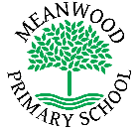 | Home Learning Task  Year Reception
Week beginning 13th July 2020
Try to complete 3-4 tasks a day
Weekly Maths Tasks |  | Weekly Reading Tasks
- Collect some different sized containers from around your home like cups, bowls, bottles etc. Put some water into them and discuss which ones are empty, nearly empty, half full, nearly full and full. Which container will hold the most water? Estimate then check.  - Solve this number problem:  Miss Johnson has 2 sandwiches and Mrs Booth has 4. How many do they have altogether?  - Follow the link below to order the capacity of the coconuts.  https://www.topmarks.co.uk/ordering-and-sequencing/coconut-ordering |  | - Below is a link to the story The Lighthouse Keeper’s Lunch  https://www.youtube.com/watch?v=46wCRq50Wwg  What is the story about? Try some of the Lighthouse Keeper’s stories on YouTube. Which is your favourite? Why?  - _{Now try reading Billy’s Bucket}  https://www.youtube.com/watch?v=h46WN31pIRk  What is the story about?  If you had a bucket like Billy, what would you see inside?
Weekly Spelling Tasks |  | Weekly Writing Tasks
Learn these spellings. Use each word in a sentence and if you can write each one in a sentence.  now  down  for  look |  | - Write a postcard to a family member/friend. Tell them what you have been doing.  - Design a menu for a healthy lunch for Mr Grinling.  - Draw and label a picture of what you would see in your bucket.
Weekly Learning Tasks |  | Useful Websites
- Talk about holidays and days out with your family. What is your favourite memory of it? Where did you go? What did you do?  - Play the memory game with your family. I went on holiday and took …  - Make a boat using empty containers from around the house. Can it float?  - Make your own lighthouse 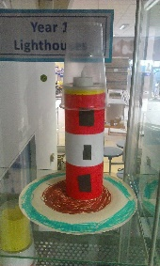 |  | Phonicsplay.co.uk  Topmarks.co.uk  Ictgames.co.uk  https://www.youtube.com/watch?v=aNcBWSBxSp0 (phase 3 sounds)
There will also be a daily activity for you to complete on our school Facebook page. There are also regular updates on here too!

