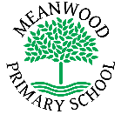 | Home Learning Task  Year 2
Week beginning 13th July 2020
Try to complete 3-4 tasks a day
Weekly Maths Tasks |  | Weekly Reading Tasks
Count to 100 from 1. Can you count backwards from 100 to 1?  Can you count in 2’s, 5’s and 10’s?  Can you write a list of odd numbers?  Can you find the missing numbers ? Remember to use the part, part, whole method to help you. Where will the biggest number appear in the model?  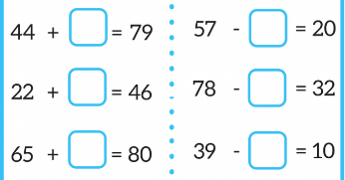  Click on this link. Try this weeks whiterose learning task.  https://whiterosemaths.com/homelearning/year-2/ |  | http://www.ictgames.com/hybrid.html  Chose a sound. Can you read the words and then find them in the wordsearch. Don’t forget to show Dj cow your best dancing moves!  Don’t forget BBC bite size daily reading club.  https://www.bbc.co.uk/bitesize/articles/z8q83j6  Can you complete the activities based on the story?  Have a look daily and see how the stories change.  Which will become your faviourite?  Can you read more stories this week than last week?  You could continue to challenge yourself weekly throughout the summer. I wonder how many books you will have read by September.
Weekly Spelling Tasks |  | Weekly Writing Tasks
Learn these spellings. Can you write a sentence including some of these words?  Contraction words;  can’t, didn’t, hasn’t, couldn’t, it’s, I’ll, I’m  we’ll, they’re, don’t, won’t, haven’t, wasn’t, they’ve,  we’ve, doesn’t, we’re  Can you write these words in full? E.g. can’t = cannot  Words ending tion;  station, fiction, motion, national, section, action addition, fiction, fraction, question, relflection |  | 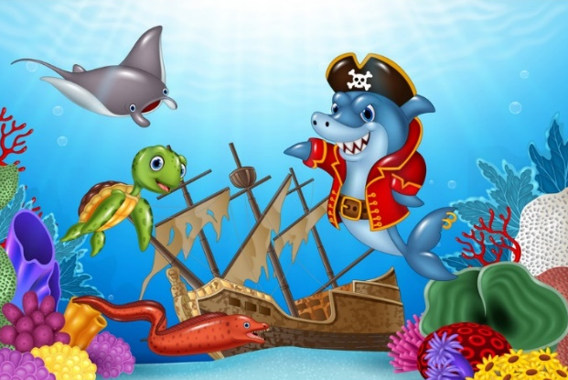  Look carefully at the picture. What is happening? Using this picture, write a story. Who is going to be the main character? Set the scene, where are they? What went wrong? Who is going to save the day? Where will they all be at the end of the story?
Weekly Learning Tasks |  | Useful Websites
Get active – Try BBC Supermovers.  https://www.bbc.co.uk/teach/supermovers/ks1-pshe-believe-with-naomi-wilkinson/zjchd6f  There are many more titles for you to dance and sing along to.  Have a look at David Attenborough on BBCbitesize. He is talking about the ocean.  https://www.bbc.co.uk/iplayer/episode/p08gd9j1/bitesize-57-year-olds-week-7-4-oceans-and-migration  Using what you learnt this week and last week, can you create an ocean fact file? You can write down your favourite facts and draw some ocean pictures too. |  | Phonicsplay  https://new.phonicsplay.co.uk/  Topmarks  https://www.topmarks.co.uk/  Ictgames  https://www.ictgames.com/  BBC Learning  https://www.bbc.co.uk/bitesize/primary  Purple mash  www.purplemash.com
There will also be a daily activity for you to complete on our school Facebook page. There are also regular updates on here too!

