Rapid Testing for Staff |  |  | Risk Rating including mitigations (Likelihood x Severity = Risk)
 |  |  | Likelihood | Severity |  | Risk
 |  |  | 5 | 1 |  | 5
Who might be at risk? | Risk Focus | How are you already controlling this risk? | Further mitigations / protective measure required? |  | Who needs to carry out the action? |  | When is the action needed by?
Staff | COVID-19 spreading in the school community | - Schools following government recommended control measures set out in the school’s protective measures risk assessment.  - At Meanwood Primary School, mass testing of staff will take place twice a week and staff will take these tests at home. These tests are to be taken 3-4 days apart.  - Tests to be taken at 5pm  - Staff results to be recorded on a staff register and recorded by the person online. This will support identifying staff with positive results for contact tracing and managing stock and distribution.  - Those with symptoms are also expected to order a test online or visit a test site to take a polymerase chain reaction (PCR) test to check if they have the virus. | - Ensure test is taken at 5pm on allocated day of choosing and may have to bring to work to complete  - Continue all other Covid risk assessment precautions whether talking part in testing or not including the use of PPE, social distancing and keeping in bubble groups |  | Staff |  | Ongoing
 | Regular communication to staff | - Information booklet given to staff including:  - what rapid testing is, about using the how to guide and the video content available  - the requirement for them to report their test results.  - the process and who to contact if they have an incident while testing at home.  - Covid Co-ordinator: Caroline Taylor  Covid Registration Assistant: Caroline Taylor  - Staff will need to sign for their test kits and the lot number will be recorded against their name. Staff will collect their first set of tests and instructions w/c 25/1/21 from the Mezz.  - A mask should be worn at all times when collecting and signing for tests | - Staff need to ensure that they check emails daily for updated guidance/changes |  | Staff |  | Ongoing
 | Tests to be stored correctly and collection managed in a safe way | - Tests to be kept securely in Mezz to prevent unauthorized access  - Not be stored outside. Stored in a cool, dry place. Test kits will be stored in a temperature between 2 and 30 degrees.  - The kits should be used at room temperature (15 to 30 degrees). If the kit has been stored in a cool area less than 15 degrees, leave it at normal room temperature for 30 minutes before using.  - Enough space for social distancing will be allowed when giving out tests.  - Tests will be allocated and lot number recorded and a form to sign will be made available. Those collecting their kit should:  - wear appropriate face covering at all times  - hand sanitise before collecting and signing  - maintain 2m from staff coming to collect their test | - Social distancing and keeping bubbles apart is essential to ensure no cross bubble contamination |  | All staff |  | Ongoing
 | Staff not reporting results | - Void, double void and positive results are communicated to the school once the test is completed.  - A negative result is to be sent to covid@meanwood.rochdale.sch.uk with date of birth and negative in subject line  - Staff must report their result online as per the instructions as soon as the test is completed either online or by telephone as per the instructions in the home test kit. | - Staff must continue to report positive and negative results if they are taking part in the testing |  | All staff |  | Ongoing
 | Low uptake on taking tests. | - Tests are optional and are not mandatory. Staff to opt in after they have read key information and privacy notice to understand data protection for testing.  - Staff are able to ask key questions about the testing by emailing Caroline Taylor or Helen Vyse | - Key information shared with staff in order for them to make an informed decision about testing |  | All staff |  | Ongoing
 | Swabs are taken incorrectly causing a false reading or cause contamination | - Schools following government control measures.  - Covid Coordinator has undertaken relevant training and informed staff of how to access the portal/training videos/documents prior to taking part in the community testing scheme.  - Instructions dated 15th January 2021 to be issued alongside the kits and staff informed that the old instructions which are contained in box must be recycled  - Test conducted on a dry, clean, flat surface.  - Hands washed or use sanitiser before taking the test.  - Online information, training and webinars available. Video available on how to take your own test.  - Information with the kits to be followed.  - Regular communication with staff about the testing process.  - If test is void, take another test. If 2 void results in a row, a PCR test should be taken.  - If a number of tests give a void result, unclear results or leaking/damaged tubes should be recorded and escalated to the DfE helpline.  - Covid Coordinator to be responsible for incident reporting on a school wide issue:  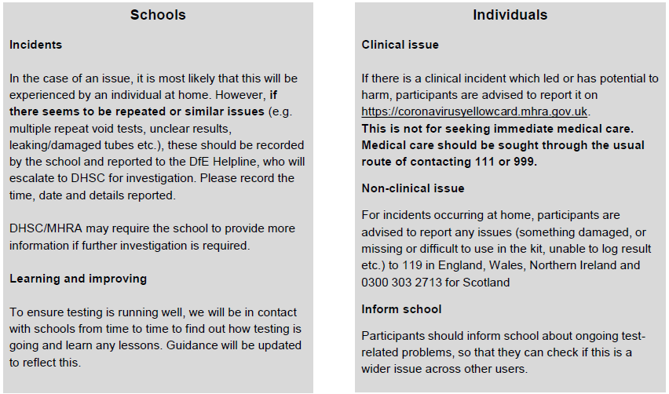 | - Option of visiting local ‘no symptom’ testing sites are open 8AM-7PM Monday to Friday and 10AM-4PM at weekend.  📍 Heywood Sports Village (drive-through facility also)  📍 Nye Bevan House, Rochdale  📍 Bowlee Sports Centre, Middleton  📍 Bowling Club, Hare Hill Park, Littleborough |  | All staff |  | Ongoing

