**Nursery**

**Summer 1**

L  
(Literacy)

Focus: Writing their name.

School: Now that the children can recognise their name we are going to practise writing it.

Home: Encourage your child to write their name or shopping lists. It doesn’t matter if it is nonsense; making marks is the early stage of writing.

PSED  
(Personal, Social and Emotional Development)

Focus: Talk about feelings - happy/sad.

School: We will be discussing feelings and being able to recognise other people’s feelings.

Home: When watching TV or reading a book with your child stop to look at people’s faces and discuss how they are feeling.

CAL  
(Communication and Language)

Focus: Expressing a point of view.

School: In Nursery we will be discussing what we like and do not like. We will learn to be respectful of other people’s choices.

Home: At home you could encourage your child to express their opinion and listen to other people’s.

PD

(Physical Development)

Focus: Developing gross motor skills.

School: We will be using lots of tools and equipment indoors and outdoors to build up our muscles in preparation for learning to write.

Home: Digging in the garden / washing a bike or car can help build these muscles.

M

(Mathematics)

Focus: Sequencing – Days of the week,

School: We are learning the days of the week and discussing, yesterday, today and tomorrow,

Home: Talk about the difference between week days and the weekend. Make plans and count down to that day.

UW   
(Understanding the World)

Focus: Plants and life cycles.

School: In Nursery we will be growing beanstalks and keeping a growth diary.

Home: Watch the plants in your garden or on your walk to school. Can you spot signs of spring? Buds opening, plants growing.

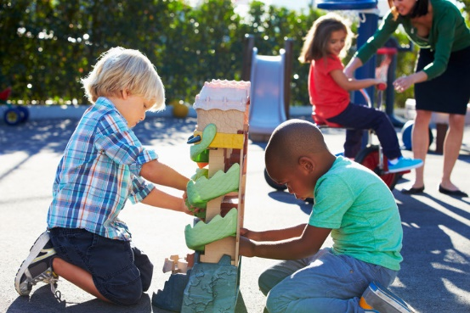

EAD

(Expressive Arts and Design)

Focus: Using our voices for effect.

School: We are learning to change a voice to show we are happy/sad, loud/quiet, big/small.

Home: Use different voices when reading with your child, encourage them to join in.

General

We are blossoming in Nursery and we are going to spend the next term getting ready to move to full days in Reception class. Please encourage your child’s independence by allowing them to carry their own bag and put their coat on and off.