**Nursery**

**Summer 2**

L  
(Literacy)

Focus: Developing phonological awareness.

School: We are starting our phonics lessons and are learning the sounds that letters make.

Home: Playing eye spy is a great way to teach children the initial sounds at the start of words.

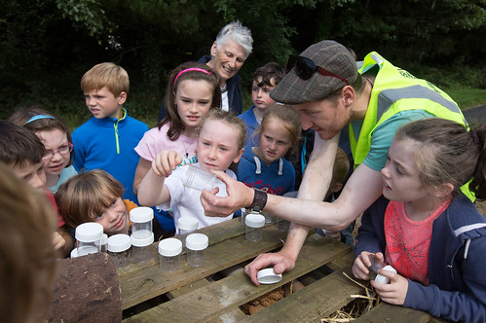

M

(Mathematics)

Focus: Talk about and identify patterns.

School: We are exploring animal prints and patterns and discussing camouflage.

Home: Look for patterns on clothes or furnishings at home. Discuss which are, stripey, dotty, spotty, camouflaged.

EAD

(Expressive Arts and Design)

Focus: Texture

School: We are exploring textures and fabrics and how things feel. Using different textiles to make pictures.

Home: Discuss how fabrics feel. Are they soft, scratchy, hard, thick, thin, waterproof?

UW   
(Understanding the World)

Focus: Respecting and caring for the environment and living things.

School: We will be creating a bug hotel in Nursery and learning to look after different animals.

Home: If you have a pet allow your child to help care for them. You could also talk to them about caring for insects and creatures that are in your garden.

PD

(Physical Development)

Focus: Using one handed tools.

School: We will be using tools to build up our muscles in preparation for learning to write. We are practicing ‘careful cutting’.

Home: Allow your child time to cut pictures out of magazines or chop up an old cereal box to put in the recycling,

CAL  
(Communication and Language)

Focus: Taking turns in a conversation.

School: In Nursery we will be encouraging the children to chat to each other and to be respectful of others by taking turns and listening.

Home: Encourage your child to chat by asking ‘why’ questions to keep the discussion going.

General

We are continuing to encourage your child’s independence in school; please support this by allowing them to carry their own bag and put their coat on and off. We love exploring outside; please ensure your child is ready for the changeable weather by applying sun cream and always sending a coat.

PSED  
(Personal, Social and Emotional Development)

Focus: Talk with others to resolve conflict.

School: We will be supporting the children to sort problems together rather than asking an adult for help.

Home: At home encourage your child to share or wait to use something so they do not just expect to have their turn immediately.