**Nursery**

**Spring 2**

PSED  
(Personal, Social and Emotional Development)

Focus: To keep safe.

School: We will be covering how to keep safe and who to talk to if you feel unsafe or concerned. We will learn about stranger danger.

Home: Make your child aware who to go to for help when they are out with you if they are lost.

UW   
(Understanding the World)

Focus: To observe nature and the seasons.

School: We will be looking for signs of spring around school. The leaves returning to the trees; more birds outside and the sunshine returning.

Home: Can you spot signs on your walk to school or the park? Can you see crocuses, daffodils or tulips starting to grow?

EAD

(Expressive Arts and Design)

Focus: To choose different textures and materials to make pictures.

School: We will be making art from different materials to explore texture.

Home: Try making a picture with things from the kitchen cupboard; rice, pasta etc.

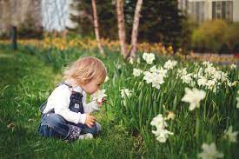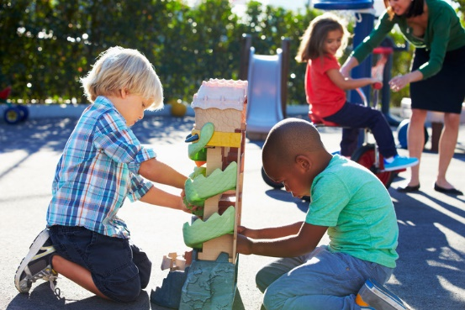

M

(Mathematics)

Focus: To make marks to represent numbers.

School: We will introduce numbers 1-5 and their formation. We will also show five lines or five dots could also represent the number 5 for example.

Home: Ask your child to show you how many on their fingers. How many cups do we have? How many yoghurts in the fridge?

L  
(Literacy)

Focus: To understand where a story is set, the events and the characters.

School: We will be identifying the main characters in stories and drawing story maps to sequence events.

Home: When reading; ask your child to retell the story and encourage them to sequence the main events. Talk about a character ask them to describe them.

PD

(Physical Development)

Focus: To keep our bodies health through exercise.

School: We will be exploring how to keep healthy by exercising and having a balanced diet.

Home: Now the days are lighter and hopefully drier you could walk to school more often to increase your exercise.

CAL  
(Communication and Language)

Focus: To spot or make up alliterations.

School: We will be sharing stories that contain alliterations and in circle time we will encourage the children to make them up.

Home: Encourage your child to make alliterations for example, Silly Sausage or Daring Dave. This helps them to hear the initial sounds in words to prepare them for learning to read.

General

Please promote independence in your child by toilet training and teaching them to put their own coats on. Children thrive by being given responsibility for their belongings allow them to pack and carry their own bag, talk about what they need to bring to Nursery depending on the weather.