**Nursery**

**Spring 1**

PSED  
(Personal, Social and Emotional Development)

Focus: Friendships. What makes a good friend?

School: We will be discussing what makes a good friend and how we can make each other happy.

Home: Talk to your child about who their friends are. Maybe you can have a playdate in the afternoon.

UW   
(Understanding the World)

Focus: What is a map?

School: We will showing the children maps. We will be draw maps of the classroom and treasure maps.

Home: Can you draw a map with your child to show the route to a friend or family member’s house. Draw the landmarks you see along the way. Discuss left and right.

M

(Mathematics)

Focus: To explore shape.

School: We will be learning the names of basic shapes and then using shapes to construct with bricks or make pictures.

Home: Can you spot shapes around the house or on your walk to school? Ask your child how many sides or edges each shape has; count them together.

L  
(Literacy)

Focus: To listen for rhythm and rhyme in stories..

School: Adults will share stories with the children that have rhymes in them and draw attention to them.

Home: Can you be silly billies and make up rhymes together? What does your name rhyme with?

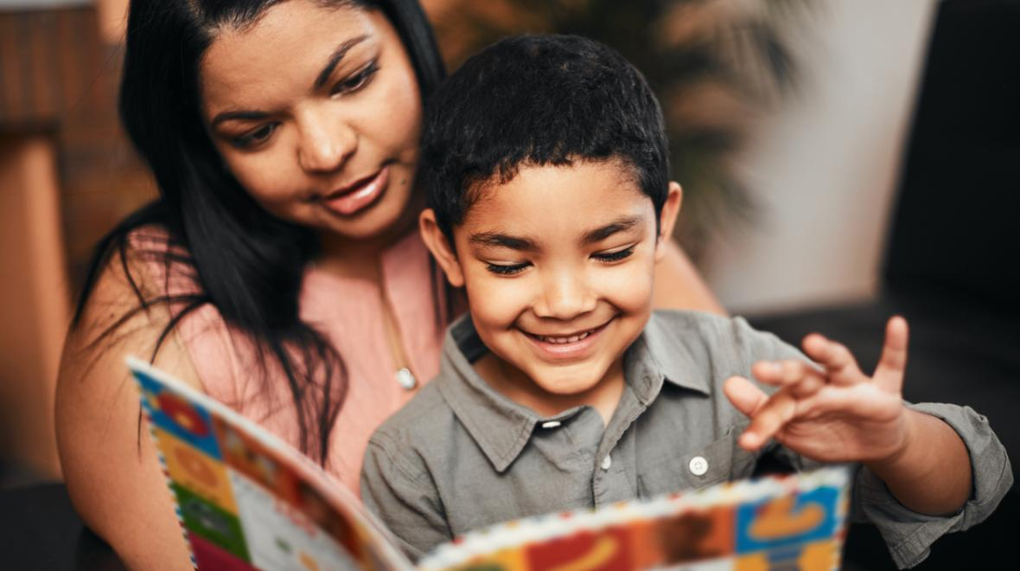

EAD

(Expressive Arts and Design)

Focus: To engage in body percussion.

School: We will be using our bodies to make sounds. We will be stomping, patting, clapping and snapping our fingers and feet.

Home: Have fun making noises with your hands and feet. Stomp like Elephants, clap the syllables in your name or snap your fingers to the music.

CAL  
(Communication and Language)

Focus: To be able to handle a book and recognise environmental print.

School: Share stories and model that we read a book from front to back and left to right. We will be drawing their attention to labels in the classroom

Home: Show your child the menu on the take away or the instructions in a cookbook etc. Explain that print gives instructions and information as well as stories.

General

We have some new children coming into nursery. Please encourage your child to make new friendships and welcome our new arrivals.

PD

(Physical Development)

Focus: To use one-handed tools and equipment

School: We are working on our gross motor skills, we will be getting outdoors and digging in the ground. We might even get to dig snow!

Home: Help your child to strengthen their muscles by riding bicycles or carrying buckets when you wash the car.