**Nursery**

**Spring 1**

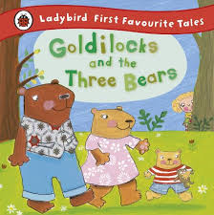 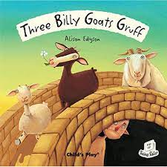

M

(Mathematics)

Focus: To carefully count objects, sounds, movements and pictures one at a time; to recognise 1, 2 and 3 in lots of different ways.

School: We will be doing lots of counting and identifying different ways of representing numbers.

Home: Go on a number hunt - how many different ways of showing a number can you find? Keep counting in everyday contexts.

EAD

(Expressive Arts and Design)

Focus: To appreciate, identify and recall simple rhythms and rhymes; to use mixed media to create pictures based on a story

School: We will be enjoying and joining in with songs and stories using lots of rhythm and rhyme; we will be creating class art works about our stories using different media

Home: Sing lots of Nursery rhymes; have fun making up funny rhymes for things, eg. cheese please Louise! A coat for a goat!

L  
(Literacy)

Focus: To join in repeated phrases from stories; to orientate a book.

School: We will be sharing books, finding the title, front and back cover; we will be joining in with repeated phrases from familiar stories

Home: Encourage your child to handle books the right way up, starting at the ‘front’; reread familiar favourite stories often and encourage them to join in.

PD

(Physical Development)

Focus: To put coats, jumpers, shoes and boots on and off; to make lines, circles and arches over and under.

School: We will be practising changing jumpers, shoes and boots and fastening zips; we will be drawing pictures like settings or characters from stories, using lines, circles and arches.

Home: Encourage your child to be more independent about getting dressed and undressed; provide paper and pencils for drawing pictures.

PSED  
(Personal, Social and Emotional Development)

Focus: To be kind and know how to be a good friend

School: We will be discussing what makes a good friend and how we can make each other happy.

Home: Talk to your child about who their friends are; maybe you can have a playdate in the afternoon.

UW   
(Understanding the World)

Focus: To know some seasonal changes related to winter; to explore different materials

School: We will be learning all about the signs of winter; we will investigate the properties of snow, ice, mud, porridge and other materials.

Home: Go on a winter walk, especially if it snows! Build a snowman and make snow angels ☺

General

We have some new children coming into nursery. Please encourage your child to make new friendships and welcome our new arrivals.

CAL  
(Communication and Language)

Focus: To answer who, what and where questions; to retell simple events.

School: We will be talking about things that have happened at home, at Nursery and in stories, and answering questions.

Home: Chat about your day; ask questions about what has happened at Nursery; ask who, what and where questions about stories.