**Nursery**

**Spring 2**

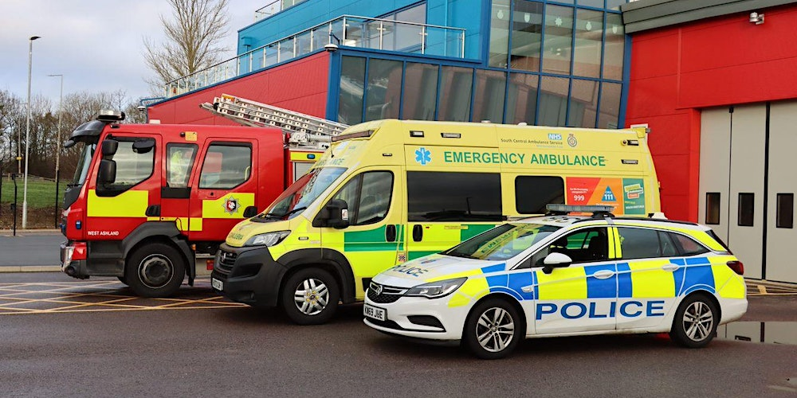

UW   
(Understanding the World)

Focus: To know people who help us.

School: We will be learning about people who help us, such as doctors, nurses, police and fire fighters.

Home: Point out these important people when you see them, and talk about what they do.

L  
(Literacy)

Focus: To listen to longer stories and remember what happens. To know that writing carries the meaning.

School: We will be reading stories and talking about what happened. We will be learning to recognise the ‘words’ and the ‘pictures’ and find where the writing starts.

Home: When reading; ask your child to retell the story and encourage them to sequence the main events. Track your finger underneath the words when you read, so that your child sees that you are reading.

M

(Mathematics)

Focus: To recognise numbers in lots of different ways.

School: We will introduce numbers 1-4 and see how many ways we can spot them – on a dice, as a numeral, as a pair of shoes, for example.

Home: Look for numbers EVERYWHERE when you are out and about, on buses, on doorways, the number of eggs in a carton, pairing two socks together, and so on.

EAD

(Expressive Arts and Design)

Focus: To make junk models.

School: We will be making model emergency vehicles from different materials.

Home: Try collecting junk such as yoghurt pots, cardboard boxes and tubes and see what you can make!

CAL  
(Communication and Language)

Focus: To describe events that have already happened. To answer who, what, where questions.

School: We will be talking about what has happened in stories, at Nursery and at home.

Home: Talk about what your child has done that day at Nursery and at home.

PSED  
(Personal, Social and Emotional Development)

Focus: To keep safe.

School: We will be learning how to keep safe and who to talk to if you feel unsafe or concerned. We will be learning about stranger danger, and the importance of keeping away from hot things.

Home: Talk to your child about keeping away from fires or the cooker. Make sure they stay close to you when you are out and about.

General

Please promote independence in your child by toilet training and teaching them to put their own coats on. Children thrive by being given responsibility for their belongings. Allow them to pack and carry their own bag, talk about what they need to bring to Nursery depending on the weather.

PD

(Physical Development)

Focus: To keep our bodies healthy.

School: We will be learning how to keep healthy by good food, fresh air, exercise and hygiene.

Home: Follow good hygiene routines such as hand washing and brushing teeth. You could also walk to school more often or go to the park, to increase your exercise.