**Nursery**

**Spring 2**

General

Hopefully we will be having some visits from the emergency services, so that is something to look forward to!

Please continue to share a bedtime story every night.

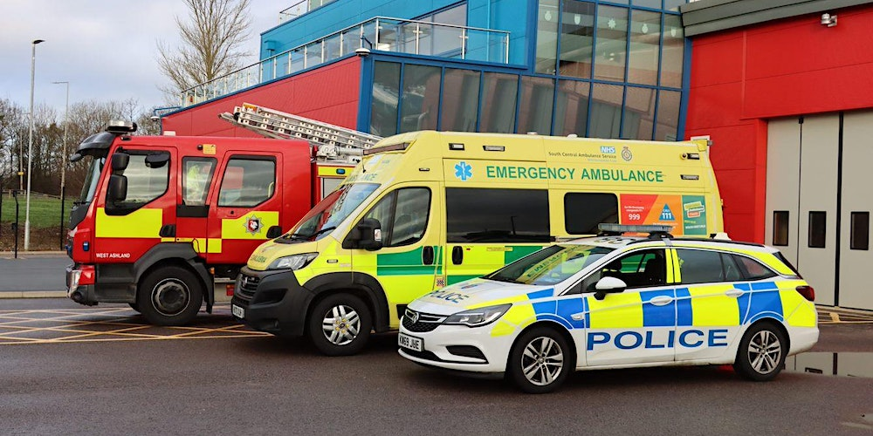

EAD

(Expressive Arts and Design)

Focus: To make junk models. To keep a simple beat using our bodies.

School: We will be making model emergency vehicles from different materials. We will continue our weekly music sessions

Home: Try collecting junk such as yoghurt pots, cardboard boxes and tubes and see what you can make!

PD

(Physical Development)

Focus: To climb and use stairs one foot at a time; to make more pre letter shapes using our pencil skills

School: We will be playing games and activities to practice climbing and using stairs. We will be practicing making dots, diagonals and horizontal lines.

Home: Take your child out to the local playground and support them to use the climbing equipment.

L  
(Literacy)

Focus: To listen for, hear and say sounds at the beginning of words; to differentiate words and pictures and know that the words tell us what to say.

School: We will be playing alliteration games. We will be finding the ‘words’ and ‘pictures’ in books.

Home: Ask your child to find the words and pictures in books. Track your finger underneath the words when you read, so that your child sees that you are reading.

UW   
(Understanding the World)

Focus: To identify people in the community - doctors, nurses, police and fire fighters

School: We will be learning about people who help us, such as doctors, nurses, police and fire fighters.

Home: Point out these important people when you see them, and talk about what they do.

M

(Mathematics)

Focus: To count and recognise numbers to 6 in lots of different ways.

School: We will continue learning about and finding numbers represented in lots of different ways. We will be carefully counting different groups of objects and saying how many.

Home: Look for numbers EVERYWHERE when you are out and about, on buses, on doorways, the number of eggs in a carton, pairing two socks together, and so on.

PSED  
(Personal, Social and Emotional Development)

Focus: To know how to stay healthy and safe

School: We will be learning how to keep safe and who to talk to if you feel unsafe or concerned. We will be learning about stranger danger, and the importance of keeping away from hot things.

Home: Talk to your child about keeping away from fires or the cooker. Make sure they stay close to you when you are out and about.

CAL  
(Communication and Language)

Focus: To develop vocabulary for People Who Help Us.

School: We will be talking about the fire, police and ambulance services and learning to recognise them.

Home: Get books and stories about the emergency services from the library and share them with your child.