**Nursery**

**Summer 1**

General

We are blossoming in Nursery and we are going to spend the next term getting ready to move to full days in Reception class. Please encourage your child’s independence by allowing them to carry their own bag, put their coat on and off, go to the toilet and wash their hands independently.

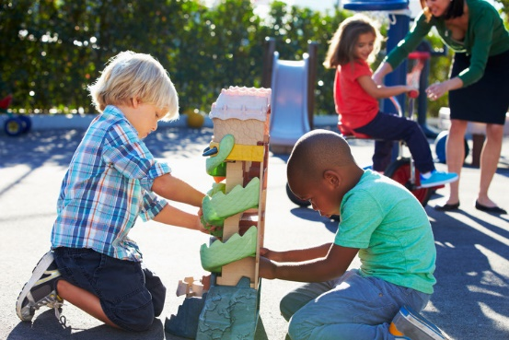

M

(Mathematics)

Focus: Recognising and counting numbers up to 6 in lots of different ways.

School: We will be spotting finger numbers, numerals, groups of objects, a number of sounds, dice patterns…

Home: See what numbers you can spot while you are out and about. Play games using a dice.

L  
(Literacy)

Focus: Knowing that the words in a book tell us what to say. Doing some pretend writing. Listening, hearing and saying the first sound in words.

School: We will be finding the ‘words’ and the ‘pictures’; showing how we can write something and read it back later on; making lists and labels together.

Home: Track your finger under the words as you are reading a story. Encourage ‘pretend writing’. It doesn’t matter if it is nonsense – pretend writing is the early stage of writing later on.

PD

(Physical Development)

Focus: To jump, balance, and hold a pose. To draw circles, dots, lines, zig zags and spirals.

School: We will be doing obstacle courses outside, and playing games like musical statues. We will making and drawing patterns.

Home: You could visit your local playground as often as possible. Encourage lots of mark making.

EAD

(Expressive Arts and Design)

Focus: Sculpture – making models using malleable materials. Learning songs.

School: We will be rolling playdough, plastecine and clay into minibeast shapes, like worms and spiders. We will also be learning a long song.

Home: Try making some home made playdough. It is very easy and there are lots of recipes on the internet. Sing lots of favourite songs.

UW   
(Understanding the World)

Focus: Local garden plants and minibeasts.

School: In Nursery we will be tending the garden, going on minibeast hunts, and looking after our tadpoles and caterpillars.

Home: At home you could.work in the garden together or go on nature walks to the local park.

PSED  
(Personal, Social and Emotional Development)

Focus: To name and talk about feelings - happy/sad/ worried/ angry.

School: We will be discussing our feelings.

Home: Ask and talk about feelings whilst watching TV or reading a book.

CAL  
(Communication and Language)

Focus: To develop vocabulary for local garden nature and wildlife.

School: In Nursery we will be gardening and exploring nature outside, and learning words for trees, flowers, grass and different minibeasts.

Home: Talk about the plants and animals that you see whilst out and about.