Home Learning Task
Year Nursery
Week beginning 18th May 2020
Try to complete 2-3 tasks a day
Weekly Maths Tasks |  | Weekly Reading Tasks
Careful Counting Skills.  Do a number exercise challenge – 10 jumps, 5 hops, and 3 skips. Can you run on the spot as an adult counts to 20. Can you count to 10 as your grownup runs on the spot?  Think of some more actions that you can count. |  | Listening and understanding skills  - Listen to the podcast of Farmer Duck. You will need to switch your listening ears on for this!  https://www.bbc.co.uk/programmes/p08b09nn  - Answer these questions  - Who stayed in bed all day?  - What jobs did the animals have to do?  - How did the animals feel? – remember to use another word and not just sad (angry, annoyed, cross, upset)  - What does the farmer keep saying to the animals?  - Tell a grown up about your favourite part of the story?
Weekly Phonic Task |  | Weekly mark making/writing Task
Letters and Sounds – initial sounds  Grownups…remember to say the sound of the letters and not the name!  Play I-SPY with a grownup.  Think carefully about the first  sound in the word.  ‘I spy with my little eye  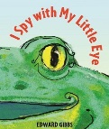  something beginning with……………….?’ |  | - Make your own story book – can you add some ‘writing’ to your story.  - Make a treasure map.  - Trace the letter sounds in your name https://www.thelearningapps.com/alphabet-tracing-game-for-kids/
Weekly Learning Tasks |  | Useful Websites
Do some junk modelling with empty boxes.  Make sure you ask a grown up first!  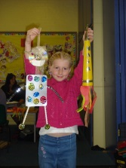 |  | - Cbbies.co.uk  - Topmarks.co.uk  - Ictgames.co.uk  - http://www.letters-and-sounds.com/phase-1.html
There will also be a daily activity for you to complete on our school Facebook page. There are also regular updates on here too!

