**Reception**

**Summer 2**

PD

(Physical Development)

Focus: Target games

School: We will show children how to collaborate in throwing, rolling, fetching and receiving games, encouraging children to play with one another once their skills are sufficient.

Home: Plan activities where children can practise moving in different ways and at different speeds, balancing, target throwing, rolling, kicking and catching.

L  
(Literacy)

Focus: To begin to write simple sentences independently.

School: We will be demonstrating writing so that children can see spelling and sentence structure in action. We will be demonstrating how to segment the sounds (phonemes) in simple words and how the sounds are represented by letters (graphemes). We will be creating opportunities for independent writing and also asking the children to write for a purpose e.g. sending postcards and creating descriptive ‘wanted’ posters for the pirates.

Home: Provide a range of opportunities to write for different purposes about things that interest them.

M

(Mathematics)

Focus: ‘Growing 6, 7, 8’, building 9 & 10.

School: Consolidating addition and subtraction within 10, number bonds to 10, 1 more and 1 less than to 10.

Home: Encourage children to count the things they see.

Talk about and use numbers to 10. Discuss how numbers are made up of smaller numbers. E.g. which two numbers make 6? Use everyday situations for addition and subtraction e.g. we are on the second stair, if we go up 3 more stairs what number stair will we be on?

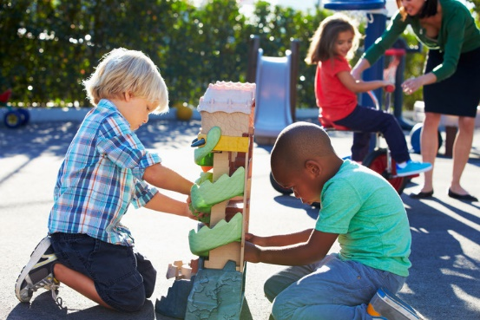

General

Finding out and exploring

•Showing curiosity about objects, events and people

•Using senses to explore the world around them

•Engaging in open-ended activity

•Showing particular interests

PSED  
(Personal, Social and Emotional Development)

Focus: Rules and responsibilities and becoming independent in preparation for Year 1.

School: We will be encouraging children to take responsibility for their own work, e.g. completing independent challenges. We will discuss changes and how it feels to be moving on to a new classroom and teacher.

Home: Discuss changes in a positive way and prepare for a new start and teacher in September.

UW   
(Understanding the World)

Focus: The world

School: We will look at different holiday destinations in the UK with a focus on Blackpool. We will compare this with Florida and Disney Land in the USA. We will talk about holiday long ago and compare them with today.

Home: Recall holidays and day trips. What did they do? Where did they go? Look at a world map to discuss similarities and differences between where we live and other countries.

EAD

(Expressive Arts and Design)

Focus: safely use and explore a variety of materials, tools and techniques, experimenting with colour, design.

School: Talk to children about ways of finding out what they can do with different media and what happens when they put different things together such as sand, paint and sawdust.

Home: Provide resources for mixing colours, joining things

together and combining materials, demonstrating

where appropriate.

CAL  
(Communication and Language)

Focus: Listen to stories, accurately anticipating key events and respond to what they hear with relevant comments.

School: We will read and discuss key stories and learn new knowledge which relate to theme e.g. pirate and under the sea stories. We will talk about our experiences of going on holiday. We will introduce new vocabulary that the children can use themselves.

Home: Make time for story time. Listen and give children opportunities both to speak and to listen.

Home: