**Reception**

Communication and Language

Focus: Develop vocabulary about themselves. Join in with stories.

School: We will be listening to stories and sitting for longer periods of time. We will join in with a group.

Home:: Make time to talk. Listen to what your child is saying and respond appropriately, extending their vocabulary and sentences.

PSED  
(Personal, Social and Emotional Development)

Focus: To recognise similarities and differences. To label emotions and practise calming strategies. To understand acts of kindness. To select resources and replace using visual support.

School: We will discuss class rules and make a display board. We will read stories which celebrate differences. We will talk about different feelings as we share ‘The Weather Inside Me!’ story.

Home: Talk about similarities and differences between themselves and others. Discus who your child is feeling. What can they do to calm down when they are overwhelmed?

UW   
(Understanding the World)

Focus: Know about different families and familiar people in the community e.g. shopkeeper, doctor. Know the place where we live is Rochdale. Know that in the past they were babies. Know about our bodies. Know people who are special.

School: Draw themselves and label body parts. Look at a skeleton and body representations. We will observe similarities and differences between each other and make an eye colour and hair colour tally.

Home: Name different body parts from your head to your eyes to your elbows. Look at pictures from when they were babies; what could they do? How have they changed?

EAD

(Expressive Arts and Design)

Focus: Know the shapes that form the features for a self-portrait. Know the primary colours. Move to a simple beat. Make sounds with instruments

School: We will create circles and lines using different mark making equipment and collage materials. We will make faces using different materials. We will draw a Self-portrait.

Home: Provide opportunities to draw, paint and created using different materials. Talk about the different colours they see around them.

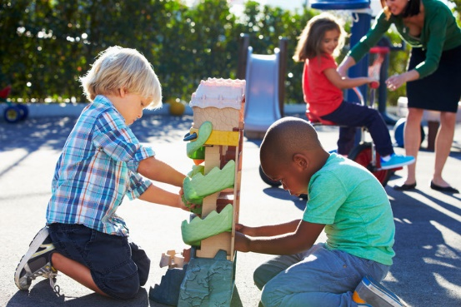

General

Stay and Plays – We will have stay and plays every half term. This half term’s date will be announced soon.

**Autumn 1**

Physical Development

Focus: Use one handed tools to make marks, cut and shape materials. Use an effective grip with fingers and thumb to hold a pencil. Manage clothing on and off – jumper, t-shirt, trousers,

dress and shoes.

School: We will be getting changed for P.E.

We will be providing a variety of resources in the fine motor

Area for all children to experience using.

Home: Encourage your child to dress themselves. Provide opportunities draw and colour pictures.

L  
(Literacy)

Focus: Learn our first sounds, make words with these sounds. Join in stories. Know the difference between words and pictures. Use marks, symbols and letters to represent words.

School: We will be drawing and labelling our family members, special people and people in our community. We will talk about how we have changed from being a baby and what we will be able to do as we grow older.

Home: Provide opportunities for drawing and mark making. Play blending games with simple, short words e.g. ‘I can see a c-a-t’ or ‘It’s time for b-e-d. Can your child work our what word you are saying? Spot letters and words as you walk to school.

M

(Mathematics)

Focus: Counting principles. Know all about numbers to 5.

School: Match objects and pictures and objects. Identify and sort sets and explore sorting techniques. Identify sets of 1, 2,3,4,5. Count representations of numbers 1,2,3,4,5

Home: Find opportunities for counting objects to 5. Match objects such as socks and cutlery.