**Reception Summer 1**

General

* Finding out and exploring

•Showing curiosity about objects, events and people

•Using senses to explore the world around them

•Engaging in open-ended activity

•Showing particular interests

M

(Mathematics)

Focus: Deep understanding of umbers to 10.

School: addition and subtraction within 10, number bonds to 10, 1 more and 1 less than to 10.

Home: Encourage children to count the things they see.

Talk about and use numbers to 10. Create opportunities for children to add and subtract e.g. ‘We need 5 plates for everyone at tea time. If I have 3 how many more will we need?’

PSED  
(Personal, Social and Emotional Development)

Focus: My healthy body

School: During our PSED lessons we will be encouraging children to be confident in speaking in a familiar group. We will be discussing self-care through the theme of healthy eating and exercise. We will be continuing with tooth brushing and reading social stories about looking after our bodies.

Home: Talk about healthy meal choices.

PD

(Physical Development)

Focus: Striking and Fielding Games 1

School: We will be showing children how to collaborate in throwing, rolling, fetching and receiving games. We will be encouraging children to play with one another once their skills are sufficient.

Home: Plan activities where children can practise moving in different ways and at different speeds, balancing and target throwing, rolling, kicking and catching.

EAD

(Expressive Arts and Design)

Focus: Designing and Making

School: We will discuss the meaning of the word design. We will show children how to use a variety of materials, tools and techniques when designing. We will talk about why vehicles are designed for their job e.g. tractors on the farm, fire truck for the fire service and rockets for space travel. We will also be building rockets on a small and large scale.

Home: Encourage children to draw and design at home using different materials. Talk about the design of different vehicles that they see outdoors e.g. the differences between motor bikes and motor cars.

UW   
(Understanding the World)

Focus: How things have changed over time (history)

How we travel around within our local area (geography)

School: We will be talking about past and present events. We will focus on transport and moving vehicles. We will be discussing how we move around on Earth and how we travel to space. We will be making maps and discussing our local area.

Home: Talk about different modes of transport. Discuss features of their immediate environment e.g. local shops and parks. Talk about how to get to familiar places e.g. ‘We turn left and the end of the street, then walk straight along the main road’. Look at the sky at night and discuss how it has changed from the daytime.

CAL  
(Communication and Language)

Focus: Listen to stories, accurately anticipating key events and respond to what they hear with relevant comments,

School: We will be sharing rhymes, reading books and stories from many cultures, and different genres. We will be orally retelling familiar stories. We will be discussing the notion of ‘Keeping Healthy’

Home: Make time for story time. Listen and give children opportunities both to speak and to listen. Encourage children to retell and act out familiar stories.

Home:

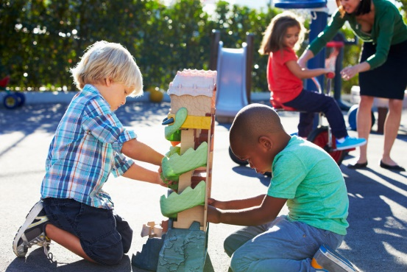

L  
(Literacy)

Focus: Write simple sentences that can be read by themselves and others.

School: We will be demonstrating writing so that children can see spelling in action. We will show how to segment the sounds in simple words and how the sounds are represented by letters. We will be asking children to read their own sentences to themselves and others.

Home: Provide a range of opportunities to write for different

purposes about things that interest them. Encourage children to use their phonic knowledge to sound out words for spelling. Ask children to read their writing.