**Reception**

**Autumn 1**

General

Finding out and exploring

Showing curiosity about objects, events and people

Using senses to explore the world around them

M

(Mathematics)

Focus: To match and sort, compare amounts and simple patterns.

School: We will learn to match and sort objects by colour or shape. We will compare amounts and understand more and fewer and to make a simple pattern with colours and objects.

Home: Encourage children to match socks at home or sort toys that are the same colour or size. Share out toys or food, who has the most and who has the fewest.

CAL  
(Communication and Language)

Focus: To enjoy listening to longer stories. To listen to simple instructions.

School: Children are read familiar stories and new ones. The children are given two step instructions, such as ‘get your coat and shoes’.

Home: Try every day to make time for a story and encourage them to discuss what has just been read.

PSED  
(Personal, Social and Emotional Development)

Focus: To make new friends and to follow new routines.

School: Children are encouraged to speak to new children and to join in play. Every day we use a timetable so the children know what is going to happen at different points of the school day.

Home: Talk about new friendships at home. Support your child in seeking out other children to play with, such as when you visit the park.

L  
(Literacy)

Focus: To recognise our names and begin to write them.

School: Children are encouraged to recognise names on pegs and to put them on the name tree every morning.

Home: Write down your child’s name and support them in forming the correct letters. This can be done in lots of different ways, for example chalk outside.

PD

(Physical Development)

Focus: To learn to dress and undress themselves.

School: We practice putting on coats and shoes independently. We will shortly begin PE, were children are encouraged to undress and dress independently.

Home: Support your child in putting on their own school uniform.

UW   
(Understanding the World)

Focus: To learn about different types of families and what a family is.

School: We will read a wide range of stories on different types of families and we will discuss who is in our family.

Home: Talk about who is in your family.

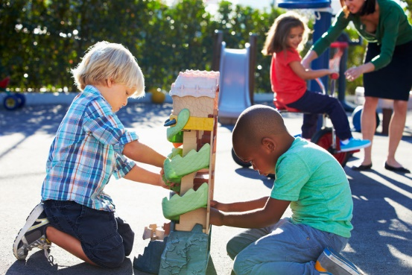

EAD

(Expressive Arts and Design)

Focus: Singing familiar and unfamiliar songs.

School: Every day we sing familiar nursery rhymes and introduce new ones to develop vocabulary.

Home: Make puppets with lollipop sticks and sing your child’s favourite song.