**Reception**

**Autumn 2**

CAL  
(Communication and Language)

Focus: Listen to and talk about selected non-fiction to develop a deep familiarity with new knowledge and vocabulary.

School: We will be reading and re-read books so children learn the language necessary articulate their understanding. Children will use new vocabulary in play and be able to answer questions using a short phrases or sentences.

Home: Read aloud books to children that will extend their knowledge of the world and illustrate a current topic.

UW   
(Understanding the World)

Focus: Note features of their own immediate environment and understand community heroes.

School: Explore the natural world around them. The children will have access to forest school activities. They will talk about changes in the environment as we move into winter. They will be able to talk about the lives of the people within their community who have significant roles.

Home: Provide children with have frequent opportunities for outdoor play and exploration.

PSED  
(Personal, Social and Emotional Development)

Focus: Relationships, Fairness, Bullying

School: Express their feelings and consider the feelings of others. Children will be listening to stories with a problem and the children will be encouraged to make suggestions as to how to solve the problems. They will be completing activities to show how to solve different problems.

Home: Congratulate children for their kindness to others and express your approval when they help.

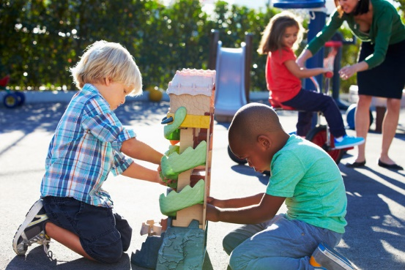

EAD

(Expressive Arts and Design)

Focus: Investigate different lines - thick, thin, wavy, straight.

School: Explore different materials freely, to develop their ideas about how to use them and what to make. Children will explore colour mixing, make firework pictures, and develop 3d model emergency vehicles, sing songs and rhymes relating to topic. Role play and re-enact known stories.

Home: Offer opportunities to explore scale. Suggestions: • long strips of wallpaper • child size boxes • different surfaces to work on e.g., paving, floor,

PD

(Physical Development)

Focus: Fundamental Movement Skills

School: Continue to develop movement – balancing, riding bikes and scooters, and ball skills. Children will learn to run safely and negotiate space, use tools to manipulate objects, be aware of other children, run an obstacle course and play games fairly.

Home: Provide children with regular opportunities to practise their movement skills alone and with others.

M

(Mathematics)

Focus: ‘ It’s Me 1,2,3’

School: Compare numbers. The children will be looking at how bigger numbers are made up of smaller numbers e.g. 3 is made up of 2 and 1, or 0 and 3, or 1 and 1 and 1. They will also look at circles and triangles and talk about positional language.

Home: Distribute items evenly, for example: “Put 3 in each bag,” or give the same number of pieces of fruit to each family member. Make deliberate mistakes to provoke discussion.

Place a favourite teddy in different places. Can the children explain where teddy is using positional language?

L  
(Literacy)

Focus: Writing clearly identifiable letters to communicate meaning.

School: Spell words by identifying the sounds and then write the sounds. Children will write words containing a consonant vowel consonant (cvc) e.g. rat, hut, dog, pig, leg. Children will be listening to fiction and nonfiction stories relating to our community heroes theme.

Home: Show children how to touch each finger as they say each sound.