**Reception Spring 1**

General

Encourage your child to speak in full sentences rather than single words.

Practise correctly forming the letters of the alphabet.

Recognising numbers 1 to 10 in and out of order.

PD

(Physical Development)

Focus: Object manipulation and development of muscle strength in upper body. To Increase fine motor skills.

School: We will be throwing and catching different P.E equipment of varying sizes. We will continue to strengthen fine motor skills by engaging in dough disco and handwriting activities.

Home: Play throwing and catching with smaller and larger balls to increase accuracy when catching. Play with playdough; squash, squeeze and press the dough.

Literacy

Focus: In a land far, far away – traditional stories

School: We will be reading and discussing traditional tales, making story maps, ordering events in stories, discussing characters and settings. We will be talking about plots: beginning, middle and end. We will be writing phrases and short sentences using capital letters, finger spaces and full stops.

Home: Read and enjoy different traditional stories. Retell traditional stories using beginning, middle and end.

M

(Mathematics)

Focus: Composition of numbers to 6. 1 more and 1 less.

School: We will be combining numbers to make other numbers. We will be saying 1more and 1 less that a number to 6.

Home: Look at different ways of making numbers. E.g. I have 4 cars, how many more do I need to make 5? Challenge your child to say and show you 1 more and one less than a given number to 6.

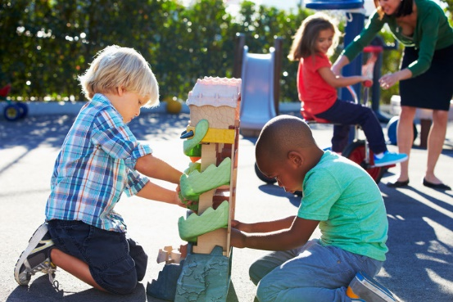

EAD

(Expressive Arts and Design)

Focus: Using different materials to design and make boats. Which is the best and why? Investigate floating and sinking.

School: We will be testing different materials to see which is best suited to make a boat for the ginger bread man to cross the river.

Home: Discuss what everyday objects are made of and why? E.g. can we have paper coats?

UTW   
(Understanding the World)

Focus: R:E – Chinese New year. Geography - Seasonal changes. History - Know about similarities and differences in relation to places, objects, materials and living things.

School: We will discuss why different people celebrate different things in different ways? We will identify and name different types of weather. We will compare how weather changes from season to season.

Home: Talk about the world around them as you go out and about on a walk. Talk about the weather each day. How is it changing?

Home:

PSED  
(Personal, Social and Emotional Development)

Focus: Healthy lifestyles. Looking after our bodies.

School: We will begin tooth brushing every afternoon. We will be following heathy recipes. We will be sorting different foods into healthy and not so healthy groups. During PSED lessons we will be discussing keeping safe.

Home: Talk about ways to keep healthy. Eat healthy foods. Make healthy dishes. Discuss the sequencing for tooth brushing. Go for walks and exercise.

CAL  
(Communication and Language)

Focus: To learn key vocabulary in relation to our traditional tales literacy topic and to use them in the correct context.

School: We will be Introducing new words and their meaning. We will encourage children to use them in a full sentence when answering questions.

Home: When reading give explanations to any words that the children may be unfamiliar with.