**Reception**

**Spring 2**

PD

(Physical Development)

Focus: Fine motor – to develop hand strength to manipulate pencils, pens and cutting equipment.

School: Handwriting practise and a variety of fine motor activities and using a knife and fork at lunch

Home: Encourage your child to write and draw freely. Be increasingly independent in cutting up food with a knife and fork.

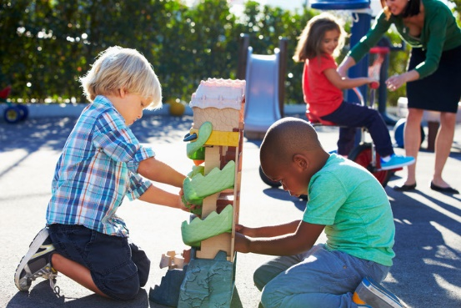

General

* Encourage children to speak in full clear sentences using words such as and, because and so.
* Encourage children to have a go at difficult tasks before helping, to develop independence.
* Join us for book share session, find out all about the Naughty Bus and the transport work we have been doing on Thursday 23rd March at 2:30.

EAD

(Expressive Arts and Design)

Focus: Designing and making objects that function.

School: Understanding the functions of different vehicles and the form needed to create them. Design and make a boat.

Home: Look at different vehicles and what they need to work – wheels, engines, ….

PSED  
(Personal, Social and Emotional Development)

Focus: To develop resilience and perseverance in the face of challenge.

School: To develop problem solving skills and how to stay calm in difficult situations.

Home: Discuss that failure is not a weakness but a sign that we are learning and developing.

L  
(Literacy)

Focus: Write 3 or more words separating them with finger spaces.

School: Write captions about vehicles and write words using phonic knowledge in labelling vehicles. Read and write non-fiction text types.

Home: Read their school book or ditty (on a sheet) 3 x a week. Bring book bags to school every day.

UW   
(Understanding the World)

Focus: To understand different forces.

School: Explore floating and sinking and the effects of pushes and pulls on objects.

Home: Explore forces around us, in the park, using toy vehicles at home, making ramps and floating and sinking in water play.

M

(Mathematics)

Focus: Addition facts within 6 to 10 and doubles/pairs 2, 4, 6, 8 and 10.

School: Securing and using addition facts to numbers 6 – 10 and applying them in spotting numerical patterns and solving problems.

Home: Encourage counting forwards and backwards within 10. Use everyday items to calculate different ways of making numbers to 10. E.g. I have 9 cars and you have 1, how many altogether?

CAL  
(Communication and Language)

Focus: Describe special events in detail.

School: Learning new vocabulary relating to spring and about different types of transport now and in the past.

Home: Encourage children to share new vocabulary learned at school when describing vehicles around them.