**Reception Summer 1**

M

(Mathematics)

Focus: Numbers beyond 10. Counting order beyond 10 and counting 10 and a bit. The location of 10 in 0-20.

School: We will look at number order, counting on a number track and numberline. Engaging in lots of oral counting. Looking at the pattern of 11, 12, 13, using ten frame and then with Numicon. Writing numbers on number lines 0-10 and 0-20.

Home: Encourage children to count the things they see.

Talk about and use numbers beyond 10. Create opportunities for children to count beyond 10.

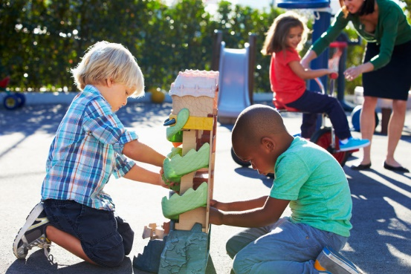

PSED

(Personal, Social and Emotional Development)

Focus: Solving Problems

School: During our PSED lessons we will talk about how we can negotiate and solve problems without aggression.

We will be working as part of a group or class and understand and follow rules. The children will talk about their own and others’ behaviour and its consequences.

Home: Talk about solving problems fairly and discuss rules that you may have in the home.

General

Finding out and exploring

Showing curiosity about objects, events and people

Using senses to explore the world around them

Engaging in open-ended activity

Showing particular interests

PD

(Physical Development)

Focus: Striking and Fielding Games 1

School: We will be showing children how to collaborate in throwing, rolling, fetching and receiving games. We will be encouraging children to play with one another once their skills are sufficient.

Home: Plan activities where children can practise moving in different ways and at different speeds, balancing and target throwing, rolling, kicking and catching.

UW   
(Understanding the World)

Focus: Know about living things and identify whether it is plant or animal. Know how animals change. (Farm animals – pigs/piglet, cow/calf, horse/foal, sheep/lamb, kitten/cat, dog/puppy and their babies). Know the signs of spring and compare it to previous seasons. Know how religions welcome babies.

School: We will draw maps of a story setting. We will be gardening – identifying plants and animals. We will be looking at signs of spring. We will visit a farm and recognise animals and their babies.

Home: Enjoy being out and about, looking for signs of spring – flowers growing, the weather changing. Talk about different animals and their babies.

EAD

(Expressive Arts and Design)

Focus: Shape malleable materials to achieve a planned effect. Identify features of their end product which successfully reflect the intended design. Tap out beats on percussion instruments.

School: We will be rolling legs and body shapes using plasticine and using tools to create texture. We will be looking at photos of farm animals and drawing them. We will make clay models of a farm animal.

Home: Encourage children to draw and design at home using different materials. Make playdough and practise rolling to create bodies and legs for an animal. Discuss the differences between different animals and draw them.

CAL  
(Communication and Language)

Focus: Listen to stories, accurately anticipating key events and respond to what they hear with relevant comments.

School: We will be retelling stories once the children have familiarity with the text, some with exact repetition and some in their own words.

We will be developing vocabulary about farm animals.

Home: Make time for story time. Listen and give children opportunities both to speak and to listen. Encourage children to retell and act out familiar stories. Discuss animals that you may see on the farm.

Home:

L  
(Literacy)

Focus: Know that stories have an ending. Retell simple stories using repetitive story language. Write a simple sentence to end a story.

School: We will read Jack and the Beanstalk, join in with repeated refrains. We will map the story.

Draw a retell of our visit to the farm. We will read The Odd Egg and engage in some independent writing and re-writing checking for finger spaces and phonic attempts at words.

Home: Provide a range of opportunities to write for different

purposes about things that interest them. Encourage children to use their phonic knowledge to sound out words for spelling. Ask children to read their writing.