Meanwood Primary School

RELATIONSHIPS EDUCATION POLICY

Next review date: January 2025
Document Control

Revision History

Revision date | Revised by | Previous version | Description of revision
January 2024 | G Sidell | n/a | Updated to reflect current practice

Document Approvals

This policy requires approval from: Full Governing Board

Approval date | Approved by

Document Distribution

This policy will be distributed to:
- All staff

Distributed to | How distributed | Date
Contents
1. Aims 4
2. Statutory requirements 4
3. Policy development 4
4. Definition 5
5. Curriculum 5
6. Delivery of Relationships Education 5
7. Roles and responsibilities 6
8. Parents’ right to withdraw 6
9. Training 6
10. Monitoring arrangements 7
Appendix 1: PSHE and RE Curriculum maps 8
Appendix 2: By the end of primary school pupils should know (statutory requirements) – Relationships Education and Science 9
Appendix 3: Parent form: withdrawal from sex education within Relationships Education 12

1. Aims
The aims of Relationships Education at our school are to:
- Provide a framework in which sensitive discussions can take place
- Prepare pupils for puberty, and give them an understanding of their bodies development and the importance of health and hygiene
- Help pupils develop feelings of self-respect, confidence and empathy
- Create a positive culture around issues of sexuality and relationships
- Teach pupils the correct vocabulary to describe themselves and their bodies
- To help our school community promote resilience, respect and honesty.

2. Statutory requirements
As a maintained primary school we must provide Relationships Education to all pupils as per section 34 of the Children and Social work act 2017.
We are not required to provide sex education but we do need to teach the elements of sex education contained in the science curriculum.
In teaching Relationships Education, we must have regard to guidance issued by the secretary of state as outlined in section 403 of the Education Act 1996.
We must also have regard to our legal duties set out in:
- Sections 406 and 407 of the Education Act 1996
- Part 6, chapter 1 of the Equality Act 2010
- The Public Sector Equality Duty (as set out in section 149 of the Equality Act 2010). This duty requires public bodies to have due regard to the need to eliminate discrimination, advance equality of opportunity and foster good relations between different people when carrying out their activities
At Meanwood Primary School, we teach Relationships Education as set out in this policy.

3. Policy development
This policy has been developed in consultation with staff. The consultation and policy development process involved the following steps:
- Review – a member of staff pulled together all relevant information including relevant national and local guidance

- Staff consultation – all school staff were given the opportunity to look at the policy and make recommendations
- Ratification – once amendments were made, the policy was shared with governors and ratified

4. Definition
The focus of our curriculum will be ensuring children are taught about respect and making positive choices with regards to all aspects of relationships and health. We believe this is crucial in preparing them for the next stage of their lives and education and will support them in making a positive contribution to society and their community.
Relationships Education is about the emotional, social and cultural development of pupils, and involves learning about relationships, healthy lifestyles, diversity and personal identity.
Relationships Education involves a combination of sharing information, and exploring issues and values.
Relationships Education is not about the promotion of sexual activity.

5. Curriculum
Our curriculum is set out as per Appendix 1. We use the 3D PSHE curriculum, which will cover not only aspects of Relationships Education but PSHE as well, we may need to adapt it as and when necessary.
If pupils ask questions outside the scope of this policy, teachers will respond in an appropriate manner so they are fully informed and don’t seek answers online.
Primary puberty education will focus on:
- Preparing boys and girls for the changes that adolescence brings
- Why these changes take place - this is how a baby is created.
- Parents will be sent a letter informing them about the puberty talks, led by the school nursing tea,
- Puberty sessions will take place for all children in Year 5 and Year 6.

6. Delivery of Relationships Education
Relationships Education is taught within the personal, social, health and economic (PSHE) education curriculum. Biological aspects of Relationships Education are taught within the science curriculum, and other aspects are included in religious education (RE).
Pupils also receive stand-alone puberty sessions delivered by a trained health professional - our school nurse.
Relationships Education focuses on teaching the fundamental building blocks and characteristics of positive relationships including:
- Families and people who care for me
- Caring friendships
- Respectful relationships
- Online relationships
- Being safe

These areas of learning are taught within the context of family life taking care to ensure that there is no stigmatisation of children based on their home circumstances (families can include single parent families, LGBT parents, families headed by grandparents, adoptive parents, foster parents/carers amongst other structures) along with reflecting sensitively that some children may have a different structure of support around them (for example: looked after children or young carers).
For more information about our Relationships Education curriculum, see Appendices.

7. Roles and responsibilities
7.1 The governing board
The governing board will approve the Relationships Education policy, and hold the head teacher to account for its implementation.
7.2 The head teacher
The head teacher is responsible for ensuring that Relationships Education is taught consistently across the school, and for managing requests to withdraw pupils from non-statutory components of Relationships Education (see section 8).
7.3 Staff
Staff are responsible for:
- Delivering Relationships Education in a sensitive way
- Modelling positive attitudes to Relationships Education
- Monitoring progress
- Responding to the needs of individual pupils
- Responding appropriately to pupils whose parents wish them to be withdrawn from the non-statutory components of Relationships Education
Staff do not have the right to opt out of teaching Relationships Education. Staff who have concerns about teaching Relationships Education are encouraged to discuss this with the PSHE Co-ordinator or the head teacher.
The Relationships Education developer is Mrs Gillian Sidell (PSHE Co-ordinator) and the Governors are updated annually on the content of the PSHE curriculum.
7.4 Pupils
Pupils are expected to engage fully in Relationships Education and, when discussing issues related to Relationships Education, treat others with respect and sensitivity.

8. Parents’ right to withdraw
Parents do not have the right to withdraw their children from Relationships Education.
Parents have the right to withdraw their children from the non-statutory components of the puberty talk within Relationships Education.
Requests for withdrawal should be put in writing using the form found in Appendix 3 of this policy and addressed to the head teacher.
Alternative work will be given to pupils who are withdrawn from the puberty talk.

9. Training
Staff are supported on the delivery of Relationships Education and it is included in our continuing professional development calendar.
The PSHE Co-ordinator attends all Relationships Education RUSC group meetings and disseminates important information to changes to staff. Staff meetings are organised accordingly.

10. Monitoring arrangements
The delivery of Relationships Education is monitored by Mrs Gillian Sidell through:
Book scrutiny, using curriculum books, learning walks and displays.
Pupils’ development in Relationships Education is monitored by class teachers using assessment tools from the 3D Scheme of Work.
This policy will be reviewed by Mrs Gillian Sidell ever year. At every review, the policy will be approved by the Governors.

Appendix 1: Curriculum maps
PSHE Curriculum Overview
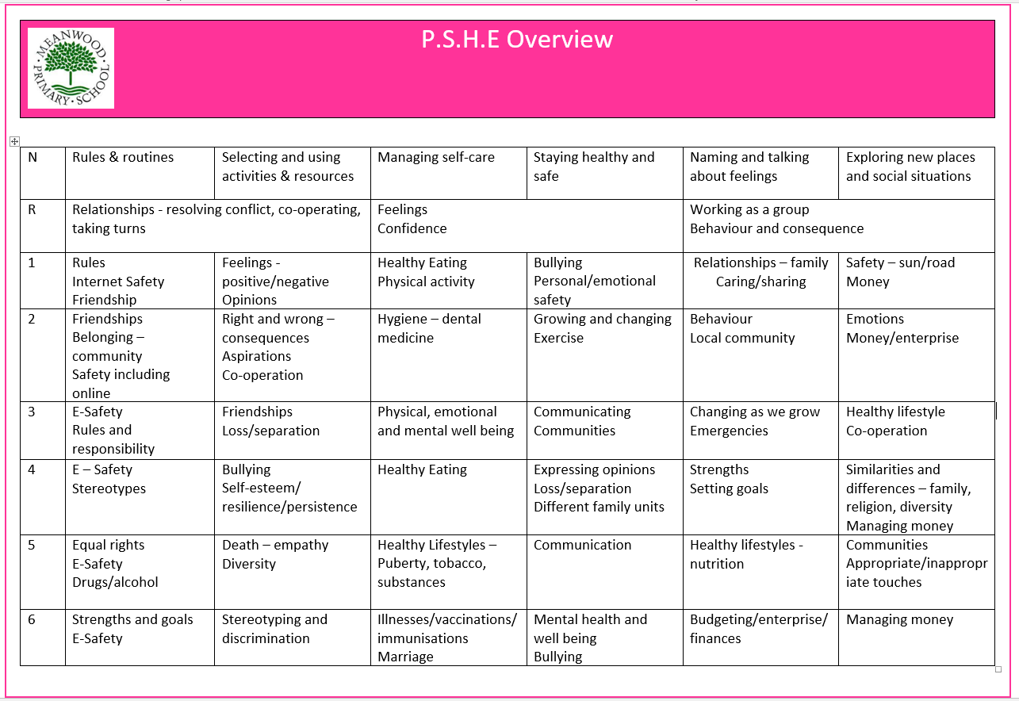

RE Curriculum Overview

Appendix 2: By the end of primary school pupils should know (Statutory Guidance for RELATIONSHIPS EDUCATION)
TOPIC | PUPILS SHOULD KNOW
Families and people who care about me | - That families are important for children growing up because they can give love, security and stability  - The characteristics of healthy family life, commitment to each other, including in times of difficulty, protection and care for children and other family members, the importance of spending time together and sharing each other’s lives  - That others’ families, either in school or in the wider world, sometimes look different from their family, but that they should respect those differences and know that other children’s families are also characterised by love and care  - That stable, caring relationships, which may be of different types, are at the heart of happy families, and are important for children’s security as they grow up  - That marriage represents a formal and legally recognised commitment of two people to each other which is intended to be lifelong  - How to recognise if family relationships are making them feel unhappy or unsafe, and how to seek help or advice from others if needed
Caring friendships | - How important friendships are in making us feel happy and secure, and how people choose and make friends  - The characteristics of friendships, including mutual respect, truthfulness, trustworthiness, loyalty, kindness, generosity, trust, sharing interests and experiences and support with problems and difficulties  - That healthy friendships are positive and welcoming towards others, and do not make others feel lonely or excluded  - That most friendships have ups and downs, and that these can often be worked through so that the friendship is repaired or even strengthened, and that resorting to violence is never right  - How to recognise who to trust and who not to trust, how to judge when a friendship is making them feel unhappy or uncomfortable, managing conflict, how to manage these situations and how to seek help or advice from others, if needed
Respectful relationships | - The importance of respecting others, even when they are very different from them (for example, physically, in character, personality or backgrounds), or make different choices or have different preferences or beliefs  - Practical steps they can take in a range of different contexts to improve or support respectful relationships  - The conventions of courtesy and manners  - The importance of self-respect and how this links to their own happiness  - That in school and in wider society they can expect to be treated with respect by others, and that in turn they should show due respect to others, including those in positions of authority  - About different types of bullying (including cyberbullying), the impact of bullying, responsibilities of bystanders (primarily reporting bullying to an adult) and how to get help  - What a stereotype is, and how stereotypes can be unfair, negative or destructive  - The importance of permission-seeking and giving in relationships with friends, peers and adults
Online relationships | - That people sometimes behave differently online, including by pretending to be someone they are not  - That the same principles apply to online relationships as to face-to face relationships, including the importance of respect for others online including when we are anonymous  - The rules and principles for keeping safe online, how to recognise risks, harmful content and contact, and how to report them  - How to critically consider their online friendships and sources of information including awareness of the risks associated with people they have never met  - How information and data is shared and used online
Being safe | - What sorts of boundaries are appropriate in friendships with peers and others (including in a digital context)  - About the concept of privacy and the implications of it for both children and adults; including that it is not always right to keep secrets if they relate to being safe  - That each person’s body belongs to them, and the differences between appropriate and inappropriate or unsafe physical, and other, contact  - How to respond safely and appropriately to adults they may encounter (in all contexts, including online) whom they do not know  - How to recognise and report feelings of being unsafe or feeling bad about any adult  - How to ask for advice or help for themselves or others, and to keep trying until they are heard  - How to report concerns or abuse, and the vocabulary and confidence needed to do so  - Where to get advice e.g. family, school and/or other sources

Statutory Parts of the Science Curriculum relating to Relationships Education

Key Stage One
Identify, name, draw and label the basic parts of the human body and say which part of the body is associated with each sense.
Notice that animals, including humans, have offspring, which grow into adults.
Describe the importance for humans of exercise, eating the right amounts of different types of food, and hygiene.
Key Stage Two
Identify that animals, including humans, need the right types and amount of nutrition, and that they cannot make their own food; they get nutrition from what they eat.
Describe the changes as humans develop to old age.
Recognise the impact of diet, exercise, drugs and lifestyle on the way their bodies function.

Appendix 3: Parent form: withdrawal from sex education within Relationships Education
TO BE COMPLETED BY PARENTS
Name of child |  | Class
Name of parent |  | Date
Reason for withdrawing from sex education within Relationships Education
Any other information you would like the school to consider
Parent signature

TO BE COMPLETED BY THE SCHOOL
Agreed actions from discussion with parents

