**Year 1**

Maths

**Multiplication and division**. The children will be learning how to make equal groups by grouping and sorting. The children will also make doubles, arrays, equal groups and adding equal groups.

**Fractions.** Whilst learning about fractions the children will be both finding and making a half, whole and a quarter of objects.

**Position and directions.** The children will be learning what a turn is and how to describe the turn that they have made, including what position they are in. They will be using language such as: North, South, East and West.

English

We will be focussing on set 2 and set 3 sounds.

**Set 2:** igh, ow, oo, oo, ar, or, air, oy, ir, ay, ou and ee.

**Set 3:** ea, oi, a-e, i-e, o-e, u-e, aw, are, ur, er, ow, ai, ew, ire and ear.

**Writing:**

All children will be building and holding sentences based upon what they have read. We are working upon using capital letters, fingers spaces and full stops.

**Reading:**

Reading is based upon the sounds that we are learning. We are now beginning to read more fluently using fred talk. (Sounding out). Words are split into red and green words. Green words you can fred talk but red words are a little more tricky.

**Summer 1**

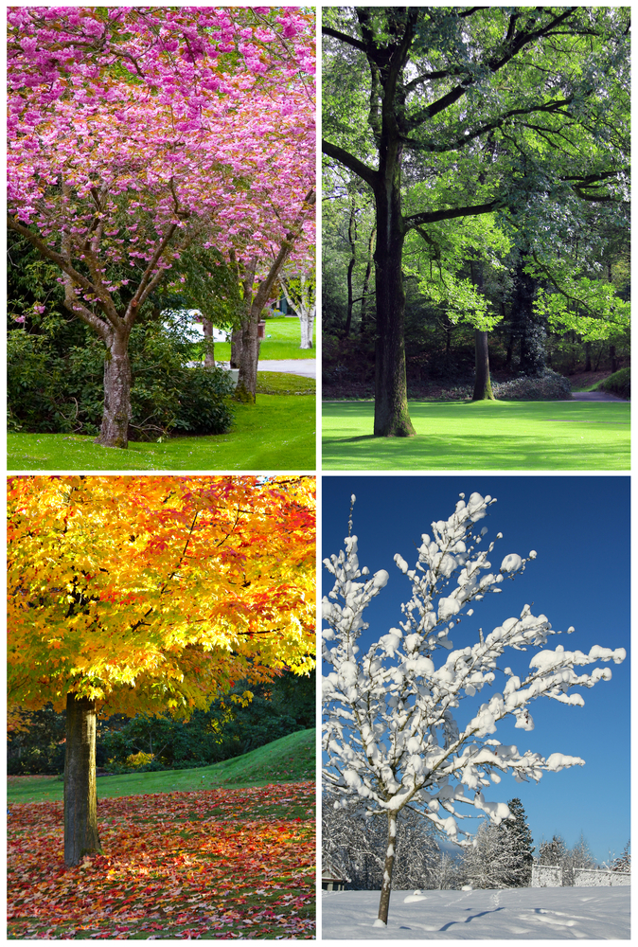

RE

**What does it mean to belong to a faith community?** The children will be discussing what a community is and what community groups the children could belong to such as: Cubs, Rainbows and sports clubs.

Music

In Music, the children will be developing their ability to sing with both accuracy and expression through the songs of Jack and the Beanstalk as well as music by the composer Dalcroze.

Science

**Seasonal changes**

How do we know it is summer or spring?

Children will look at how the day length varies from summer to spring.

They will also observe and describe the weather in spring.

They will observe and begin to recognise the signs of spring.

This unit will conclude with a lesson all about how to stay safe in the sun.

PE

**Invasion games**, the children learning how to throw and receive both bounce and chest passes with improved accuracy. They shall also be dribbling balls with one hand and using their finger to push a ball down.

**Dance –Minibeasts**

Moving to music in a variety of minibeast styles such as butterflies, worms and caterpillars.

Computing

Computing Systems and Technology—Technology around us

The children will develop their understanding of technology and how it can help us. They will start to become familiar with the different components of a computer by developing their keyboard and mouse skills. Learners will also consider how to use technology responsibly.

Art/DT

Landscapes using different media. In this series of lessons, the children learn about composition and work with different art materials to create texture for a seascape.

PSHE

**Recognising family and special people to us**

**Lending and borrowing**

**Being kind and caring**

During PSHE lessons we will be discussing the importance of money and being kind and caring to family and people who are special to us.

**Spring Summer**