**Year 1**

Maths

In maths, we will be extending our addition and subtraction 20.Once this has been completed, the children will then focus on place value of numbers up to 50. This shall include comparing numbers using < >, counting forwards/backwards, representing numbers to 50, counting 1 more or 1 less and ordering numbers.

English

The children will be progressing on their phonics journey and will continue to learn 1 and 2 sounds.

**Set 1:** m, a, s, d, t, I, n, p, g, o, c, k, u, b, f, e, l, h, sh, r, j, v, y, w, th, z, ch, qu,x, ng and ng.

**Set 2:** igh, ow, oo, oo, ar, or, air, oy, ir, ay, ou, ng and ee.

**Writing:**

All children will be building and holding sentences based upon what they have read. We are working upon using capital letters, fingers spaces and full stops.

**Reading:**

Reading is based upon the sounds that we are learning. We are now beginning to read more fluently using fred talk. (Sounding out). Words are split into red and green words. Green words you can fred talk but red words are a little more tricky.

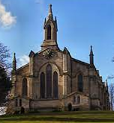**Spring 1**

Art

Painting! In Art, we shall be learning about what primary colours are and how they can be used to create secondary colours. Whilst painting, the children will experiment with different sized paintbrushes and different thicknesses of paint. To end the unit, the children will apply of the skills taught to create a painting in the style of Van Gogh.

Computing

In this unit of work, the children will use Purple Mash to access and create spreadsheets. The children will learn how to open a spreadsheet and input data into a cell. They will also be able to add images into a spreadsheet and learn how to use the speak and count tools to count items.

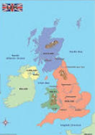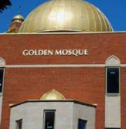

PSHE

In PSHE, the children will be learning about their personal hygiene and how we can keep ourselves clean. They shall also learn about healthy eating and what they can do themselves to lead a healthy lifestyle.

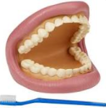

Geography

Our key question for Geography is, ‘What is the UK?’ The children will learn about the countries and capital cities that make up the United Kingdom. We will also identify the seas and oceans that surround it. The children will look at the human and physical features of the UK and discuss what the UK is like. Finally, we will discuss, ‘Where in the world is the UK?

RE

Our RE will focus upon the question: What makes some places sacred? The children will learn what a place of worship is, how and why a Mosque is s special place to Muslims and how and why a Church is a special place to Christians. They will learn the names of special objects found both a Mosque and a Church. We shall also identify what is the same and different between a Mosque and a Church? We hope to visit both a Mosque and Church to enhance our learning.

Science

In Science, the children will be learning about animals including common pets, human’s body parts and senses. The children will be classifying animals into groups. They will know the diet of different animals and how they eat these foods with their use of teeth to chew. They will identify similarities and differences between animals and describe different animal’s features. We shall be very busy!

PE

In indoor PE, the children will be continuing to learn about gymnastics but with a focus on how to roll safely. In outdoor PE, the children develop their skills of object manipulation. This involves, lifting, bouncing, dribbling, throwing and striking balls.

Music

This term in music the theme is ‘Polar’. The children will learn about timbre, dynamics and tempo. They will also describe sounds in terms of timbre, slow, fast, dynamics and mood.

Dalcroze