**Year 2**

English

We will continue with our new writing approach ‘The Write Stuff’. We will continue with writing our own set of instructions for how to make a bird feeder and then use these to make some for our outdoor area. Please keep any used yoghurt pots, toilet roll tubes and plastic bottles so that we can use these to make our bird feeders with. We will then learn how to write a non-chronological report about big cats. We will also be writing a story based on the book ‘George and the Dragon’ by Christopher Wormell. In preparation for Key Stage 2, we will be introducing the children to the Accelerated Reader programme where they can access a wider range of both paper and electronic books.

Maths

In Maths we will be learning about position and direction; time; mass, capacity and temperature.

In our position and direction lessons we will be learning to describe position, movement, turns and make patterns with shapes.

In our time lessons, we will be learning to tell the time to the hour, half hour, o’clock and half past, quarter past and quarter to, telling the time in 5 minute intervals, hours in a day, finding and comparing durations of time and writing the time.

In our mass, capacity and temperature lessons we will be learning how to measure and compare mass, measure mass in grams and kilograms, measure capacity, compare volume, measure capacity in millilitres and litres and measure temperature.

**Summer 2**

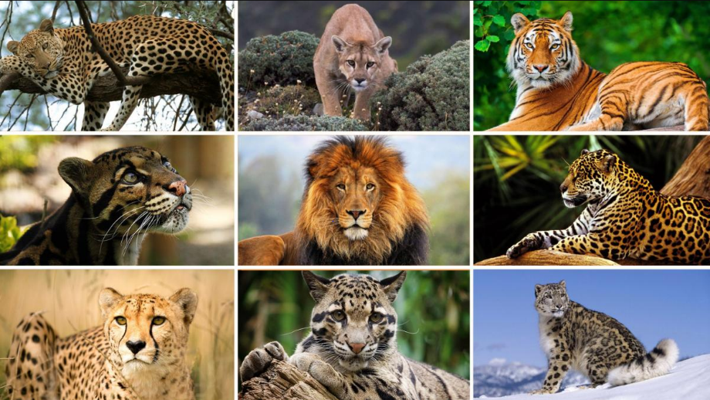

Art

In art we will be developing our art and design skills. We will be developing our drawing, design, craft and art appreciation skills; exploring two different printing techniques, using 2D shapes to explore a variety of media, mixing different shades of one colour and discussing the work of artist Louis Wain.

Geography

In geography we will be studying our local environment, finding out more about where we live. We will be learning about the difference between a village, a town and a city; looking at the key features of our local area; what our community is like; what types of houses there are in our local area and studying maps of our local area.

PSHE

In PSHE we will be covering the strands of relationships, living in the wider world and health and wellbeing. In our relationships lessons, we will be learning about bullying and fairness. In our living in the wider world lessons, we will be learning about communities, money and finance. In our health and wellbeing lessons, we will be learning about changing and growing, and our emotions.

PE

In our indoor PE sessions, we will be developing and improving our fundamental movement skills.

In our outdoor PE lessons, we will be competing in striking and field games.

Computing

In computing we will be developing our questioning and presenting ideas. We will be exploring how a story can be presented in different ways; to make a quiz about a story or class topic; to make a fact file about a non-fiction topic and make a presentation to the class.

Music

In music, we will be learning to play the recorder.

RE

In RE we will be continuing with our learning about what it means to belong to a faith community.

Science

In Science, our new topic is living things and their habitats. We will be learning about what a habitat is, the different types of habitats, the animals that live there and how they have adapted to their habitats.

We will be working scientifically by developing our skills of identifying and classifying and observing changes over time.

We will also be going a trip to Blackpool Zoo to learn about a variety of animals and their habitats. Exciting!