**Year 2**

English

We will continue with our new writing approach ‘The Write Stuff’. Children will be learning how to write a story based on the book ‘The Owl Who Was Afraid of the Dark’ by Jill Tomlinson. They will also be learning about the features of a non-fiction text by learning how to write a set of instructions for how to make a bird feeder. In preparation for Key Stage 2, we will be introducing the children to the Accelerated Reader programme where they can access a wider range of both paper and electronic books.

Maths

In Maths we will be learning about length and height, position and direction, and time. We will choose and use appropriate standard units to estimate and measure length/height in any direction (m/cm); mass (kg/g); temperature (°C); capacity (litres/ml) to the nearest appropriate unit, using rulers, scales, thermometers and measuring vessels. We will use mathematical vocabulary to describe position, direction and movement including movement in a straight line and distinguishing between rotation as a turn and in terms of right angles for quarter, half and three-quarter turns. We will be learning to tell and write the time to five minutes, including quarter past/to the hour and draw the hands on a clock face to show these times. We will learn how many minutes there are in an hour and the number of hours in a day.

**Summer 1**

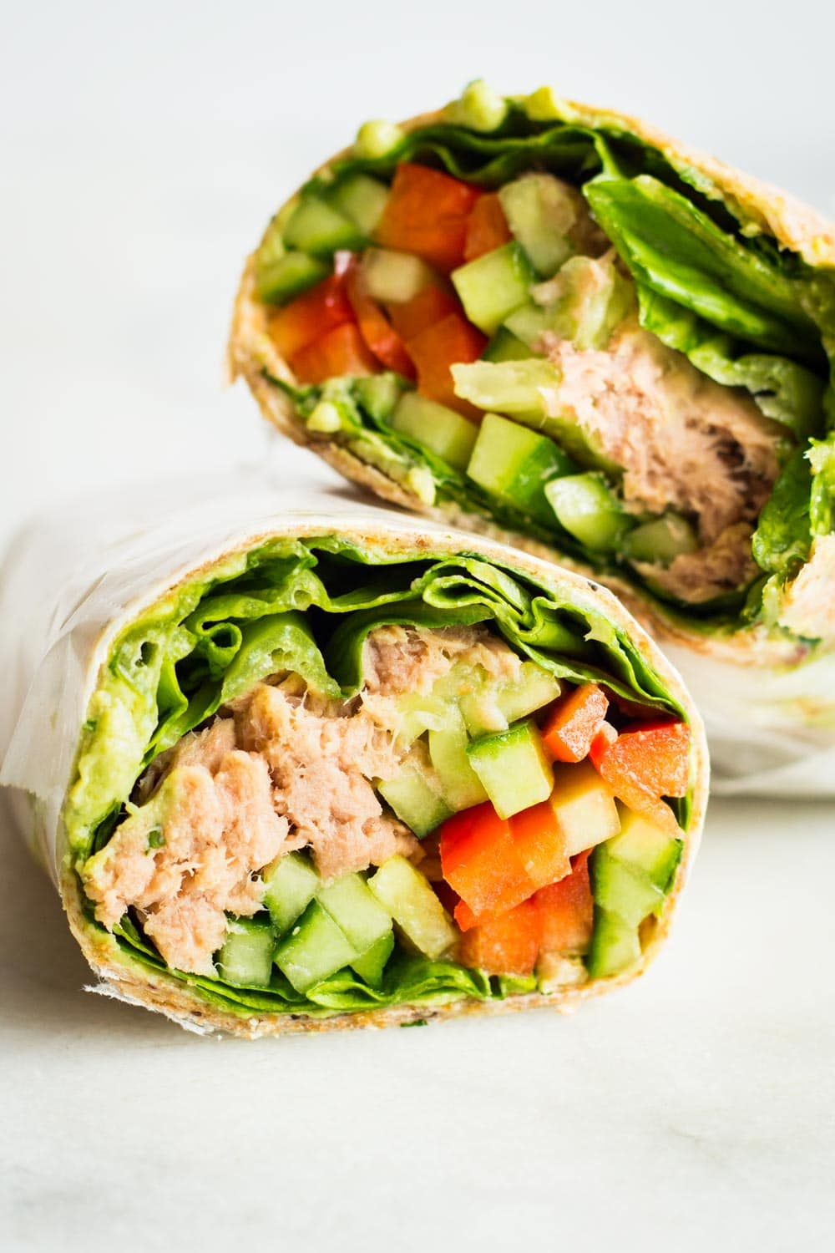

Computing

In computing we will be learning about how to create digital pictures. The children will learn to recognise that different devices can be used to capture photographs and will gain experience capturing, editing, and improving photos. Finally, they will use this knowledge to recognise that images they see may not be real.

Music

In music, we will be developing our singing voices by singing with expression and accuracy.

PSHE

Our focus for our PSHE lessons is relationships. We will be learning about bullying and what to do if we or someone we know is being bullied. We will be learning about the importance of families caring for each other as well as recognising how our behaviour and actions can affect others.

RE

In RE we will be learning about the importance of belonging to a faith community.

PE

In our indoor PE sessions, we will be continuing to develop our gymnastic skills of spinning, turning and twisting. In our outdoor PE sessions, we will be developing our catching and throwing skills by taking part in net and wall games.

Geography

In geography we will be studying the country of Zambia in Africa and comparing the village of Mugurameno to where we live in Rochdale.

DT

In our design and technology lessons the children will explore what makes a balanced diet and taste test food combinations of different food groups. They will also aim to make a wrap that includes a healthy mix of protein, vegetables and dairy, and learn about the term ‘hidden sugars’.

Science

In Science we will be learning about living things and their habitats.

We will spend our first science lesson identifying the differences between something that is dead or alive. By exploring outside, and through observation, we will look at the differences between things that are living, dead, and have never been alive. We will then explore the school grounds on the hunt for microhabitats and draw or photograph what is going on there. We will be researching creatures in larger habitats and ask ourselves: why do these living things live there? To enhance our learning, we will be going on an exciting trip to Blackpool Zoo! We will then move on to learning about food chains and understand that living things need each other in order to survive. We will then draw on our understanding of microhabitats to design and make a bug hotel to encourage a variety of creatures into our school environment!